
Math Activity One Pager Station Sheet

Jenga Math
(Title of the Activity/Game)

Grade Level Any Grade!!!
Topic/Math Concept Any Concept!!
Outcome(s) Any Outcome. Any content area!

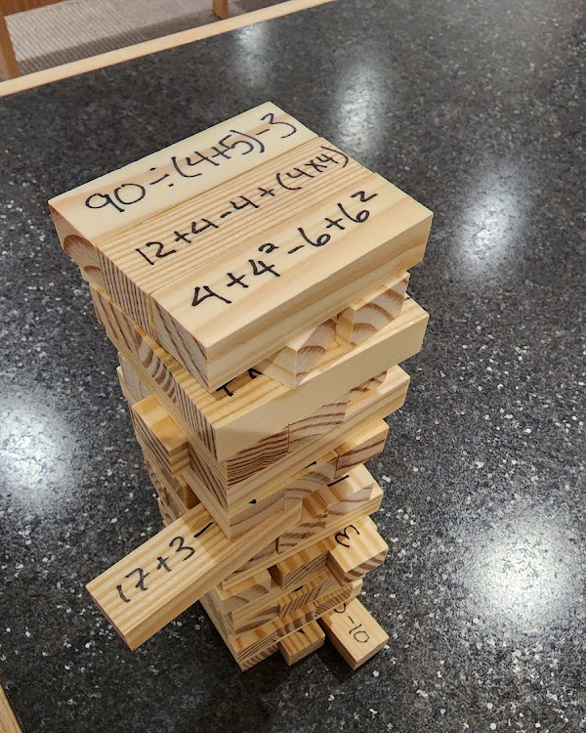
Materials Required Commercial game, Jenga, or it’s cheaper knock-off version, “Tumbling Tower”, which is even better, because it doesn’t have “Jenga” stamped on every tile!

Instructions
Use a jiffy marker to write practice questions on each tile. Pretty simple…kids play and must answer the question correctly on the tile they pull to stack. Opponents help coach for correct answers. Players can use paper and pencil to track the work they do. If you like, you can make a template where they write down each question and show their solution to hand in.

I love this because: Kids love it, it’s engaging. Can be used for any topic. Kids can play standing or on floor. It provides a movement break. Great game for kids that finish classwork early.

Source Cindy
Contributor and Email Cindy Smith smitc01@cttcs.ca

