Grade: | Kindergarten | Grade 1 | Grade 2 | Grade 3 | Grade 4 | Grade 5 | Grade 6 | Grade 7 | Grade 8 | Grade 9
Patterns and Relations Outcomes: | PK.1 –  Demonstrate an understanding of repeating patterns (two or three elements) by:  - identifying  - reproducing  - extending  - creating  patterns using manipulatives, sounds, and actions.  NK.5 –  Compare quantities, 0 to 10, using one-to-one correspondence. | P1.1 - Demonstrate an understanding of repeating patterns.  P1.2 –  Translate repeating patterns from one form of representation to another.  P1.3 –  Describe equality as a balance and inequality as an imbalance, concretely, physically, and pictorially (0 to 20).  P1.4 –  Record equalities using the equal symbol. | P2.1 - Demonstrate understanding of repeating patterns (three to five elements).  P2.2 - Demonstrate understanding of increasing patterns.  P2.3 - Demonstrate understanding of equality and inequality concretely and pictorially (0 to 100). | P3.1 - Demonstrate understanding of increasing and decreasing patterns.  P3.2 - Demonstrate understanding of equality by solving one-step addition and subtraction equations involving symbols representing an unknown quantity. | P4.1 - Demonstrate an understanding of patterns and relations [using tables]  P4.2 - Demonstrate an understanding of equations involving symbols to represent an unknown value. | P5.1 –  Represent, analyze, and apply patterns using mathematical language and notation.  P5.2 –  Write, solve, and verify solutions of single-variable, one-step equations with whole number coefficients and whole number solutions. | P6.1 –  Extend understanding of patterns and relationships in tables of values and graphs.  P6.2 –  Extend understanding of preservation of equality concretely, pictorially, physically, and symbolically  P6.3 –  Extend understanding of patterns and relationships by using expressions and equations involving variables.  SS6.4 –  Understanding of the first quadrant of the Cartesian Plane and ordered pairs (whole numbers)  SP6.1 –  Extend understanding of data analysis to include line graphs | P7.1 –  Demonstrate an understanding of the relationships between oral and written patterns, graphs and linear relations.  P7.2 –  Demonstrate an understanding of equations and expressions.  P7.3 –  Demonstrate an understanding of one- and two-step linear equations of the form ax/b + c = d (where a, b, c, and d are whole numbers, c ≤ d and b ≠ 0) by modeling the solution of the equations concretely, pictorially, physically, and symbolically and explaining the solution in terms of the preservation of equality.  P7.4 –  Demonstrate an understanding of linear equations of the form x + a = b (where a and b are integers) by modeling problems as a linear equation and solving the problems concretely, pictorially, and symbolically.  SS7.4 –  Understanding Cartesian Plane and ordered pairs with integral coordinates | P8.1 - Demonstrate understanding of linear relations concretely, pictorially (including graphs), physically, and symbolically.  P8.2 –  Model and solve problems using linear equations of the form:  - ax = b  - x/a = b, a ≠ 0  - ax + b = c  - x/a + b = c, a ≠ 0  - a(x + b) = c  concretely, pictorially, and symbolically, where a, b, and c are integers. | P9.1 - Demonstrate understanding of linear relations.  P9.2 –  Model and solve situational questions using linear equations of the form:  - ax = b  - x/a = b, a ≠ 0  - ax + b = c  - x/a + b = c, a ≠ 0  - ax = b + cx  - a(x + b) = c  - ax + b = cx + d  - a(bx + c) = d(ex + f)  - a/x = b, x ≠ 0  where a, b, c, d, e, and f are rational numbers.  P9.3 - Demonstrate understanding of single variable linear inequalities with rational coefficients.  P9.4 - Demonstrate understanding of polynomials (limited to polynomials of degree less than or equal to 2).
Grade: | Kindergarten | Grade 1 | Grade 2 | Grade 3 | Grade 4 | Blue Fill refers to PATTERNS | No Fill refers to RELATIONS
Progression of Learning: | Students can identify and create a repeating pattern with 2 or 3 elements with sounds, manipulatives, shapes, and actions.  Students can identify more, fewer, as many as, or the same number.
Progression of Learning: | Students will compare two sets by determining if there is more than, fewer than, as many as (0-10).
Progression of Learning: |  | Students can identify and create a repeating pattern with 2 - 4 elements in its core with sounds, manipulatives, shapes, and actions.  Students will translate repeating patterns from one form to another (ie same pattern, different stuff)
Progression of Learning: |  | Students will describe equality as a balance and inequality as an imbalance. (0-20)  Students will use the equal sign to represent equality or balance.
Progression of Learning: |  |  | Students can identify and create a repeating pattern with 3-5 elements in its core with sounds, manipulatives, pictures, actions, and numbers to 100.  Students can reproduce, extend, and describe an increasing pattern.  Students can determine the pattern rule for an increasing pattern.  Students can describe the core of a repeating pattern.
Progression of Learning: |  |  | Students will describe equality as a balance and inequality as an imbalance (0-100).  Students will use record inequalities by using the not equal sign.
Progression of Learning: |  |  |  | Students can reproduce, extend, and describe an increasing and decreasing pattern.  Students can determine the pattern rule for an increasing and decreasing pattern.
Progression of Learning: |  |  |  | Students will solve one step equations (addition and subtraction) involving symbols representing an unknown quantity.
Progression of Learning: |  |  |  |  | Students will represent and extend patterns in a chart.
Progression of Learning: |  |  |  |  | Students will solve one step equations (addition, subtraction, multiplication and division) involving symbols representing one unknown quantity.  Students will solve equations by inspection and/or guess and check.  Students will write an equation to represent a problem.
Progression of Learning: | Grade 5 | Grade 6 | Grade 7 | Grade 8 | Grade 9 | Blue fill refers to PATTERNS | No Fill refers to RELATIONS
Progression of Learning: | Students can describe the relationship between numbers in two columns in a table of values using mathematical words and symbols.  Students use variables to describe an unknown.
Progression of Learning: | Students will use a variable as the unknown.  Students will verify the solution.  Students will write an expression for a table of values (one operation).
Progression of Learning: |  | Students will be able to plot coordinates in the positive quadrant of the Cartesian Plane.  Students will represent algebraic relationships using a graph, tables of values, equation, manipulatives, pictures, and words.
Progression of Learning: |  | Students will understand that to preserve equality you must perform the same operation to both sides.  Students will create and record symbolically equivalent forms of an equation and verify the results.  Students will use expressions and equations using variables.  Students will write an expression for a table of values (two operations).
Progression of Learning: |  |  | Students will understand the relationship between different relationships amongst different representations of linear relations.  Students graph linear relations in the first quadrant of the Cartesian plane. (Whole numbers)
Progression of Learning: |  |  | Students will demonstrate understanding of the difference between expressions and equations.  Students will solve an equation using the steps that demonstrate the preservation of equality.  Students will solve equations of the form x + a = b, where a and b are integers.
Progression of Learning: |  |  |  | Students graph linear relations on all four quadrants of the Cartesian plane (Integral values)  Students will demonstrate an understanding of linear relations concretely, pictorially, physically and symbolically.
Progression of Learning: |  |  |  | Students will solve equations where x is on one side of the equation that includes parentheses (distributive property) and the constants are integers.
Progression of Learning: |  |  |  |  | Students will demonstrate an understanding of linear relations  Students graph linear relations (Rational numbers)
Progression of Learning: |  |  |  |  | Students will solve equations where x is on both sides of the equation and the constants are rational numbers.  Students will solve inequalities.

Grade: | Kindergarten | Grade 1 |  | Grade 2 |  | Grade 3 | Grade 4
Big Ideas: | Much of the mathematics of the other strands is built on a pattern foundation  Patterns exist everywhere  Patterns represent identified regularities  Patterns can be recognized, extended or created  The same pattern can be found in many forms  Quantities can be compared
Big Ideas: |  | An element of patterns is that they have a core that repeats  Patterns can be represented using symbols  A pattern can be translated into different forms (ABBA = clap, stomp, stomp, clap)  An equal symbol represents equality or balance and inequality means an imbalance
Big Ideas: |  |  |  | Patterns can increase
Big Ideas: |  |  |  |  |  | Patterns can decrease  Symbols can represent an unknown quantity
Big Ideas: |  |  |  |  |  |  | Patterns can be displayed in a table  Equations show equality between two mathematical expressions (4 + 8 = + 5)
Big Ideas: | Grade 5 | Grade 6 |  | Grade 7 |  | Grade 8 | Grade 9
Big Ideas: | Variables are symbols that take the place of numbers or ranges of numbers  Algebra is a way to represent and explain mathematical relationships and to describe and analyze change
Big Ideas: |  |  | Patterns can be represented with a graph  Relationships between quantities can be described efficiently using variables  An ordered pair describes a unique point on the coordinate plane  Whatever you do to one side, you need to do to the other side (preservation of equality)
Big Ideas: |  |  |  |  | Preservation of equality can be used to solve equations
Big Ideas: |  |  |  |  |  |  | All types numbers can be part of linear equations  Not all relations are linear

Grade: | Kindergarten | Grade 1 | Grade 2 | Grade 3 | Grade 4 | Grade 5 | Grade 6 | Grade 7 | Grade 8 | Grade 9
Vocabulary: | - fewer  - more  - repeating pattern  - the same as | - core  - element | - increasing pattern  - pattern rule | - decreasing pattern | - chart  - diagrams  - equation  - solution  - solve an equation  - table | - by inspection  - coefficient  - consecutive numbers  - mathematical language  - notation  - single-variable  - variable | - Cartesian plane  - coordinate grid  - coordinates  - ordered pair  - quadrant  - X axis  - horizontal axis  - Y axis  - vertical axis  - commutative property  - expression  - input output machine  - origin  - preservation of equality  - relations  - simplify | - algebra  - algebraic expression  - constant term  - divisibility rules  - evaluate an expression  - integers  - linear relation  - numerical coefficient  - relation  - systematic trial  - verify | - discrete data  - distributive property  - given restriction | - base  - exponent  - power  - binomial  - monomial  - polynomial  - trinomial  - degree  - dependent variable  - extrapolation  - interpolation  - independent variable  - inverse operations  - irrational numbers  - rational numbers  - like terms  - non-linear function  - term

Online resources for definitions:
Visual Mathematics Dictionary
Math is Fun
Mathwords

Grade: | Kindergarten | Grade 1 | Grade 2 | Grade 3
Instructional Strategies: | Conversation and observations – what is changing and what stays the same?  Providing opportunity for students to explain and justify their thinking (moving from students knowing to student understanding).  Use literature for students to find patterns, represent patterns found in literature, create or extend patterns from literature.  Provide opportunities for student story telling which may involve patterns.  Use sorting games and manipulatives to practice sorting, creating sorting rules and determining sorting rules.  Use Number Talks to describe, explain, verify, share, and identify patterns.  Take a Math Walk where students will look for, identify, and reproduce (by drawing or taking a picture) patterns found in their environment.
Instructional Strategies: | Use sounds with instruments to create pattern sounds  Use types of body patterns (kinesthetic) to create patterns  Use a variety of manipulatives including attribute blocks | Use the following manipulatives to reproduce, extend, create or translate patterns:  ATTRIBUTE BLOCKS 3-D SOLIDS PATTERN BLOCKS MUSICAL INSTRUMENTS CALENDARS  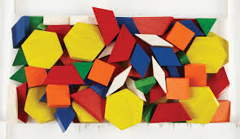  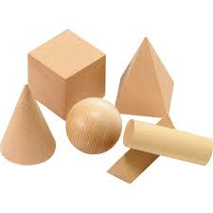  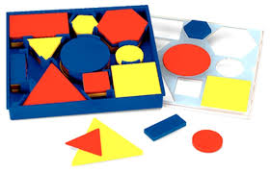  Use the following manipulatives to create increasing or decreasing patterns:  COUNTERS LINKING CUBES TOOTHPICKS  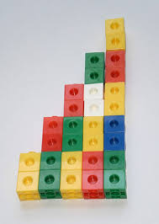  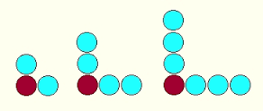  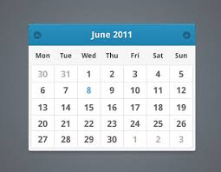  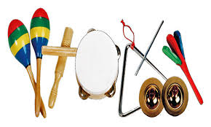  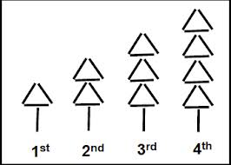

Grade: | Kindergarten | Grade 1 |  | Grade 2 | Grade 3
Instructional Strategies (K-3) continued: | In addition to creating patterns, use the following manipulatives and tools to demonstrate equality:  100 CHART TEN FRAMES (AND FIVE FRAMES) BALANCE SCALE  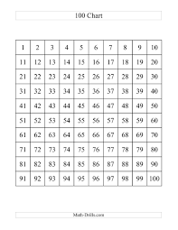  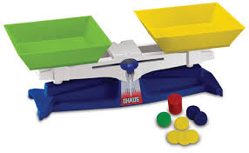  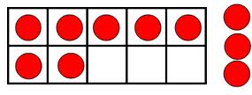  Provide opportunities for multi-attribute patterns as well (example, using a pattern with shapes as well as colors).
Instructional Strategies (K-3) continued: |  |  | - Play “Guess My Pattern Rule”  - Activity “Same Pattern, Different Stuff” (Activity 10.3, VanDeWalle page 278 K-3 book)  - Activity “What’s Next and Why?” (Activity 10.8, VandeWalle page 285, K-3 book)  - Activity “Calculator Skip Counting” (Activity 10.9, VandeWalle page 285, K-3 book)  - Activity “Start and Jump Numbers” (Activity 10.10, VandeWalle page 286, K-3 book)  - Activity “Start and Jump on the Hundreds Chart” (Activity 10.11, VandeWalle page 287, K-3 book)  - Activity “Fractured Chart Pieces” (Activity 10.12, VandeWalle page 288, K-3 book)  - Activity “How Many Ways?” (Activity 10.13, VandeWalle page 289, K-3 book)  - Activity “One Up and One Down: Addition” (Activity 10.14, VandeWalle page 289, K-3 book)  - Activity “Diagonal Sums” (Activity 10.16, VandeWalle page 290, K-3 book)  - Activity “Tilt or Balance” (Activity 10.22, Van de Walle page 300 K-3 book)

Grade: | Grade 4 | Grade 5 | Grade 6 | Grade 7 | Grade 8 | Grade 9
Instructional Strategies (Grades 4-9): |  |  |  | Teach P7.4 in integer unit if it has not occurred before this unit. | Graphing on the whole Cartesian Plane | Equation Persuasion Game (Math Makes Sense page 287)
Instructional Strategies (Grades 4-9): | Manipulatives:  In addition to the above mentioned manipulatives:  National Library Of Virtual Manipulatives  Glencoe.com Virtual Manipulatives  In addition to using manipulatives to demonstrate patterns and relations represented concretely, use the following pictorial and symbolic representations:  Grids  Charts  Calendars  Tables  Diagrams  Open number lines  Closed number lines  Drawing pictures  Calculators (constant, term) |  | Manipulatives:  In addition to the above mentioned manipulatives:  National Library Of Virtual Manipulatives  Glencoe.com Virtual Manipulatives  Manipulative apps  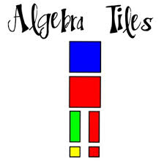  Algebra tiles Graphing calculators and other technology Graphing apps  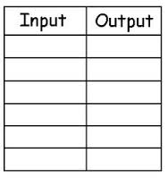  In addition to using manipulatives to demonstrate and represent patterns and relations, use the following pictorial and symbolic representations:  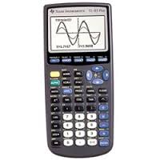    INPUT/OUTPUT MACHINE  Student Strategies may include:  - Using manipulatives  - Drawing a picture  - Solve a simpler problem (dividing to balance the scale, subtracting to balance the scale)  - Solve an equation by maintaining balance  - Work backward  - Guess and test (guess and check)  - Make an organized list  - Use the inverse operation  - Using a graph to describe relationships

Grade: | Grade 4 | Grade 5 | Grade 6 | Grade 7 | Grade 8 | Grade 9
Instructional Strategies (Grade 4-9) continued: | - Explore activity – match the card with the written description (ie. 8 is 3 more than a number matched with 8 = ____ + 3)  - Play “What’s my Rule?”  - Activity “Story Translations” (Activity 10.10, VandeWalle, page 307, Grade 3-5 book)  - Activity “Number Tricks” (Activity 10.11, VandeWalle, page 308, Grades 3-5 book)  - Activity “What’s True for All Numbers?” (Activity 10.12, VandeWalle, Page 308)  - Activity “Special Quantities” (Activity 10.13, VandeWalle, Page 309, Grades 3-5 book)  - Activity “Adjust the Balance” (Activity 10.16, VandeWalle, page 312, Grade 3-5 book)  - Activity “One Up and One Down: Multiplication” (Activity 10.15, VandeWalle page 290, K-3 book)  - Activity “Guess My Rule” (Activity 10.18, VandeWalle, page 316, Grade 3-5 book)  - Activity “Number Tricks” (activity 10.19, VandeWalle, page 298, K-3 book) |  | - Activity “Perimeter Patterns” (Activity 10.1, VandeWalle, page 292, Grades 5-8 book)  - Activity “How Many Gallons Left?” (Activity 10.2, Van de Walle, page 294, Grade 3-5 book)  - Activity “Designing the Largest Box” (Activity 10.3, Van de Walle, page 296, Grades 5-8 book)  - Activity “Fun Function Experiments” (Activity 10.6, Van de Walle, page 302, Grades 5-8 book)  - Activity “Sketch a Graph” (Activity 10.7, Van de Walle, page 303, Grade 5-8 book)  - Activity “Create a Journey Story” (Activity 10.8, Van de Walle, page 304, Grades 5-8 book)  - Activity “Bottles and Volume Graph” (Activity 10.9, Van de Walle, page 304, Grades 5-8 book)
Instructional Strategies (Grade 4-9) continued: | Use Number talks  Story-telling and finding patterns in stories  Integrate literature:  - Anno’s Magic Seeds (Anno, 1995)  - Anno’s Mysterious Multiplying Jar (Anno, 1983)  - The Rajah’s Rice: A Mathematical Folktale from India (Barry, 1994)  - The Token Gift (McKibbon, 1996)  - Pattern Fish (Harris, 2000)  - Pattern Bugs (Harris, 2001)  - Two of Everything (Hong, 2003)  - Sea Squares (Hulme, 1999)  - Nature’e Paintbrush: The Patterns and Colours Around You (Stockdale, 1999)  - Lots and Lots of Zebra Stripes: Patterns in Nature (Swinburne, 1998)

Grade: | Kindergarten | Grade 1 | Grade 2 |  | Grade 3 | Grade 4 | Grade 5 | Grade 6 | Grade 7 | Grade 8 | Grade 9
Common Misconceptions: |  | The equal sign means do something or find an answer rather than ensuring equality
Common Misconceptions: |  |  |  | Students may be unaware of multiple possible patterns and may see growing patterns only as repeating patterns
Common Misconceptions: |  |  |  |  |  |  | Students may look at the pattern rule relating one element to the previous element rather than the relationship between two columns in a table of values.  Students may think expressions and equations are the same rather than expressions being parts of an equation.  Students may think we solve expressions rather than simplifying them.  Students have difficulty identifying what is staying the same in a relation and therefore are unable to assign the variable.  Students may interpret a multiplication sign as the variable x or interpreting the variable x as a multiplication sign.
Common Misconceptions: |  |  |  |  |  |  |  | Students solve equations left to right rather than following the order of operations
Common Misconceptions: |  |  |  |  |  |  |  |  | Students may think whatever I do to one term, I have to do to all terms rather than what I do to one expression, I need to do to both expressions  Students may think that when solving equations, we move numbers over to the other side in order to solve rather than using preservation of equality to isolate the variable

Resources:
Small, Marion, Making Math Meaningful to Canadian Students, K-8, Second Edition, Nelson Education, United States of America, 2013.
VandeWalle, John A. and Lovin, LouAnn H., Teacher Student-Centered Mathematics Grades K-3, Pearson Education, Inc., United States of America, 2006.
VandeWalle, John A. and Lovin, LouAnn H., Teacher Student-Centered Mathematics Grades 3-5, Pearson Education, Inc., United States of America, 2006.
VandeWalle, John A. and Lovin, LouAnn H., Teacher Student-Centered Mathematics Grade 5-8, Pearson Education, Inc., United States of America, 2006.

