
Math Activity One Pager Station Sheet

Sort It Out / Build That Pattern / Pattern Chains

Grade Level: Kindergarten
Topic/Math Concept: Sorting, Patterning

Outcome(s)
- PK..1 – Demonstrate an understanding of repeated patterns (2 or 3 elements)

Materials Required
- Sort It Out – Coloured manipulatives, coloured bowls, tweezers/fine motor tool (optional)
- Build That Pattern – Linking cubes, pattern examples
- Pattern Chains – Linking chains, pattern examples

Instructions – Each of these activities can be used in various formats (small group, independent activity, invitations, etc.)
- Sort it Out – Students will use the tweezers to sort the bears by colour (while also working on fine motor skills)
- Build That Pattern – Students will attempt to build the patterns shown on the cards (as well as make their own)
- Pattern Chains – Students will attempt to build and extend the patterns shown on the cards (as well as make their own)

I love this because: Each of these activities provide students with a hands-on way to engage with patterns. They are simple to set up, require very minimal instructions, and can be adapted to meet the needs of students at various levels. Each activity also builds upon skills developed in those prior (sorting replicating patterns extending patterns), which also supports differentiating by having students move on as they progress at different rates.

Source: Myself, Learning Resources Inc. (Linking Mats)

Contributor and Email: Lauren Sauser [sausl01@cttcs.ca]

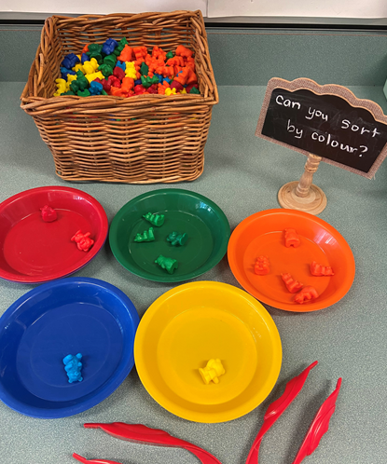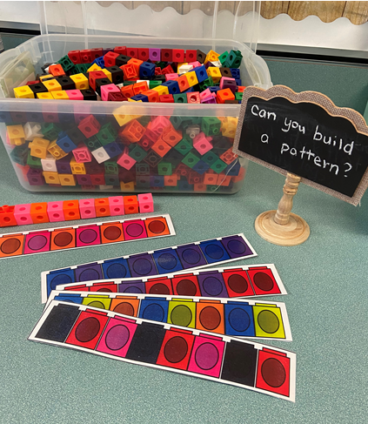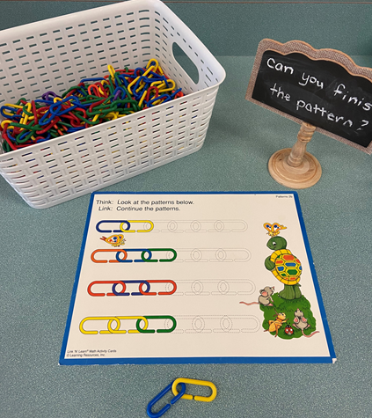
Sort It Out Build That Pattern Pattern Chains

