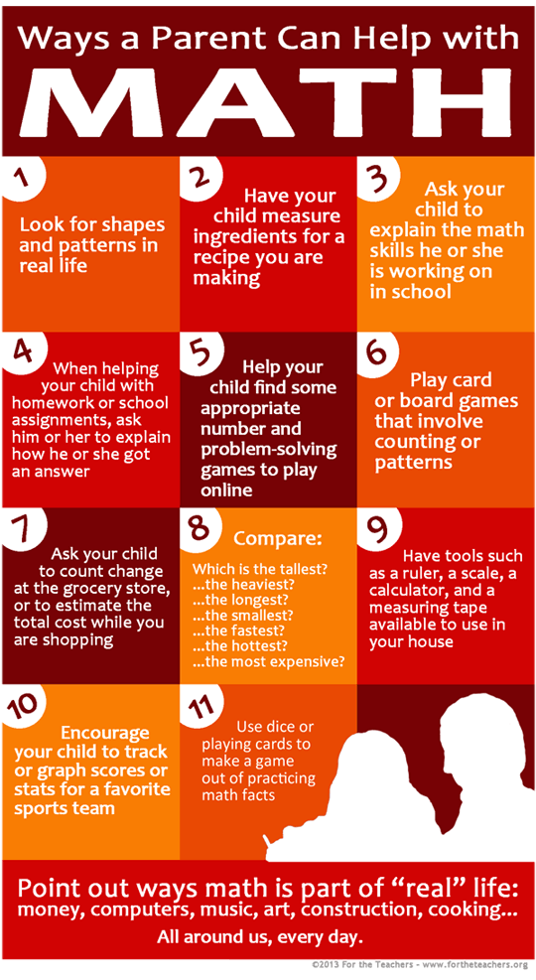
Tips for Parents Helping Students Learn Math At Home

  - When your child is struggling with a math problem, encourage her/him by looking for helpful mathematical thinking.
  - Math is not a race; do not time your child when she/he is working on math fluency.
  - Never share with your children the idea that you were bad at math at school or you dislike it.
  - Encourage number sense-the ability to separate and put numbers together flexibly-by talking with your child about how you solve math problems.
  - Encourage a growth mindset, the idea that ability and smartness change as you work more and learn more.

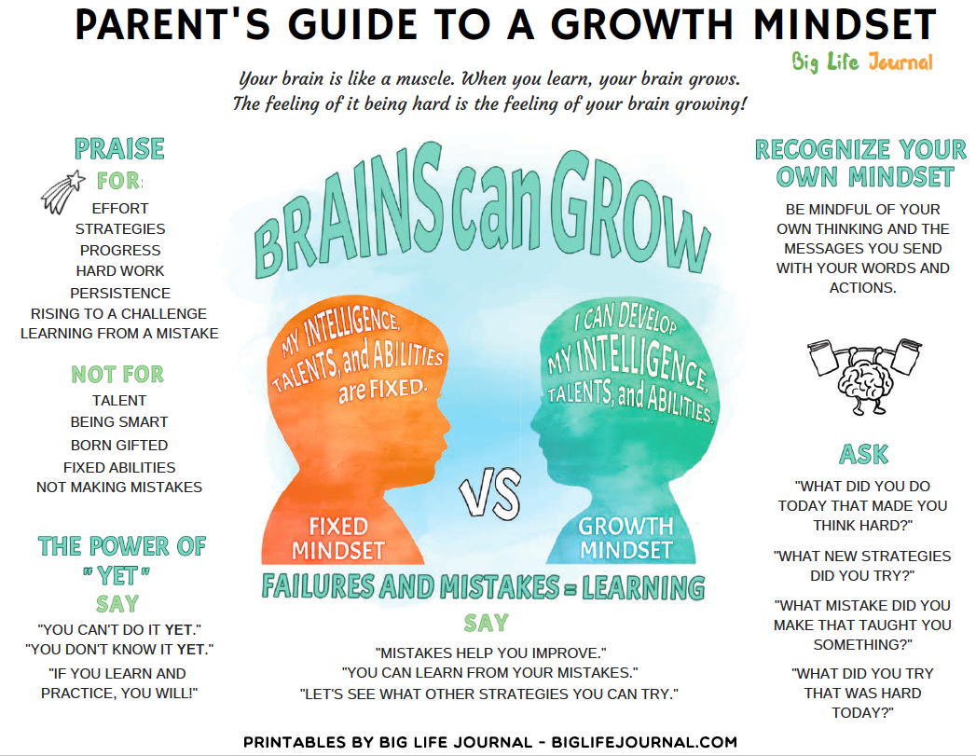

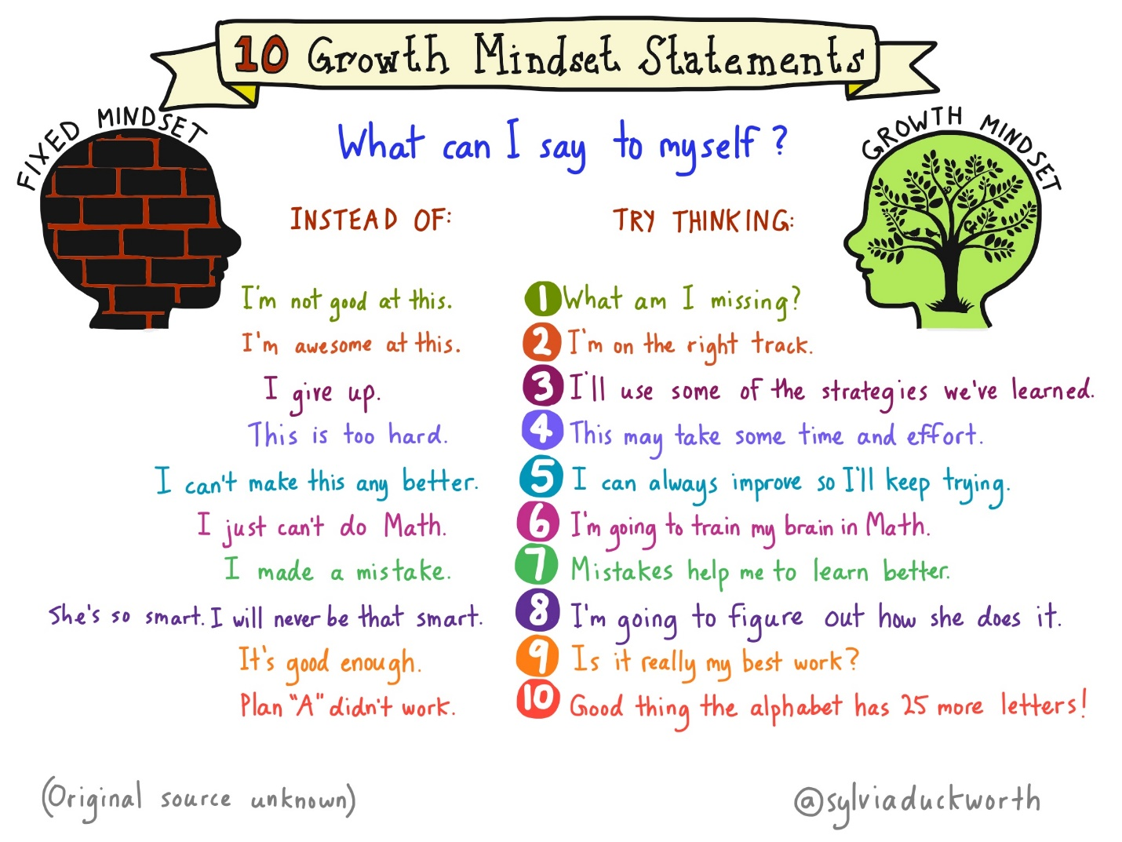

Support Math Readiness Through Math Talk

by: Eugene Geist
A father and 3-year-old son, Clark, walk through the supermarket. Clark asks, “Can we get donuts?” “How many should we get?” his father responds. “A hundred!” Clark exclaims. Dad counters, “Wow, that’s a lot of donuts! How many do we need so Mommy, Daddy, your sister, and you can have one?” Clark proceeds to think, count, and problem solve as the father continues to prompt him to use math to decide how many donuts to purchase.

Talk is a fundamental way children learn, even before they understand what is being said. Children who come from homes where there are a lot of books and where family members talk about what they have read, for example, have been shown to have better literacy outcomes in kindergarten and successive grades¹. This same principle holds true for mathematics. The more parents talk with their child about math at home, the more a child’s mind is stimulated to think about math. Here are five ways to use math talk with your child.
1. Use age appropriate math talk. Math talk grows with your child. Math talk is simply talking to your child about the math that they experience. Here are a few examples for each age and stage.
Infants: When a dad hides his face behind his hands and says, “One, two, three, peek-a-boo!”his baby learns to anticipate seeing his dad’s face as a result of the counting (even as an infant).
Toddlers: An aunt walking down the street with her toddler nephew says “Let’s count the light poles! I see one light pole! OH! I see another! That is two! Do you see another one?” That’s math talk.
A mother cooking with her child says, “How many more times do I need to stir the brownies?” and then “OK, I stirred them five times. How many more times do I need to stir?”
Preschoolers: Preschool children are capable of some amazing mathematical thinking. Parents can discuss simple addition problems—such as “I wonder what four plus four is”—and let the child think about it and work it out. The key here is to engage in discussion, not rapid fire question and answer sessions. Preschoolers need time to work out the problem on their own. Soon they will begin asking you questions. One morning my 4-year-old told me that eight plus eight was sixteen. I asked him how he knew, and he showed me using his fingers.
Even wrong answers provide opportunities. Another time my son told me three plus three was five. I said, “Really, show me.” Then he put up three fingers on each hand and began to count. As he started to count his fingers, he stopped and said, almost to himself, “Whaaaaaat?? It’s six!” Letting children talk through their solutions and math thinking is very important. Try not to correct them or interrupt them. Sometimes just being quiet and listening is the best thing we can do.
Kindergarten and older: Ask older children to help with the math that we encounter in everyday situations. A mother balancing a checkbook might ask, “Dillon, can you help me add up these numbers?” When shopping, parents can discuss how much things cost and how to decide which things are the best bargain and what things can be bought with a certain budget.
2. Look for opportunities to count or add. Count the number of green tiles on the floor of the grocery store or the number of cracks you walk over on the sidewalk. Once children are able to add, look for opportunities to allow them to do this. On a drive or a walk you might say, “I see two geese on this side of the lake and three geese on the other side. How many geese does that make?”
3. Look for opportunities to problem solve. One of my favorite places to ask my 4-year-old son questions about math is the grocery store. The problem solving involved in an everyday discussion about how much of a specific food our family needs involves a lot of math concepts and content. For example, I’ve asked my son “How many apples do you think we need to buy?” If he tells me we need six, I ask “Why do we need six?” His answers often involve explanations about the number of days in a week, how many people we have in our house, who likes apples and who does not, whether we usually cut the apples up into smaller pieces or eat them whole, and how many apples each of us usually eat in one sitting.
4. Ask open-ended questions to sustain math talk as long as possible. The goal of math talk is to keep the child talking. Instead of simply telling my son how many apples I think we need and putting them in a bag and moving on, I take the time to stop and ask open-ended questions and listen carefully to his responses. Math talk means being ready with follow-up questions that can extend and deepen your math discussions. For example, during my discussion about apples with my son I could ask him, “Should we buy the bag of apples or buy individual apples?” Sustaining the talk as long as possible is the key.
5. Be prepared to take extra time for math talk. Discussion about something like how many apples we need to buy takes time, but these types of interactions are wonderful opportunities for learning.

¹Kirkland, L., & M. Manning. 2012. “A Heritage of Literacy in the Home.” Childhood Education 88 (4): 214–16.

Dr. Eugene Geist is an associate professor in The Gladys W. and David H. Patton College of Education and Human Services at Ohio University. Dr. Geist has teaches in the Early Childhood Education program, the Curriculum and Instruction graduate program and the Teacher Education Honors Program. His areas of expertise include child development, constructivism, and the development of mathematical knowledge in young children.

Some great websites:

1. Bedtime Math https://bedtimemath.org/
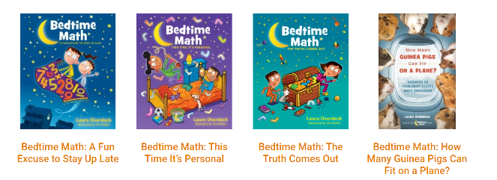

This site has bedtime stories to get kids thinking about math, but also has games, activities and other ways to engage your child in thinking about numbers.

2. From Stanford University: Talking Math with your kids is Easier than you Think; https://dreme.stanford.edu/news/talking-about-math-young-children-it-s-easier-you-think#:~:text=Research%20has%20shown%20that%20when,experiences%20into%20their%20daily%20routines.

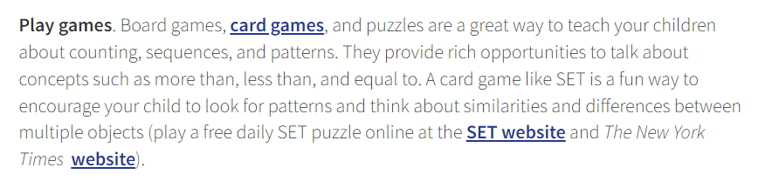

The site has links to games you can play at home, online math challenges, and other resources.

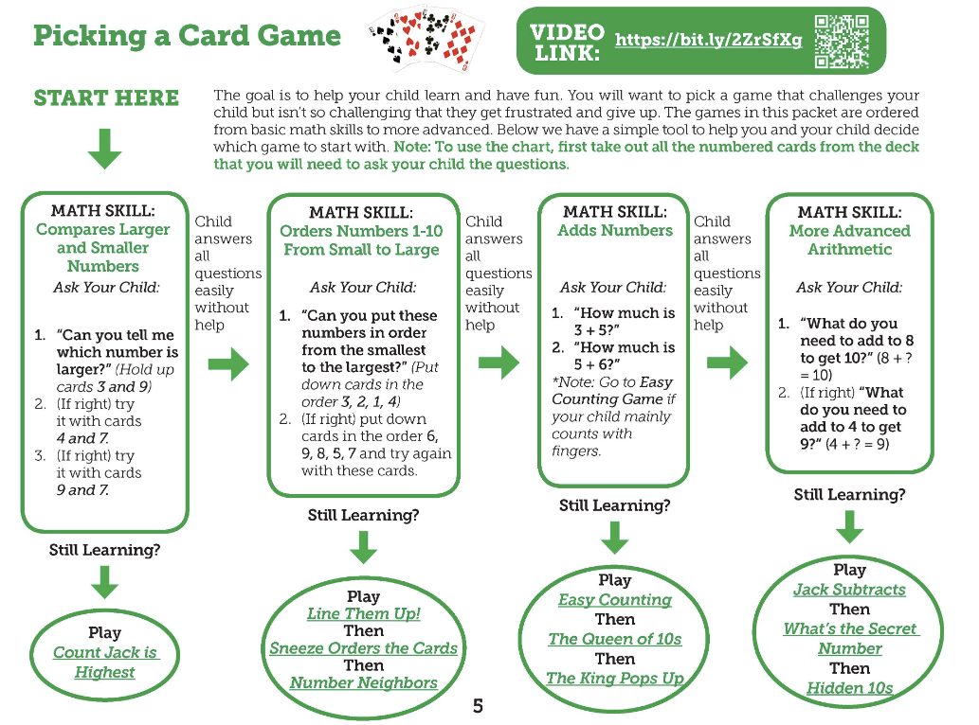

3. Build Math Minds, with Christina Tondevold
https://buildmathminds.com/

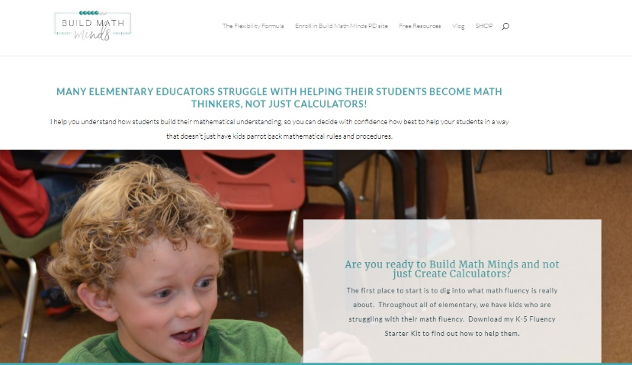
This site is for educators but there is great stuff for families too. Check out her freebies, her facebook group, youtube videos, and games.

