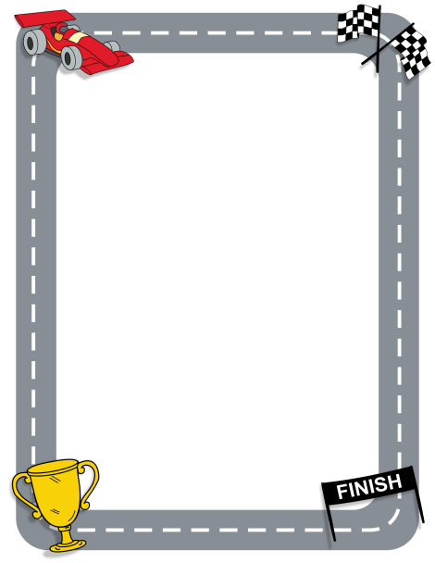
Level 1
Race to 100 (or -100)!
Roll a double sided die. The outer number is always positive and the little inside number is always negative.
Roll the operation die to see if you add or subtract the two numbers. Always start with the outer number. Winner is person farthest from zero (in a positive or negative direction)! All players calculate each roll and track score.
Opponent’s Equation
My Equation
Total |  | Total

Equation
Total |  | Total  Equation

