
Math Activity One Pager Station Sheet

Pig Addition Game
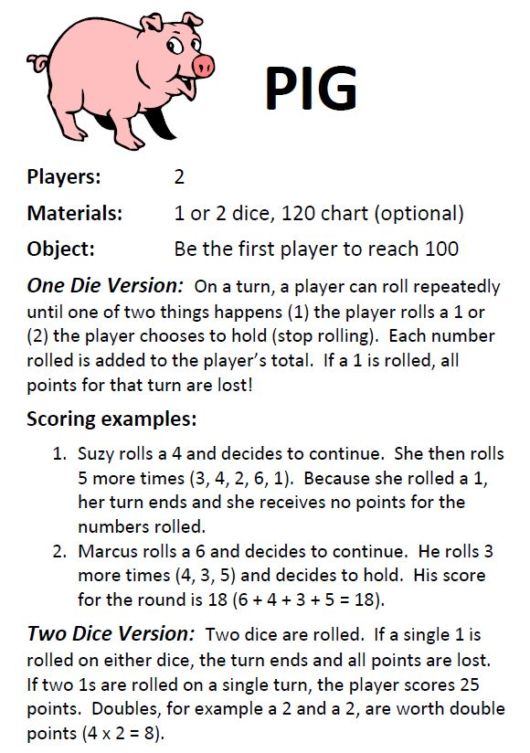
Topic/Math Concept
Addition/Subtraction

Outcome(s) N 2.2

Contributor email: ardis.wayman@cttcs.ca

