Multiplication WAR
Deal out ALL the cards

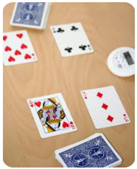
Players flip two cards at once and multiply them. The highest product (answer) wins the “war” and takes all the cards that were laid down.

Students MUST state their product or write it down. You may use dry erase boards.

Help Each Other!!!

The player with the most cards at the end of the time wins the game.

Level 2: Keep the face cards:
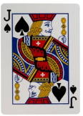 Jack = 11
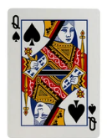Queen = 12
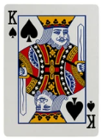King = 13

Level 1: Remove the face cards before you play.

Note: Ace = 1
