FP10.1 Post-Assessment
Factors and Products (Chapter 3)

FP10.1 Demonstrate understanding of factors of whole numbers by determining the:
- prime factors
- greatest common factor
- least common multiple
- principal square root
- cube root.

Multiple Choice: Identify the choice that best completes the statement or answers the question.

______ 1. Write the prime factorization of 630.
a. |  | b. |  | c. |  | d.

______ 2. Determine the greatest common factor of 56 and 88.
a. | 77 | b. | 616 | c. | 7 | d. | 8

_______ 3. Determine the least common multiple of 78 and 102.
a. | 1326 | b. | 6 | c. | 2652 | d. | 7956

____ ____4. One neighbour cuts his lawn every 8 days. Another neighbour cuts her lawn every 10 days. Suppose both neighbours cut their lawns today. How many days will pass before both neighbours cut their lawns on the same day again?
a. | 80 days | b. | 60 days | c. | 2 days | d. | 40 days

____ ___5. Determine the square root of 250 000.
a. | 100 | b. | 63 | c. | 500 | d. | 200

____ ___6. Determine the cube root of 42 875.
a. | 1225 | b. | 4763.9 | c. | 207.1 | d. | 35

____ ___7. A cube has volume 15 625 cm³. What is the surface area of the cube?
a. | 132 893.3 cm² | b. | 3750 cm² | c. | 25 cm² | d. | 10 416.7 cm²

____ ___8. Determine the side length of this square.

a. | 63 cm | b. | 15.83 cm | c. | 992.25 cm | d. | 441 cm

_______9. A developer wants to subdivide a rectangular plot of land measuring 600 m by 750 m into congruent square lots. What is the side length of the largest possible square?

a. | 75 m | b. | 30 m | c. | 150 m | d. | 50 m

________10. Which of the following numbers is not both a perfect square and a perfect cube?
a. | 531 441 | b. | 12 544 | c. | 117 649 | d. | 15 625

Short Answer: Show your work whenever possible.

11. Write the prime factorization of 198. Express your answer as a product of primes.

12. Determine the greatest common factor of 90 and 225.

13. Determine the least common multiple of 126 and 441.

14. List the factors of 24. List three multiples of 24. Explain the difference between factors and multiples.

15. Use prime factoring to determine whether 4913 is a perfect square, a perfect cube, or neither.

Answers

Multiple Choice:

1. c (FP10.1c)
2. d (FP10.1a)
3. a (FP10.1a)
4. d (FP10.1g)
5. c (FP10.1e)
6. d (FP10.1e)
7. b (FP10.1g)
8. a (FP10.1g)
9. c (FP10.1g)
10. b (FP10.1d)

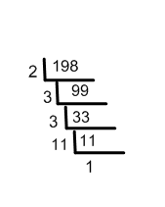
Short Answer:
11. (FP10.1c)
2 x 99
9 x 11
3 x 3
2 x 3 x 3 x 11 2 x 3² x 11

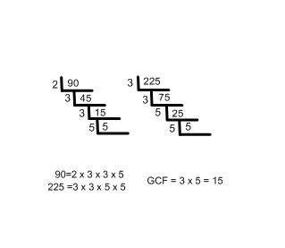
12. (FP10.1a)

90 = 2 x 3 x 3 x 5
225 = 3 x 3 x 5 x 5
GCF = 3x3x5
= 45
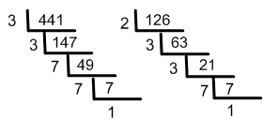
13. (FP10.1a)

441 = 3 x 3 x 7 x 7
126 = 2 x 3 x 3 x 7
LCM = 2 x 3 x 3 x 7 x 7
= 882
14. (FP10.1b)
Factors of 24 = 1, 2, 3, 4, 6, 8, 12, 24

Multiples of 24 = 24, 48, 72, 96, . . . .

Answers will vary. Responses may include: Factors are numbers that multiply together to produce a product such as 24. Factors are numbers that divide evenly into a number such as 24.
Whereas: Multiples are the numbers produced when counting by 24’s. Multiples are the product of a given number (24) and a natural number. Multiples are numbers that a number (24) divides evenly into.

15. (FP10.1d)
4913
17 x 289
17 x 17

$\sqrt[3]{4913}$ = 17
$\sqrt[2]{4913}$ = 70.09
The number 4913 is a perfect cube.

