Double Trouble
My Roll Total Opponent’s Roll Total
_______ X ______ = ______ |  | _______ X ______ = ______
_______ X ______ = ______ |  | _______ X ______ = ______
_______ X ______ = ______ |  | _______ X ______ = ______
_______ X ______ = ______ |  | _______ X ______ = ______
_______ X ______ = ______ |  | _______ X ______ = ______
_______ X ______ = ______ |  | _______ X ______ = ______
_______ X ______ = ______ |  | _______ X ______ = ______
_______ X ______ = ______ |  | _______ X ______ = ______
_______ X ______ = ______ |  | _______ X ______ = ______
_______ X ______ = ______ |  | _______ X ______ = ______
_______ X ______ = ______ |  | _______ X ______ = ______
Instructions: Roll 2 dice. Find the product by multiplying the two numbers. Fill in the equation under “My Roll”. You’re opponent will write down the equation as well, under “Opponent’s roll” . Now it’s your opponent’s turn.

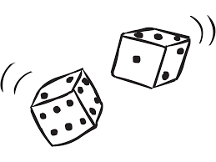
AFTER YOUR SCORE IS HIGHER THAN 36: If you roll doubles, find the product, but the amount gets subtracted from your total instead of added!

Person with the highest score wins!

