

Minds on Math at Home – Math games for all ages

Practicing math skills is important! Worksheets and text assignments are part of learning math, but games are an even better way to practice! In fact, games that involve number sense create deeper learning, especially if they are in a social setting, like playing games with friends or family. Part of developing fluency is being able to remember something we’ve learned. Educators call this “recall”. The more senses we engage while we are learning or practicing something, the more likely our brain will be able to retrieve that information later, when we need it.

Online games are easy to find, and while kids may enjoy them, they do not have the physical and social component that actual card and board games do. They are only another way to practice in isolation, like a worksheet with some animation and sound effects. Also, most kids already get plenty of screen time. We are more interested in socially interactive, hands-on games you can play together at home.

Here are a few card games that support math learning at different ages:

Grades K – 3

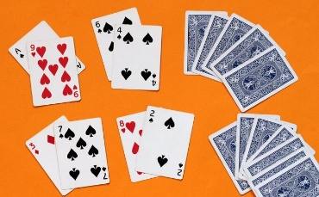
Because we work in a base ten system, our brain is always looking for tens. Children learn the number bonds to ten, or “ten pairs”, like 1 and 9, 2 and 8, 3 and 7 and so on. Games that help children find these numbers can build proficiency. Fish for Ten: Use a deck of cards, remove the face cards and two of the tens. Leave the jokers in (they equal zero). Kids play “go fish”, but instead of looking for a pair, they are looking for a “ten pair”. If I have an 8 in my hand, I will ask my opponent for a 2. (8+2=10). https://www.whatdowedoallday.com/easy-math-game-tens-go-fish/ (This version of the game has you remove all the tens, but if you leave 2 tens and 2 jokers-0-you have two chances for 10+0=10). Younger players may play this game with “dot cards”: https://thelintonacademy.blogspot.com/2012/06/printable-ten-frame-cards.html
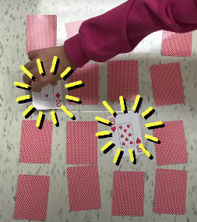
Concentration Ten: Same cards as Fish for Ten, lay them out in an array, and players take turns flipping two cards and looking for a ten pair. If they have a ten pair, they take the cards and go again. If not, they flip the cards face down again, and the other player goes. The idea is to remember where the cards are so you can find a ten pair. https://lkelempro.blogspot.com/2018/11/math-activity-to-teach-anchor-of-10.html

Grades 4-6
Multiplication War : Like regular War, but instead of laying down one card, players each lay down two cards, and state the product (multiply them). The person with the greatest product wins all 4 cards, and of course, the “war” or tie breaker, is the same. Be sure kids always say the product out loud.
https://www.joliet86.org/assets/1/6/Math_Day_5_Mult_War.pdf
Note that some people do this game as a race—kids flip over one card each, and the first student to say the product wins. While some children may like this, others find it frustrating to have to say answers out loud quickly. Timed activities and races can lead to math anxiety in some students. Some children are naturally slower to answer, and will begin to have a negative view of their math ability if their opponent is always quicker. We now know that being a fast processor does not necessarily mean a child is “better” at math. In fact, some students that process more slowly think about math more deeply. In general, collaborative games are better than timed games or races. We need to keep kids confident at math!

Handy tip: cards make a nice tracker for multiplying! If a student flips a 6 and an 8 (6X8) they may skip count by 6 eight times, pointing to the 8 shapes on the 8 card as a tracker, or vice versa.

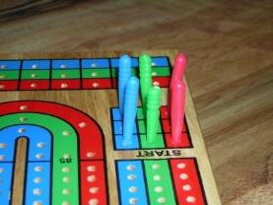
Cribbage is a great game for number sense. It is continual practice of number bonds to 15, as well as a great strategy game. Many older people know how to play crib, and would probably love to teach your kids and play with them! https://www.instructables.com/How-to-Play-Cribbage/

Grades 7 and 8
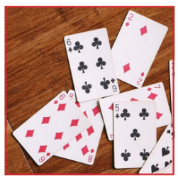
Integer War: In this version of war, red cards are negative. Students find the sum of their two cards, and the highest number wins. Let Aces = 1, Jacks = 11, Queens = 12, and Kings = 13. You can make this game more challenging by using a spinner, dice, or coin, and flipping to see if students would add or subtract their two numbers. This is interesting because when we subtract a negative it becomes a positive! Kids could also tally their scores, tracking their sum when turn cards over and keeping a running total. https://booksmartmath.com/wp-content/uploads/2018/08/Integer-Addition-Number-Battle.pdf Again, while you may find many versions of this game as a race, a collaborative game is better, where each player adds (or subtracts) their own 2 cards, saying the answer out loud, not racing to say answers. Coach children to help each other by offering strategies if a player is stuck.

Have fun!

