Saskatchewan Common Mathematics Assessments

Pre Assessment

  - Outcome: N3.1 – I understand whole numbers up to 1000
  - Name:

- How many marbles altogether? There are ___________ marbles.
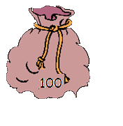
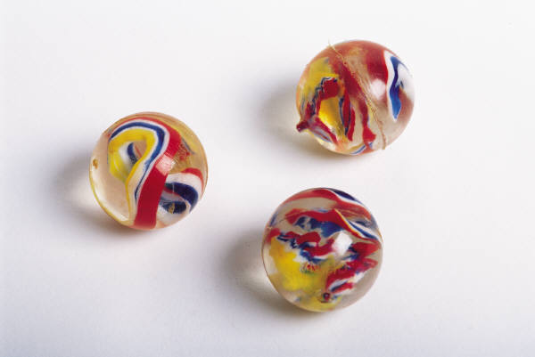
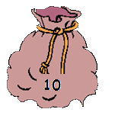
- Count the money. There is ________________ cents.
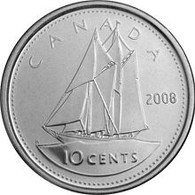

- Give the value of each underlined digit in the following numbers:
a) 777 The underlined 7 means _________________.
b) 777 The underlined 7 means ________________.
c) 777 The underlined 7 means _________________.

- Fill in the missing numbers.

621 |  | 623 | 624 |  | 626 | 627 |  | 629 | 630
 | 632 | 633 | 634 | 635 |  | 637 | 638

- Order the numbers from least to greatest.

279, 824, 491, 196

_________, _________, _________, _________,

- Fill in the missing numbers to continue the pattern.

a) 32, 37, 42, 47, _______, _______, _______.
b) 743, 753, 763, _______, _______, _______.
c) 25, ________, 75, 100, _________.
d) 67, 65, 63, _______, _______, _______.

7. Show 269 in two or more different ways using pictures, numbers or words.

8. Estimate how many objects are in the larger container using the smaller container as a referent.

a) There are about _________ groups of ten in the large container.

b) There are about __________ objects in the large container.

9. List as many different 3-digit numbers as you can, using these digits only once in each number 2, 5, 8?

