
Christ the Teacher Grade 4 Screener D1 KEY
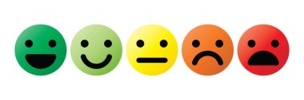

How do you feel about Math? Circle one

Recall: We can represent a number several ways
Standard Form | Expanded form | Word form
6 458 | 6000 + 400 + 50 + 8 | six thousand four hundred fifty-eight

1) Write the number 14 in word form . Fourteen
N2.1 Representing Number
2) Write $700 + 60+2$  in standard form.  762 | 3) Write the number nine hundred thirty-seven in standard form.  937
N3.1 Representing Number | N3.1 Representing Number
4) How many? 11 | 5) How much is 2 more than 10?  12
N 2.1 Representing Number | N2.2 Adding
6) What whole number is represented here? 364  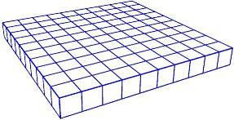  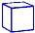 | 7) Write the value of the underlined digit. Five hundred or 5 hundred  526  If the student writes “500” have them say or write the word
N 3.1 Representing Number | N3.1 Place value
8) Draw 9 cookies, some on each plate, any way you like. Any decomposition of 9
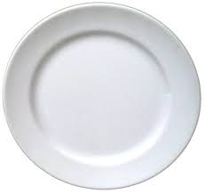

N 2.1 Representing Number, decomposing
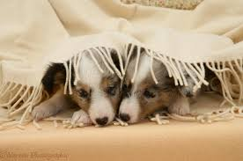  9) Mitsy has 8 puppies. I see 2 puppies. How many more puppies are under the blanket? 6 | 10)  What number is the double of 6? 12
N 2.2 Addition | N 2.2 Addition
11) Add

₌
+
N 2.2 Addition
12) Fill in the boxes of this piece of the hundreds chart.
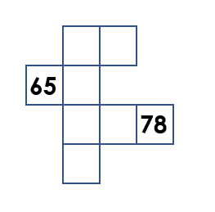

N3.1 Missing Values in Hundreds Chart
13) Order these numbers from least to greatest.
104
738
279
751

104 279 738 751
N 3.1 Place Value
14) Fill in the blanks (Continue the pattern).

754, 764, 774, 784, 794, 804 , 814

N3.1 Place Value
15) How much money? $1.85 or a dollar eighty-five  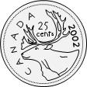  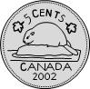  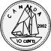  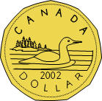 | 16) Add.  $58 + 0 =$ 58
N3.1 Whole numbers (money) | N 3.2 Addition with zero
17) Skip count by 3.

__3__ 6 9 12 15
N3.1 Whole numbers
18) Skip count by 10 starting at 22.

__22_ 32 42 52 62 72
N3.1 Whole numbers
19) Add.  $41+17 =$ 58 | 20) Subtract. Students can use an algorithm if they choose  $58-22 =$ 36
N2.2 Add | N 2.2 Subtract
21) Estimate the sum of the following.  Show your strategy.  $795 + 112$  800 + 100 = 900 IF a student calculates an answer but is unable to estimate, the item is incorrect | 22) Add.  $341+201 =$ 542
N3.2 Estimation | N3.2 Add (no regrouping)
23) Add.  452  + 381 | 24) Subtract.  381  - 163
N3.2 Add (regrouping) | N3.2 Subtract (No regrouping)
25) Subtract.  $634 - 581 =$ 53  Students can use an algorithm if they choose | 26) Rewrite $6+6+6+6$ as a multiplication sentence.  4X6 = 24 or 6X4 = 24 If they just put 4X6 or 6X 4 that’s correct
N3. Subtract (Regrouping) | N 3.3 Multiplication as repeated addition
27) $5 × 3 = 15$  Write the related division sentence.  15$÷$ 3 = 5 or 15 $÷$5 = 3 | 28) Multiply.  $3 × 4 =$ 12
N 3.3 Relating multiplication and division | N3.3 Multiplication
29) Multiply.  $3 × 6=$ 18 | 30) Divide.  $50 ÷ 5=$ 10
N3.3 Multiplication facts | N3.3 Division facts
31) Divide.  $21 ÷ 3 =$ 7 | 32) What multiplication sentence could this array represent?  5 X 4 = 20  Or  4 x 5 = 20
N3.3 Division | N 3.3 Representing Multiplication, array
33) What division sentence does this array represent?  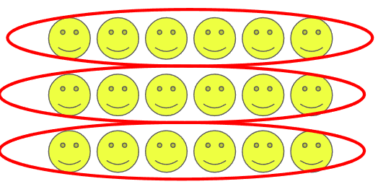  18 $÷$ 3= 6 or 18 $÷$6 = 3 | 34) Estimate.  $$785 + 114$$  800 - 100 = 700  IF a student calculates an answer but is unable to estimate, the item is incorrect
N3.3 Representing Division, array | N3.2 Estimate sums
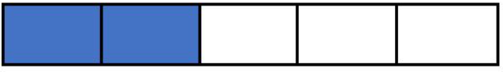  35) Name the fraction.  $\frac{2}{5}$ | 36) There are 16 triangles. Circle $\frac{7}{16}$.  any 7, even individually circled is correct
N 3.4 Representing fraction | N3.4 Fraction
37) There are 20 crayons to be shared equally by 5 students. How many crayons can each student get? 4 each
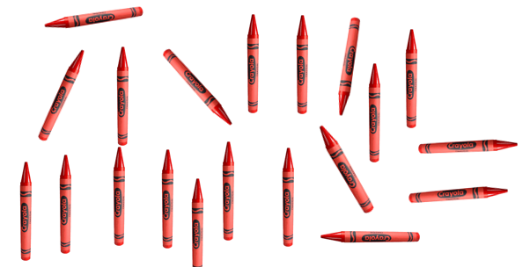
N 3.3 Division with remainder using model
38) Shade three-fifths of this chocolate bar.  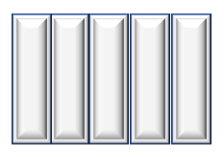 | 39)  3  8  Draw a picture to show .
N 3.4 Fraction | N 4.6 Fraction
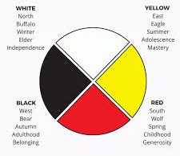  40) What fraction of this medicine wheel is white? $\frac{1}{4}$ | 41) Insert either < , >, or = between these two fractions.  7  9  3  9
N3.4 Fraction | N3.4 Fraction, compare
42) Circle the larger fraction.  $\frac{3}{4}$ $\frac{3}{10}$ | 43) What fraction of these items is ball gloves? $\frac{3}{7}$  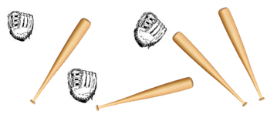
N3.4 Fraction, compare | N 3.4 Fraction of a set
44) Extend the pattern


P2.1 Patterns
45)
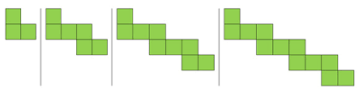
How many blocks are in the next figure? 15
P3.1 Patterns
46) What number does the circle represent?  $-6$ = 11 17 | 47) What number does the triangle represent?  6 + = 14 8
P3.2 Equations | P3.2 Equations
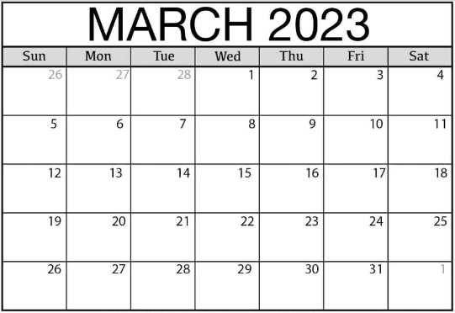
48) What day of the week is March 9?

Thursday

SS 3.1 Time
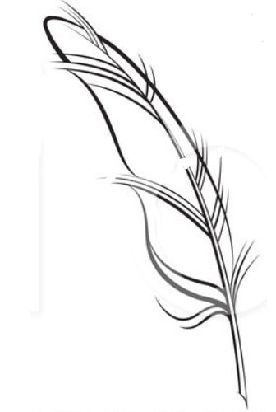
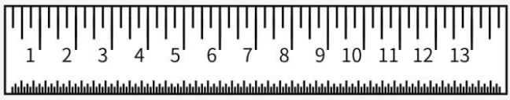
49) How long is this goose feather? 9 cm
cm

SS2.1, SS3.2 Measuring

