- Draw a line from the object to a shape you see in the object.
Name:
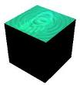

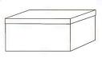

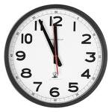



- Name the shapes you see in each object.


 

 

 

