- Look at the pictures and match the 2-D shape that would best describe it.
Name:
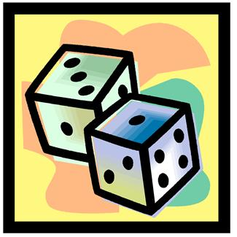

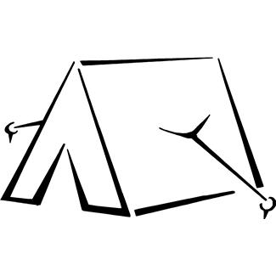


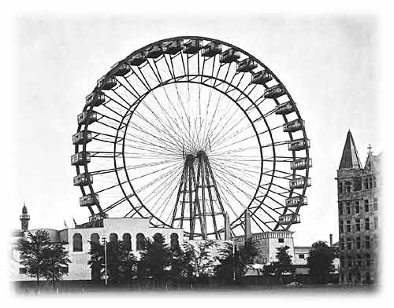

- Create your own 3-D picture. Draw the 2-D shape that would best describe it.

___________________________________ ___________________________________
Picture 2D shape
- Answer the following riddles:
- This 3-D object has one rectangular face and four triangular faces. What type of object is it?
_________________________________________

- This 3-D object has two circular faces and one curved surface. What type of object is it?
_________________________________________

- This 3-D object has six square faces. What type of object is it?
_________________________________________

- This 3-D object has one curved surface. What type of object is it?
___________________________________________

- This 3-D object has one circular face and one curved surface. What type of object is it?
___________________________________________

