FP10.4 Post-Assessment
Trigonometry (Chapter 2)
FP10.4 Develop and apply the primary trigonometric ratios (sine, cosine, tangent) to solve problems that involve right triangles
Multiple Choice: Identify the choice that best completes the statement or answers the question.
____ 1. The angle between one shorter side of a rectangle and a diagonal is 64º. One longer side of the rectangle is 9.2 cm. What is the width of the rectangle, to the nearest tenth of a centimetre?

a. | 4.0 cm | b. | 18.9 cm | c. | 8.3 cm | d. | 4.5 cm

____ 2. A submarine rises a vertical distance of 200 m to the surface. The distance measured along the submarine’s path is 500 m. Determine the angle of inclination of the submarine’s path to the nearest degree.

a. | 24º | b. | 68º | c. | 22º | d. | 66º

____ 3. A ladder leans against a wall. The base of the ladder is on level ground 1.2 m from the wall. The angle between the ladder and the ground is 70º. How far up the wall does the ladder reach, to the nearest tenth of a metre?

a. | 0.4 m | b. | 1.3 m | c. | 3.5 m | d. | 3.3 m

____ 4. Determine tan Q and tan R.
a. | tan Q = ; tan R = 0.75 | c. | tan Q = ; tan R =
b. | tan Q = ; tan R = 0.75 | d. | tan Q = 0.75; tan R =

____ 5. Determine sin A and cos A to the nearest tenth.
a. | sin A = 1.7; cos A = 0.8 | c. | sin A = 0.6; cos A = 1.3
b. | sin A = 0.8; cos A = 0.6 | d. | sin A = 0.6; cos A = 0.8

____ 6. An airplane is flying at an altitude of 7000 m. At a certain time, the angle between the ground and a person’s line of sight to the airplane is 22º. About how far away is the person from a point on the ground vertically below the airplane, to the nearest hundred metres?

a. | 17 300 m | b. | 7500 m | c. | 2800 m | d. | 18 700 m

____ 7. A flagpole casts a shadow that is 21 m long when the angle between the sun’s rays and the ground is 48º. Determine the height of the flagpole, to the nearest metre.

a. | 19 m | b. | 16 m | c. | 14 m | d. | 23 m

____ 8. From the top of an 80-ft. building, the angle of elevation of the top of a taller building is 49º and the angle of depression of the base of this building is 62º. Determine the height of the taller building to the nearest foot.
a. | 211 ft. | b. | 112 ft. | c. | 129 ft. | d. | 276 ft.

____ 9. A 55-ft. guy wire helps to support a tower. The wire is anchored to the ground 37 ft. from the base of the tower. What is the measure of the angle formed between the wire and the ground, to the nearest degree?

a. | 48° | b. | 56° | c. | 34° | d. | 42°
____ 10. A student stood 8.0 m from the base of a tree. He used a clinometer to sight the top of the tree. The angle shown on the protractor scale was 65º. The student held the clinometer 1.6 m above the ground. Determine the height of the tree to the nearest tenth of a metre.

a. | 10.4 m | b. | 5.3 m | c. | 3.7 m | d. | 18.8 m

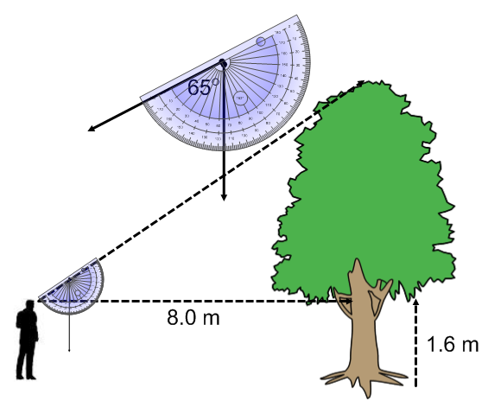

Short Answer: Show your work whenever possible.
- Guy wires are attached to buildings as shown. A student says the angles of inclination of the wires are the same. Is the student correct? Justify your answer.

- Solve this right triangle. Give the measures of the length of the sides to the nearest tenth of a centimeter and the angle to the nearest degree.
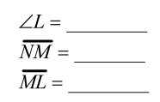

- Sue used a clinometer to sight the top of a tall building from a point 160.0 m from the base of the building. The angle shown on the protractor was 46°. Sue held the clinometer 1.8 m above the ground. Determine the height of the building to the nearest tenth of a metre.

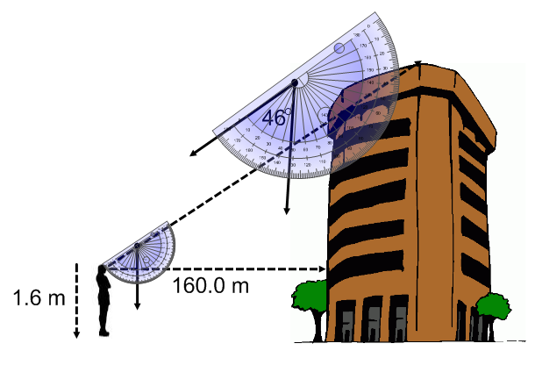

- A rectangular lawn has the dimensions shown. A gardener wants to use an electric lawnmower to mow the lawn. The electrical outlet is located at O.
- Determine the length of cord needed to reach corner C, to the nearest tenth of a metre.

b) Determine the distance between the electrical outlet and corner N, to the nearest tenth of a metre.

- Two boys are standing at the same elevation on opposite sides of a mountain. The peak of the mountain is 1350 ft. above them. Their angles of elevation to the top of the mountain are 65° and 50°. Determine the total distance, to the nearest foot, both boys have to hike in order to meet at the peak. Assume both boys are able to hike in a straight line to the peak.

Answers
Multiple Choice:
1. d (FP 10.4c) 6. a (FP 10.4d)
2. c (FP 10.4c) 7. d (FP 10.4d)
3. d (FP 10.4c) 8. c (FP 10.4c)
4. b (FP 10.4b) 9. a (FP 10.4c)
5. d (FP 10.4b) 10. b (FP 10.4d)

Short Answer:
- (FP 10.4a, c)
Method 1:
C in right ∆ABC is the angle of inclination of the guy wire attached to the shorter building.

In right ΔABC:
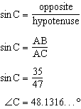
The angle of inclination of the guy wire attached to the shorter building is approximately 48.1°.

F in right ∆DEF is the angle of inclination of the guy wire attached to the taller building.
In right ∆DEF:
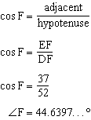
The angle of inclination of the guy wire attached to the taller building is approximately 44.6°.

The student is not correct. The angles of inclination are different as shown in the calculations above.

Method 2
In $⊿$ABC:
(35)² + (BC)² = (47)²
1225 + (BC)² = 2209
(BC)² = 984
BC = 31.37

In $⊿DEF:$
(DE)² + (37)² = (52)²
(DE)² + 1369 = 2704
(DE)² = 1335
DE = 36.54

Check to see if the triangles are similar by setting up proportional relationships among the sides:
$\frac{31}{37}$ ? $\frac{35}{37}$ ? $\frac{47}{52}$
0.8378 $≠0.9459 ≠0.9038$
The proportional relationships among the sides are not equal, therefore the triangles are not similar and the angles of inclination will not be the same.

- (FP 10.4b)
MN = 10.8 cm
LM = 16.7 cm

$∠$L = 33.0º
13)
13. (FP 10.4d)
In right ΔABC, BC is opposite $∠$A and AC is adjacent to $∠$A.
The angle between the horizontal and the line of sight is:

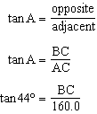

Solve this equation for BC.
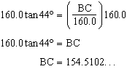

Find the height, h, of the building.
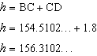
The height of the building is approximately 156.3 m.

14. (FP 10.4c)
a) In right ΔCBO, OC is the hypotenuse, CB is opposite $∠$O, and BO is adjacent to $∠$O. To determine the length of OC, use the sine ratio.

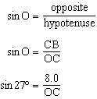

Solve this equation for OC.

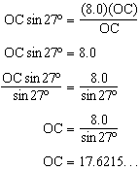

The length of cord needed to reach corner C is approximately 17.6 m.

b) In right ΔCBO, OC is the hypotenuse, CB is opposite $∠$O, and BO is adjacent to $∠$O. To determine the length of BO, use the cosine ratio.

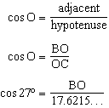

Solve this equation for BO.

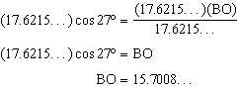

Alternately, the student could use the tangent ratio:
tan 27° = 8
OB
OB = 15.7008….

To determine the distance between the electrical outlet and corner N, subtract BO from BN.
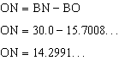
The distance between the electrical outlet and corner N is approximately 14.3 m.
A
B
C
D
65°
50°
1350 ft
- (FP 10.4c)

sin 65 = 1350
AB
AB sin 65 = 1350
AB = 1350
sin 65
AB = 1489.56 ft
sin 50 = 1350
CB
CB sin 50 = 1350
CB = 1350
sin 50
CB = 1762.30 ft

AB + CB = 3252 ft.

