
Using CTTCS Rubrics

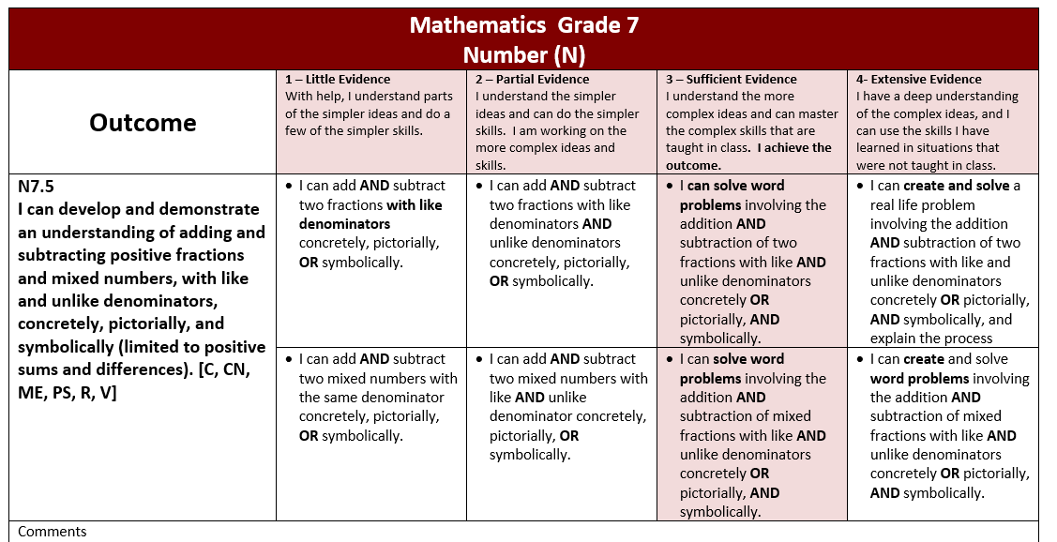
This is the Grade 7 CTTCS Rubric for adding and subtracting fractions.

The final grading of K-9 students is done using the CTTCS rubrics.. These rubrics are not as holistic as the provincial rubrics, as they are used to assess each outcome, whereas the provincial rubric gives an overall snapshot of the student’s math ability over the course of the year. In general though, grade level expectations on both rubrics are that students can independently choose and apply efficient strategies and justify reasoning.

The Saskatchewan Common Math Assessments (SCMA) have rubrics created in a different philosophy, judging “levels” (1,2,3,4) based on the complexity of the question. The SCMAs help clarify grade-level performance expectations, are a great source of formative or summative product information, and certainly the difficulty of the questions gives us information about a student’s ability; however, they are only one source of information in the form of product. They contribute to our decisions of where to place a student on the CTTCS rubric, but that decision is also based on formative assessment data, entrance and exit slips, independent practice, small group work, and especially time at the teacher table spent conferring with the teacher, explaining strategies and justifying thinking. Notice that students need to demonstrate skills concretely and/or pictorially as part of the assessment criteria for several outcomes, necessitating a teacher observing students using manipulatives or drawing and explaining on dry erase boards, and demonstrating pictorially.

Students cannot be graded on their achievement of an outcome solely based on their performance on a SCMA pre or post test.

Assessment criteria should be shared with students. It is good practice to go over the rubric at the start of a unit of study/outcome.

