
Math Activity One Pager Station Sheet

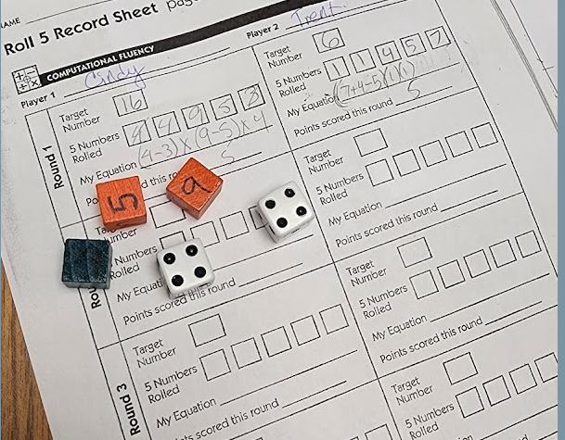
Roll 5
(Title of the Activity/Game)

Grade Level Grades 3 - 9

Topic/Math Concept
Order of Operations/ Exploring operators
Outcome(s)
Esp: N6.3
Demonstrate understanding of the order of operations on whole numbers (excluding exponents) with and without technology. ([N, ME, PS, T])
Enrichment at younger grades, practicing basic operation, review at older grades but also exploring other operators, such as roots and exponents in Gr 8 and 9, Even factorials in Grades 11 and 12
You can buy blank dice, use dry erase dice, or buy regular dice and fill the holes with whiteout correction fluid and rewrite on them

Materials Required : Two dice 0-5
Two dice 1 – 6
One die 5 – 9

Instructions: Play against one or more opponent(s). Roll any two dice, and record the product. This is your target number. Then roll all 5 dice, and record each roll in 5 boxes. Each player must use as many of their 5 numbers as possible and any operation to make an equation equal to their target number. Each player scores one point for each die used. If it is possible to use all 5 numbers, the player gets 5 points. If only 4 can be used, 4 points, and so on.

I love this because: It is naturally differentiated—players will push themselves to be more and more creative. It has multiple entry points. Kids love it! It’s creative and allows students to explore.

Source Barbara Blanke, PhD Guided Math workshop , from The Math Learning Center. There are many variations of this game.

Contributor and Email Cindy Smith smitc01@cttcs.ca

