FP10.10 Pre-Assessment
Systems of Linear Equations (Chapter 7)

FP10.10 Solve problems that involve systems of linear equations in two variables, graphically and algebraically.

Multiple Choice: Identify the choice that best completes the statement or answers the question.

Algebra Tile Representations
$$x^{2}$$
$$x$$
1
$$-x^{2}$$
$$-x$$
-1

_____1. Which points lie on the graph represented by the equation 2x + 7 = y?

P(1, 9), Q(2, 18), R(2, 11), S(0, 9)

a. P and Q b. Q and S c. R and S d. P and R

_____2. Solve the following equation 4(x + 5) = 16

a. 7 b. c. -1 d. -8

_____3. This graph represents a linear relation. Determine the value of x when y = 5.
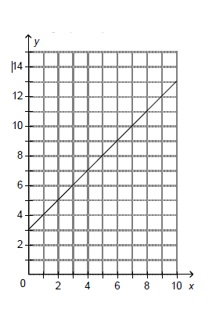
a. 8 b. 3 c. 2 d. 5

_____4. Which equation describes the graph?

a.

b.

c.

d.

_____5. Which equations describe vertical lines?

i) ii) iii) iv)

a. | i and iii | b. | ii and iii | c. | ii and iv | d. | i and iv

______ 6. Simplify: $6x+8x-2x+4x+5$

- $16x+5$ c. $12x+9$

b. $8x+9$ d. $16x^{4}$+5

______ 7. Write a simplified polynomial for the algebra tiles shown below:

a. $2x^{2}$ +2 c. $2x^{2}+x+2$

b. $-2x^{2}+x-2$ d. $-2x^{2}-2$

Short Answer: Show your work whenever possible.

8. Match each equation with a graph on the grid below.

i) ___________________

ii) ___________________

iii) ___________________

9. Which graphs represent a linear relation? There is more than one possible answer.
Graphs _______________________________

10. Graph the following lines on the same grid. Label each line with the appropriate equation.

i) y = x ii) x – 8 = 0 iii) y – 4 = 0

11. A phone company charges a fixed cost of $2.35 per month, plus $1.07 per minute for long distance calls. Write an equation that relates the total monthly cost, C dollars, to the long distance calls, m minutes.

12. Solve the following equations:
a. 2 – 3n = 2n + 7 b. 4(g + 5) = 5(g – 3)

13. The data in this table represents a linear relation. Graph the relation on the grid provided.

X | y
-6 | 1
-4 | 0
0 | -2
4 | -4

Answers

Multiple Choice:

1. d (P7.2d)
2. c (P9.2i)
3. c (P9.1g)
4. a (P8.1c, P9.1c)
5. d (P9.1d)
6. a (P9.4j)
7. d (P9.4j)

Short Answer:

8. (P9.1c) i) Graph B ii) Graph A iii) Graph C
9. (P9.1b) Q, R, S
10. (P9.1c)
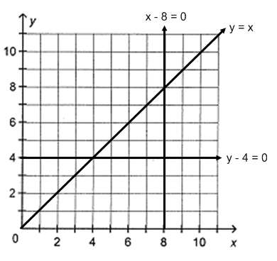

11. (P9.2c) C = 1.07m + 2.35

12. (P9.2i) a) n = -1 b) g = 35

13. (P7.1h)

Outcomes:

MC = multiple choice, SA = short answer

P7.1(SA13)
P7.2 (MC1)
P8.1 (MC4)
P9.1 (MC3, MC4, MC5, SA8, SA9, SA10i, ii, iii)
P9.2 (MC2, SA11, SA12a, SA12b)
P9.4 (MC6, MC7)

