Supporting Math at Home

Representing Numbers and understanding place value

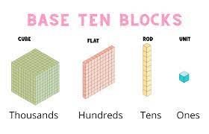
https://youtu.be/Cm6hwOdgOi4

Base ten blocks:

Use the blocks to make numbers, for instance, 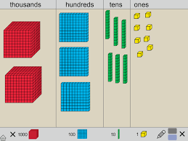 this is the number 2 368

If you write a number for a student, the student should be able to build you the number with blocks. Similarly, build a number, and have the student write it.

**The point is that you cannot have more than 9 units, or 9 ten rods, or 9 hundreds flats in any column. When a student has more than 9 unit blocks, they should regroup them to a ten rod, and so on. Occasionally make numbers with more than ten units, and have the child replace ten of them with ten rods. This is the foundation of “borrowing’ and “carrying” , which we now call regrouping.

Stating the value

Write a number for the student, and have them state the value of any digit. For example

4 675 The value of the six is _____________________________

The value of the four is ___________________________

Students need to be able to write numbers three ways:

Ex: 5 347

Standard form | Expanded form | Written form
5 347 | 5000+300+40+7 | Five thousand three hundred forty-seven

This is particularly challenging with any numbers that have a zero place holder

3 005

Standard form | Expanded form | Written form
3 005 | 3000+5 | Three thousand five

Game: Place value Yahtzee (kids LOVE this!)

Online games:
https://www.abcya.com/games/place_value_hockey
https://mrnussbaum.com/fun-place-value-block-games-from-computermice
https://www.iknowit.com/lessons/c-place-value-up-to-thousands.html

Tools: Base ten blocks, money, and Place value arrow cards

Making ten

This is the first and most important strategy in addition and subtraction.
1. Students must be fluent in the pairs of numbers that make ten.

Activity: Ten frame flash cards;
Ten frames:
Ask: how many frames have dots? Answer 7
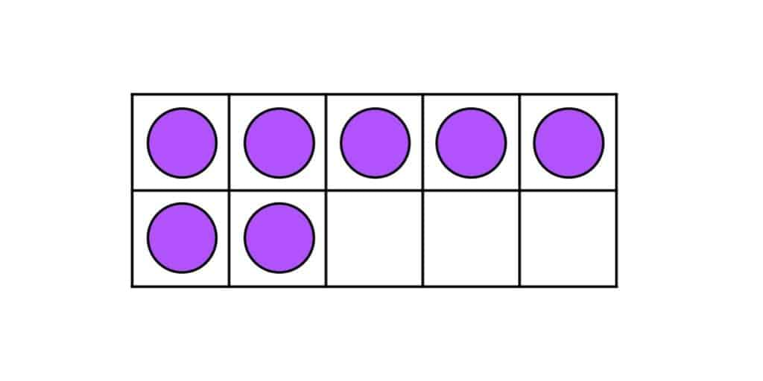
We are asking students to subitize..glance quickly at the card and know that it is 5 and 2 more.
Then, hide the card, and ask “Then how many frames don’t have dots”? The student should know it’s 3 because 7 and 3 make ten. This is both addition and subtraction, but is the basis of mental computing in our place value system

Activity: Flash cards

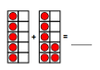
Making ten

Ex 5 + 7 =

The 7 is closer to 10, so we want the student to physically, then later mentally, move 3 dots from the 5 to make the 7 into a full 10. We are always “filling” a ten frame.
The diagram or manipulative becomes 3 + 10 which we write as 13, “ten and three more”

Games: Shut the Box
Fish for ten, making ten concentration
Use a deck of cards with face cards and tens removed.

Fish for ten is “Go Fish” but instead of making a matching pair, players make a pair that sum to ten. So if I have a 6 in my hand, I ask another player for a 4, so that I can make ten.

Concentration is the same, looking for pairs that make ten

Any games that involve adding are good! Cribbage is great!

Activity: Lots of adding, using ten frame and linking to symbolic notation
Practice adding with the “making ten” strategy, which is called “friendly numbers”

Hundreds chart mazes

Practice adding with other strategies, as per strategy cards
(doubles, near doubles, etc)

https://stevewyborney.com/2017/02/splat/
https://stevewyborney.com/2016/10/the-maze-hundreds-chart/

https://education.nsw.gov.au/teaching-and-learning/curriculum/mathematics/mathematics-curriculum-resources-k-12/mathematics-k-6-resources/101-and-youre-out

Skip Counting

https://superstarworksheets.com/math-worksheets/hundreds-chart-printables/

Skip counting is one of the foundations of multiplication. Students should be able to fluently skip count by 2,5, and 10, then by each of these starting at random numbers, then also skip count by 3, 4, 6, 7, 8, and 9.

Money

Students familiar with counting money use it as a mental model for other work, including addition, multiplication and fractions.

Have the student count money
Count by tens not on the decade (put down $3, then add $10 bills)

Count by 25s (quarters)

Students should know the names of coins and the value
Help students count stacks of money in logical ways, starting with the biggest bills, then when bills are done, starting with the biggest coins or making groups of $1.

Money is a good tool for teaching regrouping in addition or subtraction. Use only loonies, ten dollar bills, and hundred dollar bills for this.

Give the student 3 ten dollar bills and 4 loonies, and tell the child they owe you $18.
They will need to “go to the banker” and change one $10 bill for ten loonies.

This is “borrowing” (regrouping)

Practice mental addition
Adding 2 and 3 digit numbers using the algorithm and other strategies
Always link subtraction to addition (fact families) as in “Splat”.

