My Favorite Math Game: Number Boxes

Hello Cindy-

I want to share my favorite classroom math game: Number Boxes. This simple and flexible game allows you to practice any arithmetic topic. Let’s play a round now! Get a piece of paper and see if you can get closer to 75 than my two imaginary players.

Closest to 75 wins!

First, write out blanks (or boxes, like “Number Boxes”) in this arrangement:

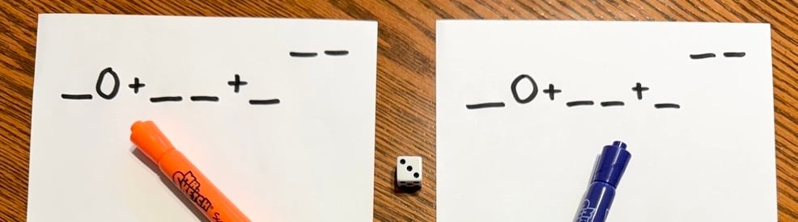

Then, we roll our die. The first number we roll is a 5. Pick a blank and place the 5 (you can’t move it once you place it).
The two blanks in the upper right are “trash” - you may discard a number if you have trash spots remaining. Note: you are allowed to go over the target number (so 81 would win if it was closer to 75 than the other numbers).

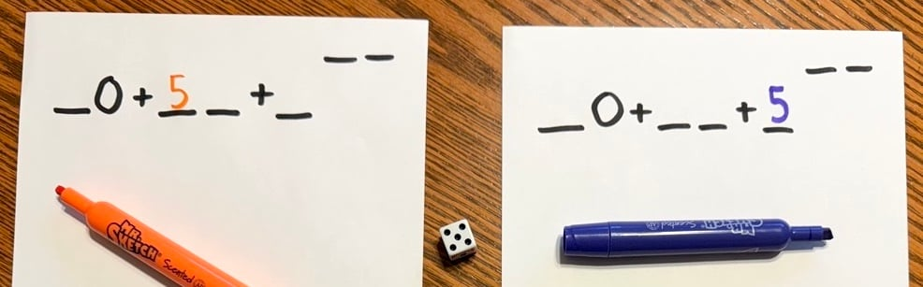

Next, we roll a 1. Place your 1.

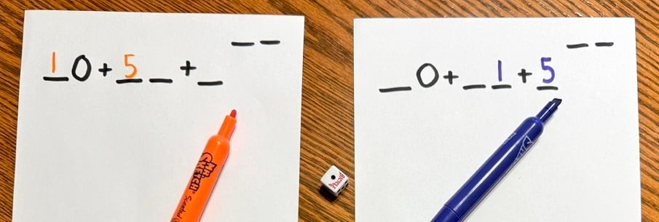

Play will continue with a 3, 2, 5, and 6 - place your numbers now (I’m speeding things along now but do each of these separately when you play with students).

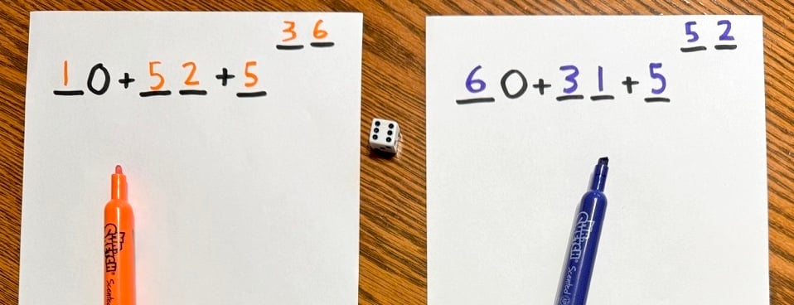

How did you do, were you closer to 75 than these two players?

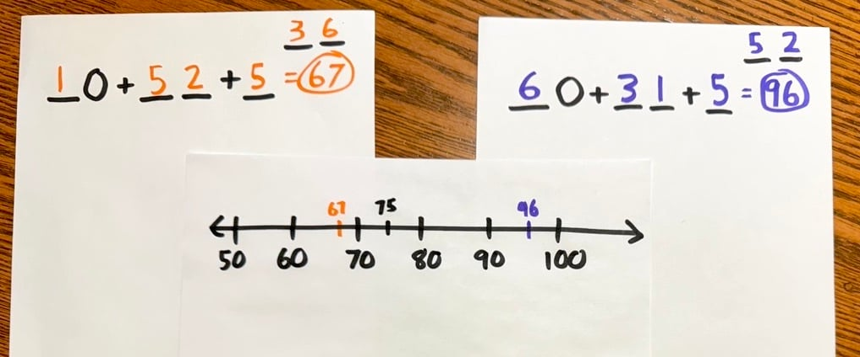

You can play this with the whole class (everyone uses the number the teacher rolls) or in pairs (each pair has a die). When I play with the whole class I draw a large number line and ask student to come up and place their numbers.
Here are some other arrangements I like (you'll have to adjust the target number if you play with 10-sided or 12-sided dice):

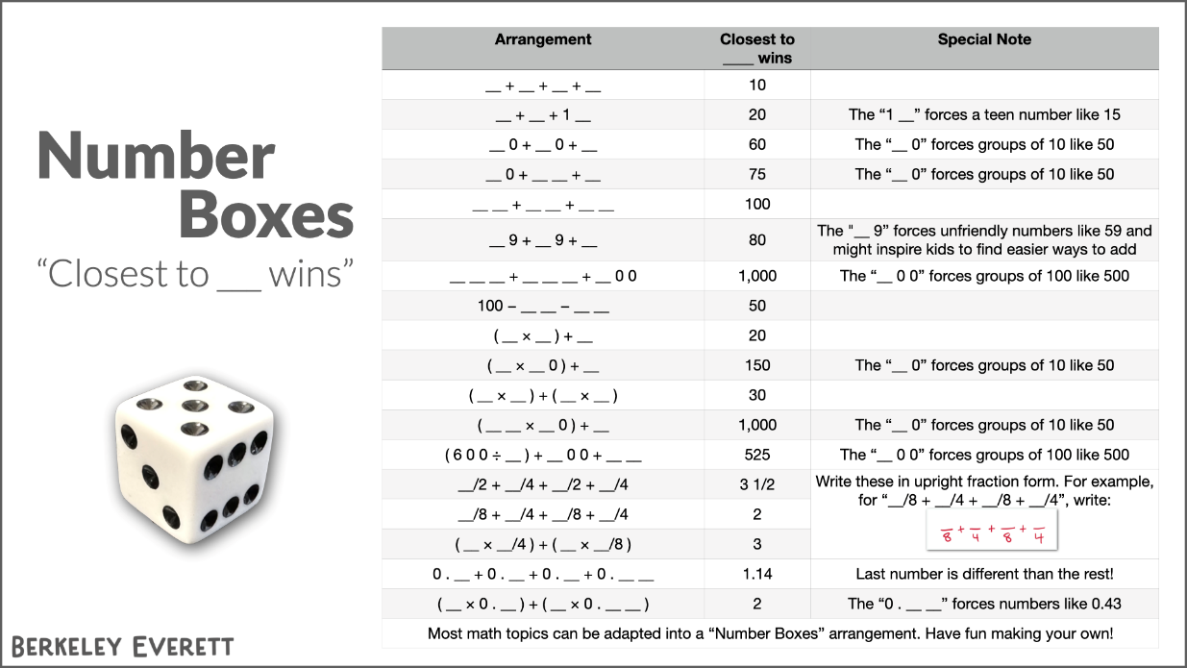

Click the image above (or here) to see this full-screen.

You can turn any arithmetic topic into a Number Boxes game so don’t let this list limit you - make up your own!

For more, check out:
- blog post from Jenna Laib with other content ideas
- blog post from Mark Chubb including the value of “Dynamic Practice” over “Rote Practice”
- online game version by Sembl - where the whole class can play together on individual devices

Hope you try it with students soon. Happy mathing!
- Berkeley

