FP10.3 Post-Assessment
Measurement (Chapter 1)
FP10.3 Demonstrate understanding of SI and imperial units of measurement including:
- linear measurement
- surface area of spheres, and right cones, cylinders, prisms, and pyramids
- volume of spheres, and right cones, cylinders, prisms, and pyramids
- relationships between and within measurement systems.
Multiple Choice: Identify the choice that best completes the statement or answers the question.
______1. Which referent could you use for 1 foot (ft.)?
- The distance between Regina and Whitehorse
- The diameter of a basketball
- The height of your math teacher
- The height of an ice hockey net
______2. How do the referents for a centimeter and an inch compare?
- A centimeter is about the width of your smallest fingernail, whereas an inch is about the width of your thumb across the joint
- A centimeter is about the width of your hand, whereas an inch is about the length of your arm
- A centimeter is about the width of your thumb across the joint, whereas an inch is about the width of your smallest fingernail.
- A centimeter is about the width of your foot, whereas an inch is about the length of your foot.

______3. On a road map of British Columbia, the distance between Vancouver and Fort St. John is 1237 kilometers. What is the distance to the nearest mile?
- 769 miles
- 673 miles
- 1991 miles
- 2061 miles

______4. Paul plans to replace 487 inches of wood railing along the top of his patio fence. The wood is sold in 8 ft. lengths. How many 8 ft. lengths does Paul need to purchase?
- 41
- 61
- 5
- 6
______5. The packaging on a pair of skate laces indicates that the length of each lace is 108 inches. You need laces that are 300 centimeters in length. Do you think you have found the laces that will fit your skates? Why or why not?
- No, they won’t fit because an inch is about 2 and one-half times larger than a centimeter. Therefore, 2 x 108 = 216 plus another half of 108 is 54, which is a total of 216 + 54 = 270 cm which means that the laces are about 30 centimeters too short.
- No, they won’t fit because an inch is about 12 times greater than a centimeter. Therefore, 10 x 108 would be 1080 plus another 2 x 108 is 216, which is a total of 1080 + 216 = 1296 cm which means the laces are way too short.
- Yes, they will fit because an inch is about 3 times larger than a centimeter. Therefore, 3 x 108 is about 300 centimeters which is about the length that you need.
- Yes, they will fit because an inch is a little less than half a centimeter. If you need 300 centimeters, this would be less than 150 inches and you do have less than 150 inches. You actually have 108 inches.

______6. On a map of Alberta 4 cm represents 62 km. If the actual distance from Calgary to Lethbridge is 217 km, calculate the distance between Calgary and Lethbridge on this map.

- 3 centimeters
- 12 centimeters
- 14 centimeters
- 16 centimeters

______7. Which equation represents an accurate measure of the surface area (SA) of the square pyramid pictured in the two views shown below?
6 cm
6 cm
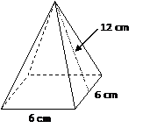
12 cm

net of the square pyramid
square pyramid

- SA = (6 cm x 6 cm) + ($\frac{1}{2}$ x 6 cm x 12 cm )
- SA = (6 cm x 6 cm) + 4 ( $\frac{1}{2}$ x 6 cm x 12 cm )
- SA = (6 cm x 6 cm ) + (6 cm x 12 cm )
- SA = (6 cm x 6 cm) + 4 ( 6 cm x 12 cm)

______8. What is the surface area of the following right rectangular pyramid to the nearest square inch?
- 126 square inches
- 197 square inches
- 143 square inches
- 138 square inches

______9. What is the surface area of this right cone to the nearest square metre?
. a. 74 m²

b. 55 m²

c. 40 m²

d. 83 m²

______ 10. A right rectangular prism with base dimensions 7.8 m by 5.1 m has a volume of 110.1 m³. What is the height of the prism to the nearest tenth of a metre?

- 2.8 m
- 8.3 m
- 1.2 m
- 5.5m

Short Answer: Show your work whenever possible.
- What is the volume of this composite object which is a right cylinder and a hemisphere, to the nearest cubic metre?

- What is the surface area of this composite object, which is a right cylinder and two right cones, to the nearest square centimetre? The diameter of the cylinder shown below is 1.4 cm and the slant height of each cone is 2.7 cm.

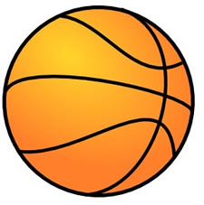
- Determine the volume of a basketball which has a surface area of 277.6 square inches. Write your answer to the nearest cubic inch.

- What is the relationship between the volume of a right cone and a right cylinder AND between the volume of a right pyramid and a right prism? In each case, both have the same base and the same height.
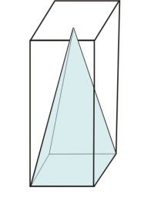
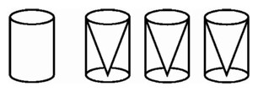
right pyramid and right prism
right cone and right cylinder

_________________________________________________________________________________________________________________________________________________________________________________________________________________________________________________________________________________________________________________________________________________________________________________________________
- When Treaty 4 was signed in 1874, each First Nation family of five was entitled to 640 acres or one section of land. How much land was this in square kilometers? Write your answer to the nearest tenth of a square kilometer.

