Double Trouble
Addition
My Roll Total Opponent’s Roll Total
_______ + ______ = ______ |  | _______ + ______ = ______
_______ + ______ = ______ |  | _______ + ______ = ______
_______ + ______ = ______ |  | _______ + ______ = ______
_______ + ______ = ______ |  | _______ + ______ = ______
_______ + ______ = ______ |  | _______ + ______ = ______
_______ + ______ = ______ |  | _______ + ______ = ______
_______ + ______ = ______ |  | _______ + ______ = ______
_______ + ______ = ______ |  | _______ + ______ = ______
_______ + ______ = ______ |  | _______ + ______ = ______
_______ + ______ = ______ |  | _______ + ______ = ______
_______ + ______ = ______ |  | _______ + ______ = ______
Instructions: Roll 2 dice. Find the sum by adding the two numbers. Fill in the equation under “My Roll”. You’re opponent will write down the equation as well, under “Opponent’s roll” . Now it’s your opponent’s turn.

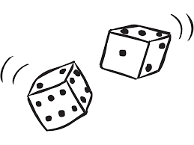
If you roll doubles, find the sum, but the amount gets subtracted from your total instead of added!

Person with the highest score wins!

