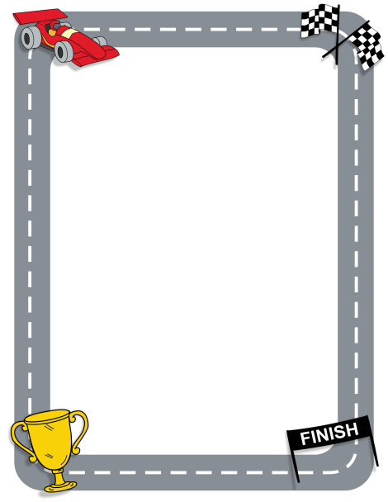
Level 1
Race to 100 (or -100)!
Roll a double sided die. The outer number is always positive and the little inside number is always negative.
Winner is person farthest from zero (in a positive or negative direction)! All players calculate each roll and track score.
Opponent’s Equation
My Equation
Total |  | Total

Equation
Total |  | Total  Equation

