Grade 2 Math Answer Key
Show what you know!


This is the teacher guide. Instructions that go with questions are in yellow filled boxes. You will need linking cubes and some solo cups or other cups to put cubes in.

You will show the questions on the SMART board one at a time, and read the questions out loud to eliminate math errors that are actually reading errors.

Explain to students before you start that they have to do only the question that is up on the SMART board, not to work ahead. Everyone does one question at a time, together. The questions are both numbered and colour coded to help you keep students all on the same question. Do your best to ensure kids can’t see each other’s work, or your results will not be valid.

Help students understand that it’s ok if they don’t know something. This is not about seeing “who’s smart”—it’s about knowing what we need to teach.
Growth mindset talk, etc. We mark items either “Correct” (1) or “Not yet” (0)

Use your judgement on wait time. If kids can’t do it in a reasonable amount of time, they probably don’t know it. You don’t need to give long wait times, and risk fidgety off task kids. If you have one or two very slow processors you could let them redo the assessment sometime, even with an EA or SSST. Record the information about the need for excessive time.

How do you like math? Circle one
Name_____________________________________________

1. Write the numbers 1 to 10

Students are not penalized for making numerals backward
N K.1 Number sequence to ten
N1.1 Number sequence one hundred
Say the number “35” out loud. Repeat it if you need to. Do not write the number. We are testing their knowledge of writing down a number they hear.

2. Write this number:

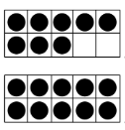
N 1.3 Counting, using parts to count groups.
3. What number is this?

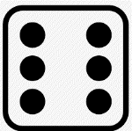
N 1.2 Familiar arrangements of objects
Call students’ attention to watch. Show the die image for 3 seconds—long enough for students to see but not long enough for them to count. If you need to show it again for a couple seconds because someone missed it, do so. We are testing subitizing, so avoid letting them count.
4. Look at the picture on the SMART board quickly. What number is shown?
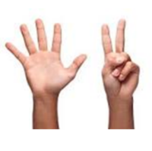
N 1.2 Familiar arrangements of objects
Call students’ attention to watch. Show the hands image for 3 seconds—long enough for students to see but not long enough for them to count. If you need to show it again for a couple seconds because someone missed it, do so. We are testing subitizing, so avoid letting them count.
5. Look at the picture on the SMART board quickly. What number is shown?

N 1.9 Addition
6. Sherry has 4 library books at home and brings home 5 more. How many does she have all together?

Have students watch you count out 12 blocks into two cups. Put 5 blocks in one and 8 in the other. You can count five and eight out loud. Students will need to add the quantities without being able to count.
N 1.9 Addition
7. How many blocks does your teacher have altogether in the two cups?
Take two of the eight blocks from one cup and add those two cubes to the five in the other cup. Ask them how many blocks in the two cups now. Be sure the students see that you did not remove any, just moved them from one cup to the other. This is testing students’ understanding of equality, that rearranging groups of obects does not change the total. You may prompt them that their answer may be same as last answer, or different. “Is the amount the same? Then rewrite your last answer”. Note that if they got # 7 wrong (miscounted), but kept the same total for #8, you will mark #8 right.
N 1.3 Set has only one count
8. How many blocks does your teacher have?
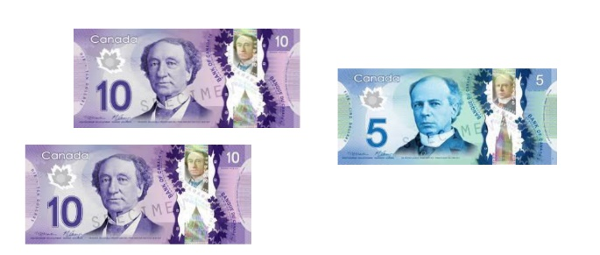
N 1.1 Skip Count, N 1.9 Addition in parts
9. How much money?

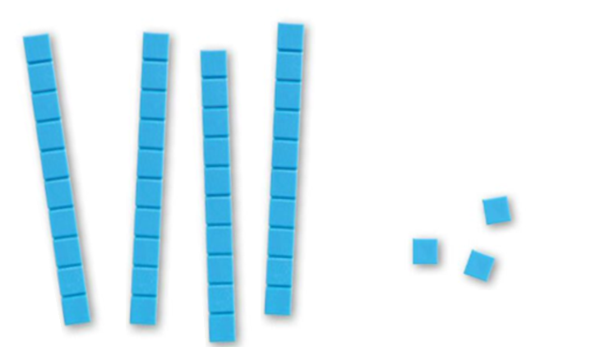
N 1.1 Familiar Arrangement, N 1.3 Using parts to count
Hopefully students are familiar with base ten blocks from K and Gr 1, but if not, you can help them count that a rod is ten, and then tell them the rods are always ten. They don’t have to count each square in every rod. We are testing if students can add using place value, adding tens as units. If a student can’t do this then mark it wrong.
10. How many?
N 1.1 Record a numeral presented orally
In this question the students can read the written (word) form of the number as well as hear you say it out loud.
11. Write the number form of fifty-six.
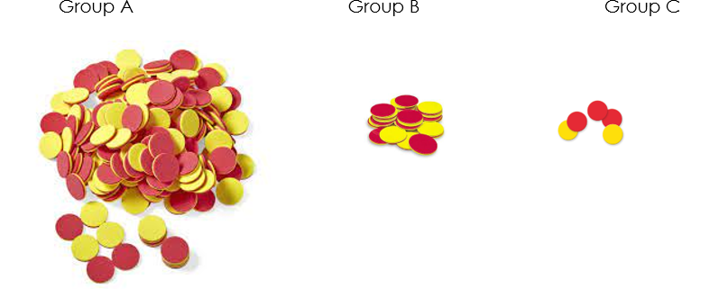
N 1.6 Estimate
12. Circle the group that has about 18 counters.
You may need to explain this task. These number slide so you can move them. “Where do you think the 3 goes? Here, or here, or here?” You may demonstrate drawing tic marks and writing in a number, like 1 or 5. Don’t draw tic marks all along, only for a number that you are modeling placing. (if students draw tic marks all along that’s ok, but better if they don’t)

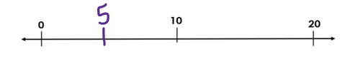

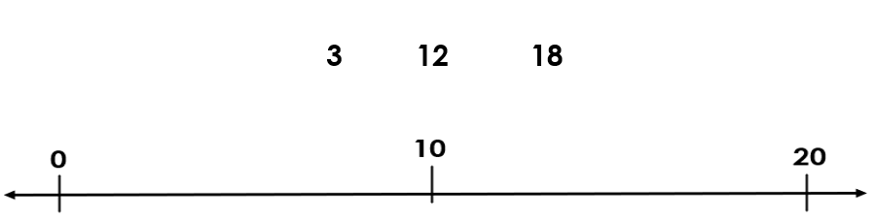
N 1.4 Place numbers on number Line
13. Write these numbers where you think they belong on the number line
N 1.4 Represent whole number to 20
14. Draw 12 circles.

Use your judgement in prompting or supporting an understanding of “fewer”. We are testing the knowledge of comparative language.
N 1.5 Compare sets, comparative language
15. Circle the set that has fewer leaves.

N 1.8, one or two more/less
16. Write the number that is 1 more than 18.
N 1.8, one or two more/less
17. Write the number that is 2 less than 10.
N 1.8, one or two more/less
18. Write the number that is 1 less than 12.

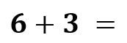
N 1.9 Addition
19.
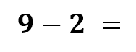
N 1.9 Subtraction
20.
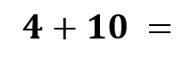
N 1.9 Addition
21.

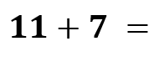
N 1.9 Addition
22.
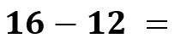
N 1.9 Subtraction
23.


You may need to model a number sentence for students to understand this task
N 1.9 Represent addition problem
24. Write a number sentence for this picture:
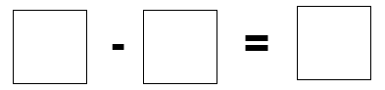
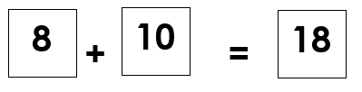
You may need to explain “rearrange”. We are testing knowledge of fact families, addition and subtraction as related. Some kids won’t know to begin the subtraction with the biggest number, in which case we would mark it wrong—they don’t yet have that understanding.
N 1.9 Addition and corresponding subtraction fact
Rearrange the numbers in the boxes above to make a subtraction sentence.
25. This is an addition sentence:
P 1.1 Repeating pattern
You may need to explain that they can draw shapes in the blanks
26. Extend this pattern:

You can explain that they circle the word “equal” or “not equal”, otherwise some students may circle groups. They should circle only the words, not a group of stars with the words. You can define the word equal as “Just as many” or “same amount”.
N 1.5 Comparing sets
Equal
Not Equal
27. Are these groups equal? Circle your answer.
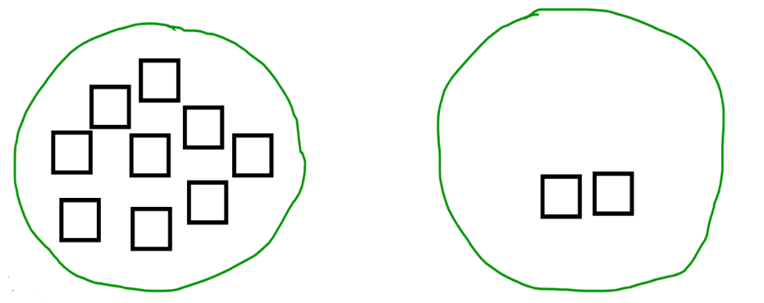
N 1.5 Making equal groups
28. Draw squares in the second group to make these two groups equal.

Part II Math Conference

1. Ask a student to count 15 cubes or counters and check for one-to-one correspondence. Check for ability to find numbers past ten. (N K.3 Counting N 1.1 Numbers to 20, N1.3 Counting and Quantity)

2. Write the numeral 46 on a paper or white board, and ask the student to read the number. (N 1.1 Number sequence to 100)

3. Ask the student to count up by ones from that number, 46, till they get to at least 60. (N 1.1 Number sequence to 100)

4. Ask the student to write the number 10, then ask them to count back from 10 by ones s to one (or zero). (N 1.1 Counting back)

5. Ask the student to count up by tens to 100. (N 1.1 Skip Counting)

6. Ask the student to count 20 cubes or counters by skip counting by twos. (N 1.1 Skip Counting)

7. Check for skip counting by fives by counting nickels, or five-dollar bills, or sets of linking cubes joined in sets of five. (N 1.1 Skip Counting)

8. Tell the student that you have 8 cubes or counters in a cup. If you add in 5 more cubes how many are there? (N 1.9, Addition/subtraction/strategies).

9. Tell the student you have 18 cubes or counters in your cup. Take out 6. Ask the student how many are left. (N 1.9, Addition/subtraction/strategies)

10. Check the student’s knowledge of ten-pairs. Show a ten frame with 6 dots. (Clarify that the ten frame always holds ten.)
Ask how many dots? Then cover the ten frame and ask how many squares are empty. Repeat this with two more combinations of tens (ex, 1 dot, 9 are empty, 8 dots, 2 are empty).

Write the number 3 and ask how many more to make ten? Write the numeral 6, how many more to make ten? (N 1.9, Addition/subtraction/strategies)

Q # | Outcome | 0 or 1
29 | (N K.3 Counting N 1.1 Numbers to 20, N1.3 Counting and Quantity) Counting objects
30 | (N 1.1 Number sequence to 100) Saying a double digit number, reading from numeral
31 | (N 1.1 Number sequence to 100) Counting up from a double digit number
32 | (N 1.1 Counting back)
33 | (N 1.1 Skip Counting) Skip count by ten, recite
34 | (N 1.1 Skip Counting)Count objects by twos
35 | (N 1.1 Skip Counting)Fives, groups
36 | (N 1.9, Addition strategies).Check strategy. Counting up? One addend or both?
37 | (N 1.9, Subtraction/strategies). Counting back?
38 | (N 1.9, Addition/subtraction/strategies) Ten pairs

