Be sure to teach the number/place value system as “periods”, which means a repeating pattern.
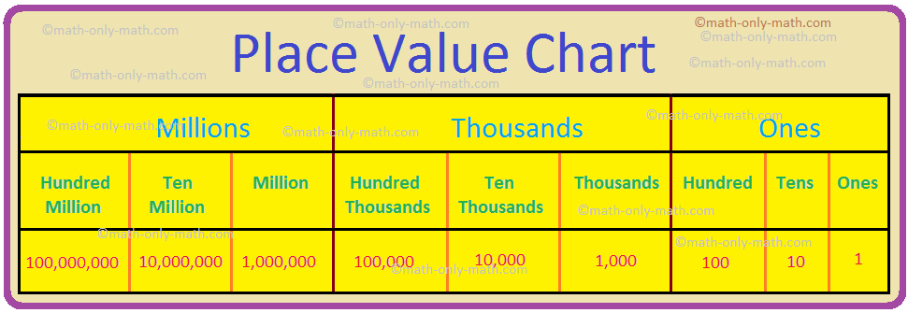
This helps students see there is a repeated pattern to how we say numbers:
For instance 67 345 238 356

“Sixty seven billion”, “three hundred forty-five million” “two hundred thirty-eight thousand” “three hundred fifty six”

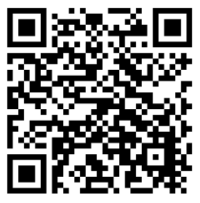
We say the “billions, millions, thousands” are like family last names, and the family members all have the same names—hundreds, tens, ones. So we always say the groups of three like it’s a 3 digit number, in the hundreds, then we say the last name. In the example above, notice we say “sixty seven”(billion), then “three hundred forty-five”(million), then “two hundred thirty-eight” (thousand) and so on. Its always hundreds, tens, ones—then the family last name.

Printable place value worksheets: Base ten blocks and ten frames
https://www.k5learning.com/free-math-worksheets/first-grade-1/base-ten-blocks

Games online https://mrnussbaum.com/place-value-workshop-online
https://www.iknowit.com/lessons/c-place-value-up-to-thousands.html
https://www.splashlearn.com/math/place-value-games
https://www.free-training-tutorial.com/place-value-games.html
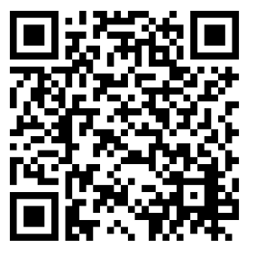
Virtual base ten blocks (manipulative) https://www.coolmath4kids.com/manipulatives/base-ten-blocks

