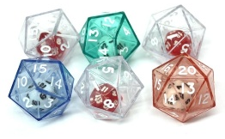
Double Dice Multiplying!

Name:__________________
Record all your calculations below.

Double Dice Multiplying!

Name:__________________
Record all your calculations below.

