
Math Activity One Pager Station Sheet

Decimal Maze
(Title of the Activity/Game)

Grade Level: 7
Topic/Math Concept : Operating with decimals

Outcome(s): N7.2
Expand and demonstrate understanding of the addition, subtraction, multiplication, and division of decimals to greater numbers of decimal places, and the order of operations.

Materials Required
- Calculators
- Handout: Maze Playing Board

Instructions

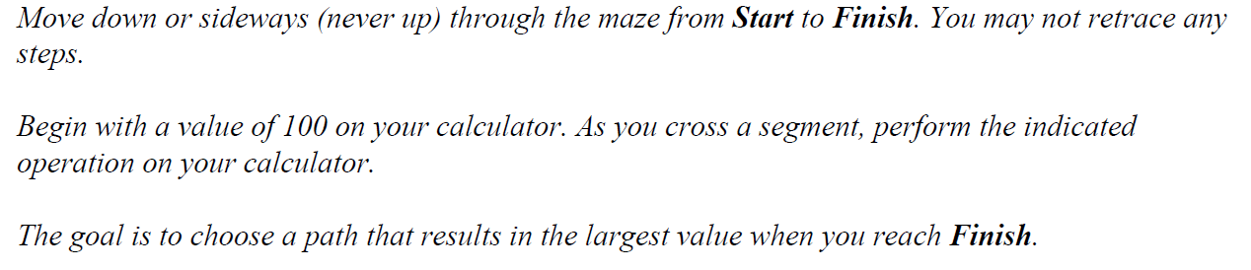

I love this because it’s problem solving (indicator d) Solve a problem involving the addition, or subtraction, of two or more decimal numbers; indicator f) Solve a problem involving the multiplication or division of decimal numbers with more than a 2-digit multiplier or 1-digit divisor (whole number or decimal), with the use of technology.)

Source: https://www.youcubed.org/ ; https://illuminations.nctm.org/

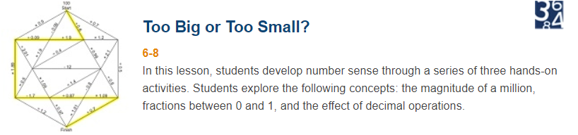

Contributor and Email: Robin Dubiel, robin.dubiel@cttcs.ca

