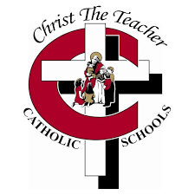
Observation/Conversation Checklist SS 5.3 SS5.3 Demonstrate an understanding of volume
Given various prisms of same volume, explain which is most suitable for a particular situation
Construct possible rectangular prisms of a given volume
Use manipulatives to determine the volume of a 3-D object and explain if it is exact value or estimate
Provide referents for cm³, and m³ and explain the choice
Name

