21 Ways to Differentiate in the Secondary Math Classroom
FEBRUARY 16, 2021 BY RACHEL
In our schools we have a range of students. Some of them come with IEPs or 504 plans. Then, there are students who don’t have individual plans and aren’t in any special programs, but we know that they have a similar need for additional support. At the same time, there are the students who don’t really struggle or need a lot of extra support. When there’s such a wide range of student abilities entering our math classrooms, what can we do in our 50-65 minutes together that meets the needs of all students? How do we differentiate our math instruction to give all students a path to success in our classroom?

We want to help those struggling students during our regular math class, but sometimes that seems too overwhelming. In fact, sometimes it feels like the only solution is to teach 3 different classes simultaneously, which is completely overwhelming.
I don’t know about you, but sometimes when I hear people say “just differentiate!” it sounds like an impossible task. It conjures images in my mind of completely different lessons plans and lessons, not to mention coordinating a wide range of student activities while ensuring that everyone is doing just what they should be.
But that’s not what differentiating needs to be. There are pragmatic steps that we can take in our regular math classes that help more students experience success. So, what can we do that meets the students where they are without running teachers out of the profession? Let’s dig into low-prep, high-impact strategies to meet our students’ needs and help them move forward.

Differentiated Instruction Background
When I started writing this article I reflected on the many trainings I’ve attended, I read a lot of other people’s articles, and I thumbed through a couple books I’ve read before about differentiation. One thing I noticed- there are some books or articles that come at this topic with a more scholarly approach that hardly seems to be rooted in the classroom.
In my opinion, it’s not possible to give all students choices all of the time, or to make sure that every lesson has three distinct levels. Also, it’s not necessary.
When I was a new teacher, Theresa and I differentiated everything, all the time. We had 3 different levels of ELL students and were left to teach them English in whatever classroom, closet, or hall space was available (no exaggeration). Even with so many challenges, my students were eager to learn English and willing to work hard. I had 12 students and they were most definitely at 3 different levels. No English, some English, and fluent social English speakers (having been in US schools since kindergarenten, but with low academic language).
The two of us and our bright-eyed optimism were working until 10 o’clock every night and on weekends coming up with different lessons for the wide-range of student needs. Now, that experience definitely shaped me as a teacher and taught me so much about teaching and learning.
But, while I learned the importance of differentiating, I also gained the appreciation for differentiating in a reasonable way. It’s not reasonable to ask people to differentiate everything all the time. It’s impractical to say that the solution to a wide discrepancy in student abilities (i.e. some students at a 2nd grade math level and others at an 8th grade level) is to simply differentiate. The truth is, differentiating instruction in those extreme ways can be ridiculously time-consuming, and frankly I couldn’t do it right now in my life.

Low Prep Strategies for Differentiation
So, today I want to share teaching approaches and strategies that differentiate for student needs without creating entirely different lessons for different students. These approaches worked for me in the math intervention classroom, and translated well into the mainstream math classroom:
- Create a routine
- Sentence Starters
- Got It – Not Yet Cards
- Math Paths
- Pre-Teaching Concepts
- Discovery Lab & Activities
- The Ripple
- Exit Tickets
- Gallery Walks & Scavenger Hunts
- Students Tracking Their Progress
- Split-Questions
- Support in Note-Taking
- Students Choice of Activities
- Partner Work
- Model it Again
- Task Cards with Increasing Difficulty
- More Time for Students
- Create a Culture of Learning from Mistakes

Create a routine
Creating a routine might not seem like a strategy for differentiation, but the students who struggle the most need structure. If they don’t have boundaries, they’ll wander. Sometimes they wander with the behavioral choices they make and other times their mind wanders. Some of them actually wander around the room.
Begin by making your routines simple, structured, and consistent. Once you’ve established routines, then you can get fancy with mixing things up. Some routines that have worked for me are: 1) have one activity that students start the class period with every day, 2) have them sit in the same seats each day, and 3) have them work with the same partner over a period of time. If the class has the sense of calm and normalcy, then you have a good canvas on which to differentiate.

Sentence starters
I am the Queen of Sentence Starters. They’re the one of the easiest ways to differentiate. We use them whenever students have to produce sentences. Students get the option to use or not use them. I find that students that don’t need them typically don’t use them, and students who don’t know where to start get started by writing with the sentence starter.
Here’s my favorite tips for using sentence starters:
- Use sentence starters for spoken responses as well as written responses.
- Have students write first, then orally share answers.
- Embed target vocabulary into the frame. This gets students practice using academic vocabulary.
- Make an expectation that answers will be given in complete sentence form, whether or not students choose to use the frame.
- When starting out, have all students use the frame. You can change that expectation over time.
Sentence starters can work miracles. With this simple support, you’ll see that most kids will get started and then have great ideas to share. Or sometimes what they share is that they have no idea what they are doing. The best part is that it gets the door open for everyone. That’s at the core of differentiation. To learn more about this simple strategy, check out our video discussion in this post.

Got it, Not Yet Cards
If you’re doing split or parallel tasks with students, you need to have some strategies on how to know who is in which group. For example, sometimes I’ll give direct instruction, and then I’ll have an “exit ramp” when I tell students that we’ll do more practice together, but if they’re ready to move onto independent practice, they can go now. I find that letting the students themselves tell you when they’re ready to move on works really well.
You might be wondering if students will just skip to the other group even if they aren’t ready. That does happen, but if you use this approach consistently, a lot students really find to go where they’re comfortable. Plus, if students start the independent practice and then get stuck, they can jump back into the “still practicing” group.
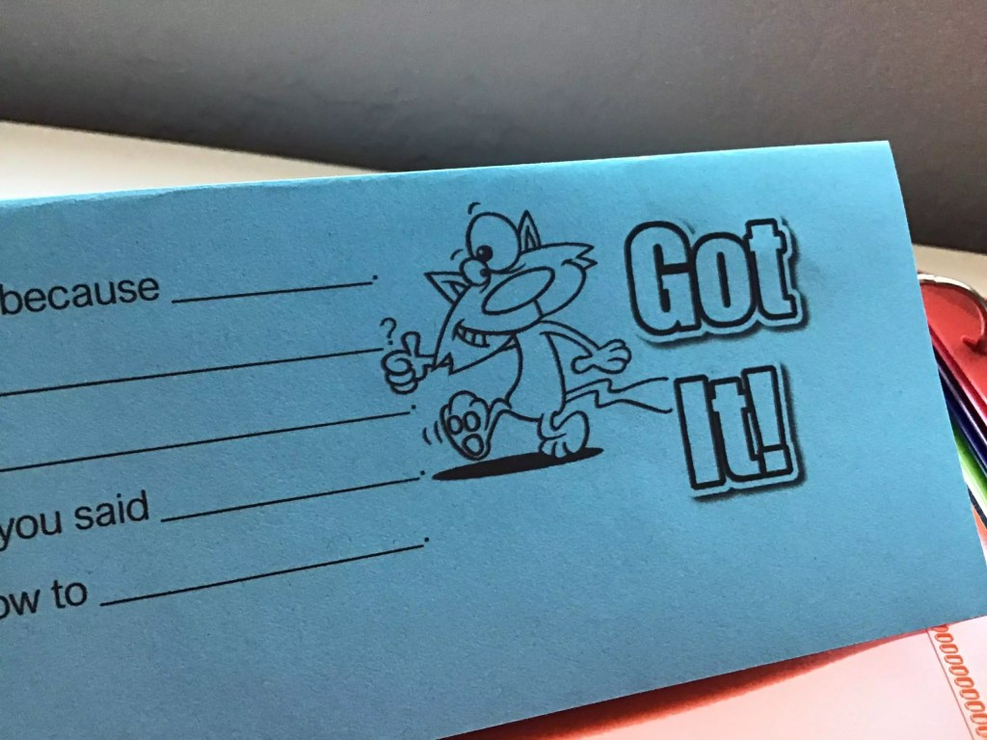
You can do this strategy with Got It, Not Yet Cards. I use these name placards and students can just turn the way it’s facing the teacher to show if they’re moving on, or if they need to keep working with you. Then, you can see in a glance who feels like they get it and who’s still following you for more explanation It’s a simple strategy that doesn’t really shine a huge light on the students that need more support. There’s no pulling them to the back table, it’s just continuing to teach while giving permission for students to move ahead at their own pace.
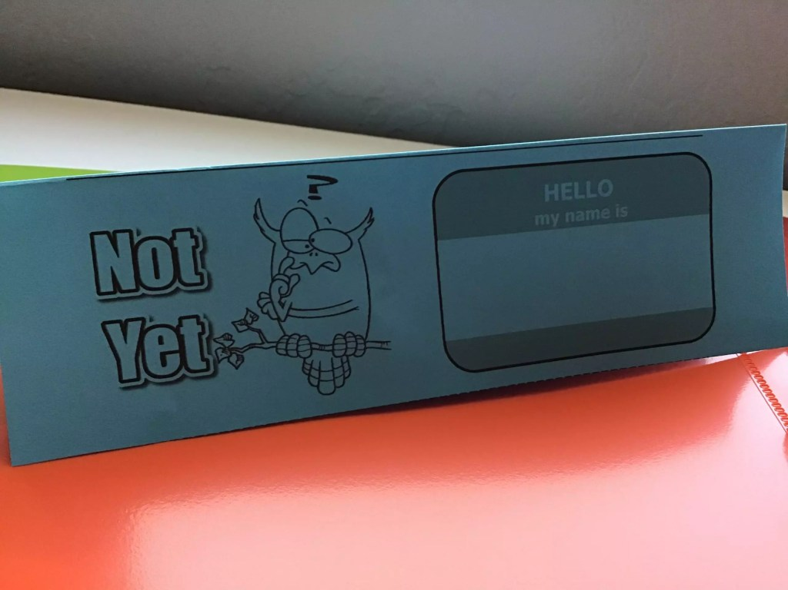
Do you want to grab your own FREE download of this Got It – Not Yet card for students? It’s one of 7 resources you’ll get when you sign up to have the 7 Resources & Tips for Math Intervention sent right to your inbox!

Math paths
When I was in 4th grade the two 4th grade teachers put all of our two classes together and gave each of us a math path. It was a mimiographed sheet of tasks to complete related to a topic (I can still smell that Ditto ink!). This was back in 1987 and I think they were a little progressive for the time. I went through these paths like a cheetah hunting prey. Sometimes I’d work with others who went at my speed, and sometimes I worked alone. Other students went a lot slower. This method has always stuck with me because I never got bored and I was constantly challenged.
As a teacher I’ve built on that method and have used something similar. It’s a set course of assignments in a sequence. The part that is differentiated is where students start on the course. The path ends with more difficult work, usually a harder open-ended challenge. Also, we usually have 2 or 3 starting points. Students get working, but with this approach their work and speed depends on their own ability. I don’t expect all students to complete all portions of this path, necessarily. Instead, there’s a baseline expectation of work that I make sure all students complete, and then additional practice depends on what they need.
The way I see it is this- if you think of learning like practicing a sport, you’d never expect that every player would make the same progress in the same session. You just want to make sure that each students has the optimal chance to make the optimal progress in that class period.

Pre-teach grade level concepts
Pre-teaching grade level concepts is an approach you can use with the students who need the most support. Usually, they have some sort of support class where they can get a 15 minute mini-lesson on the upcoming topic. Giving them a little preview helps them during the whole class lesson. They get more out of it, and boosts their confidence during the lesson. Coordinating with a support teacher to pre-teach grade level concepts can increase what those struggling students achieve during regular class time.
Another technique is to take some time during the beginning of class or end of class and pull a group over and pre-teach for 5 to 10 minutes. This gives them some background that they’ll need when the new topic comes. Most of the other students already have this background and pre-teaching gives more kids a chance to participate at the beginning of a concept.
My students love this approach, and they’ll raise their hands to answer questions like never before. Also, they’ll be the ones helping their partners, giving them a huge motivation boost.

Discovery Labs or Activities
Discovery activities make a level playing field for students. These activities give students mathematical situations, and students have to figure things out. I like to start units with these, before we’ve taken notes on a topic.
Students can’t just ask the teacher for help or look back in their notes. They examine the scenario and makes observations and guesses. This pushes students to think differently, and they have to have productive struggle. By having students work on this activity in partners or small groups, they share different ways of thinking about the situation. If the discovery activity is working, then it won’t be super easy for anyone.
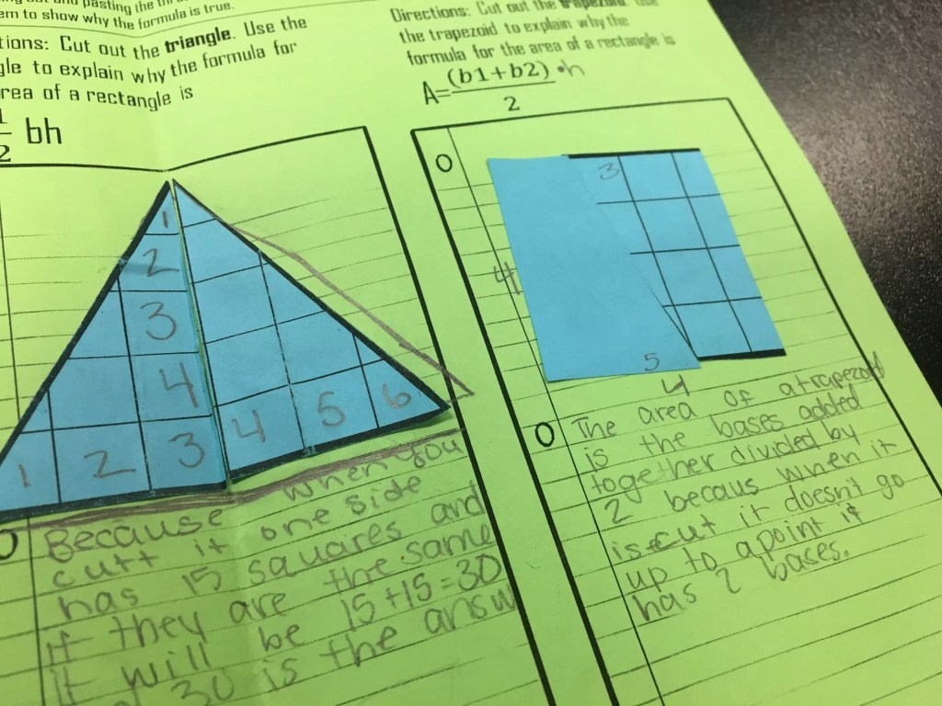
Using discovery-based activities creates a differentiation opportunity because all students have chance to learn. I’ve found that this activity kind of turns the classroom hierarchy on its head. Some of the high flyers shut down because they don’t already know the answer. Also, some of the students who struggle, but are willing to make mistakes, shine in this type of activity.

The Ripple
Everywhere you go in education you’ll hear about Think-Pair-Share. When it is mentioned at a professional development with veteran teachers in it, you will inevitably hear a sigh. Well, Think-Pair-Share got an upgrade when Pérsida and William Himmele molded it into the Ripple.
With the Ripple, each student thinks about and answers the question in their head and on their paper. Then, they share their well thought out answer with their partner. Finally, a select few students are randomly called on to share with the class. The key is that every students is given time to answer the question and that they write down their answer. Then, every student has the chance to hear another’s thinking and share their own. Finally, every student is accountable to be prepared to share with the class, whether or not their name is ultimately called.
In a typical question and answer part of the lesson, the same three students tend to do all the thinking and talking. With the Ripple, every student is doing the thinking and the random name calling means that everyone has some skin in the game. Also, everyone has had the opportunity to get prepared.

Exit Tickets
Gathering formative assessment information gives you information for differentiating. Plus, the exit tickets themselves can be differentiated. One easy way to differentiate the exit ticket is to have a list of prompts that students can respond to. This gives them a chance to decide what they want to reflect on.
I’ve used an exit ticket prompt that asks students to talk about a mistake they made, and how they fixed it. Sometimes they didn’t make a mistake and this doesn’t work for certain students. Maybe the exit ticket asks them to tell about a math term they learned today. It’s possible that not all students learned the term you thought you were teaching, or that some students already knew the term, so they didn’t really learn it.
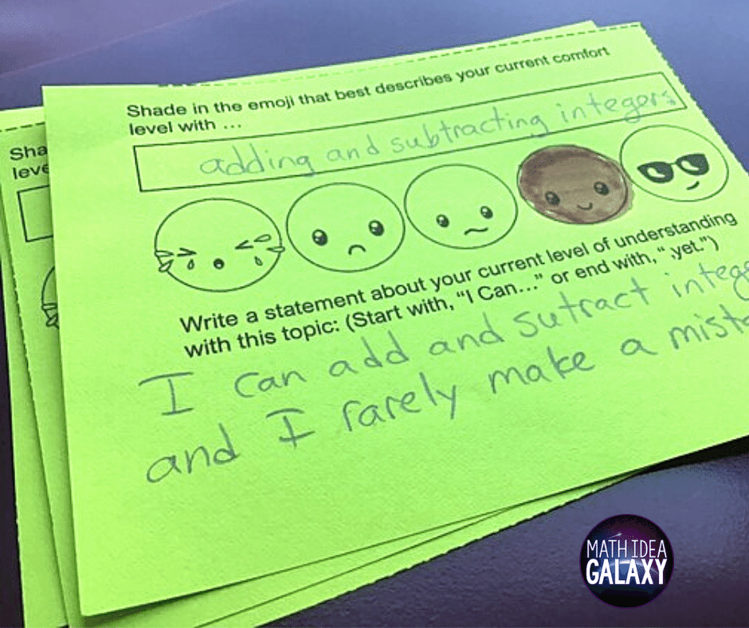
You can differentiate exit tickets by giving students different prompts to choose from. I like to have a set of common exit ticket prompts inside their math notebooks or posted on the wall, so they’re easy for students to choose from and use.
Oh, and for one of my all-time favorite exit tickets, the emoji reflection exit ticket seen above, be sure to sign up here for the 7 Resources & Tips for Math Intervention

Gallery Walks or Scavenger Hunts
Most students love to work with a partner and to walk around the room. I find that gallery walks and scavenger hunts get students excited and engaged. Now, how can you differentiate with them? Well, you can differentiate by the way that you pair students to work together. ou can pair them by heterogenous (varied) or homogenous (similar) readiness levels, or you can let them choose their partner.
Thoughtfully partnering students allows for differentiation and support in the classroom. One way to think about creating heterogenous groups is to break your students into 4 overall groups: high achievers (1), high average (2), lower average (3), and those who struggle (4). When pairing students, don’t put the high achievers and those who struggle together. It’s best to put students from group 1 and 3 together, and then students from group 2 and 4 together. This structure can provide students the best opportunity to learn from each other.
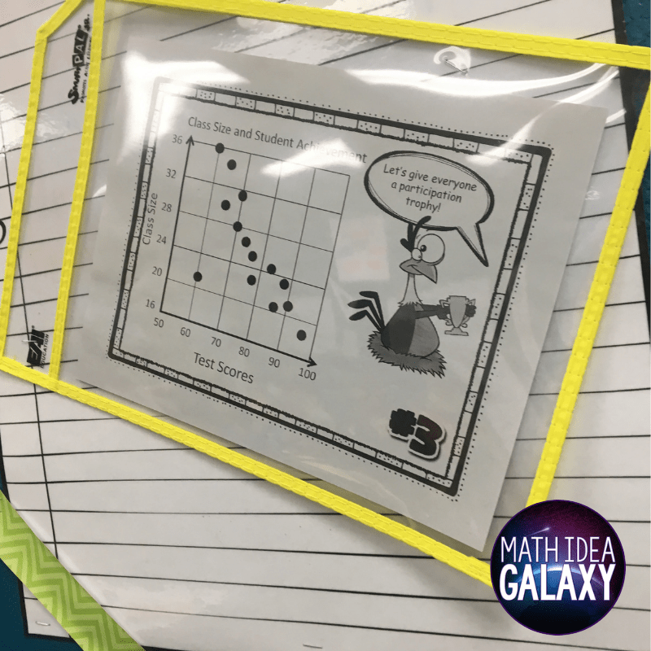

Have students track their own progress
If you want each student to learn and to be able to articulate what they’ve learned, then have them track their progress. They can track test scores, or monitor their progress with I Can statements.
When tracking test scores, it’s important to not just tell them what their scores are and assume those numbers mean something to them. You have to explain to them what the results mean. Frame everything in what they know and what they don’t know, YET.
This helps focus students on their own current level and their own path forward- which is really at the heart of differentiating.
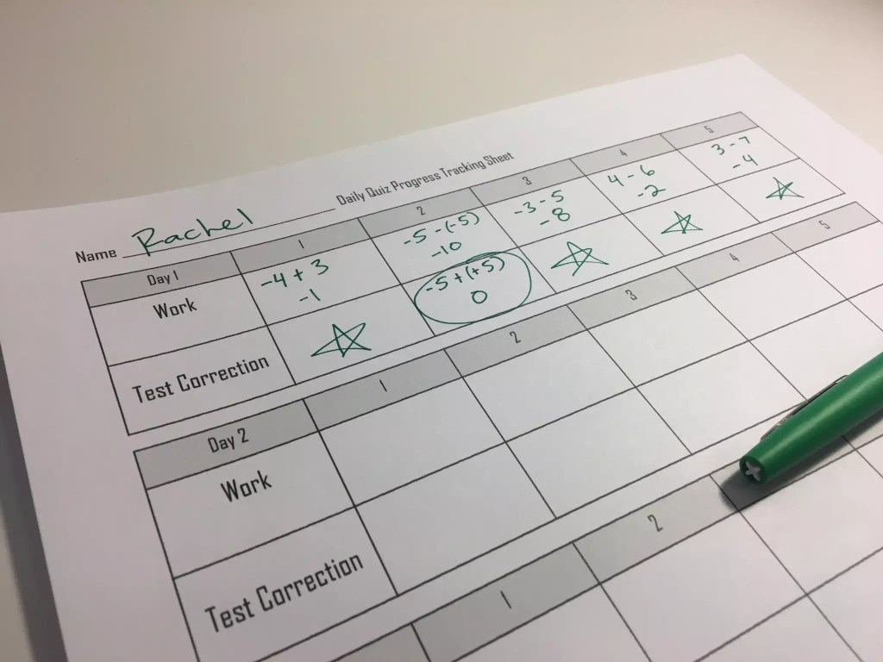
We keep a set of I Can statements in our notebook and we refer to it on basically a daily basis. Students get to see what they are expected to learn and then self-evaluate how they’re doing.
With test scores they can keep track of those in their notebooks as well. Remember that you have to discuss what test scores mean, and to be honest you’ll find they mean different things to different people.
Be sure to grab this amazing download of 7 Tips and Resources for Math Intervention. This download will help your math intervention students show their progress, reflect on their learning, and stay engaged in learning math. Just click here & download these 7 tips & resources to help make your math intervention run a little more smoothly.

Split-Questions
This technique is new to me, but the idea behind it seems amazing. You post two questions on the board instead of one. Then, students answer the one that they are the most comfortable with. This creates a way for students to self select into two groups.
You can learn about your students by which group they self select into. At first they might struggle knowing which question is at that just right level. If you do this activity often and model for them how to choose the right question, they’ll get better.
Read more about the split-question method in this article.

Different level of support when giving notes
Throughout my years of teaching, I’ve seen many students that cannot keep up with note-taking. Some students can’t go that fast and others struggle to copy off the board.
When using interactive notebooks you can offer different students different levels of notes. With the notes I’ve created over the years, I like to have a couple of versions. One version of the notes have a little bit of information filled-in for the student, while another version might have all the “notes” already filled in. Instead of spending their time copying, students would instead underline and circle key aspects of their notes.
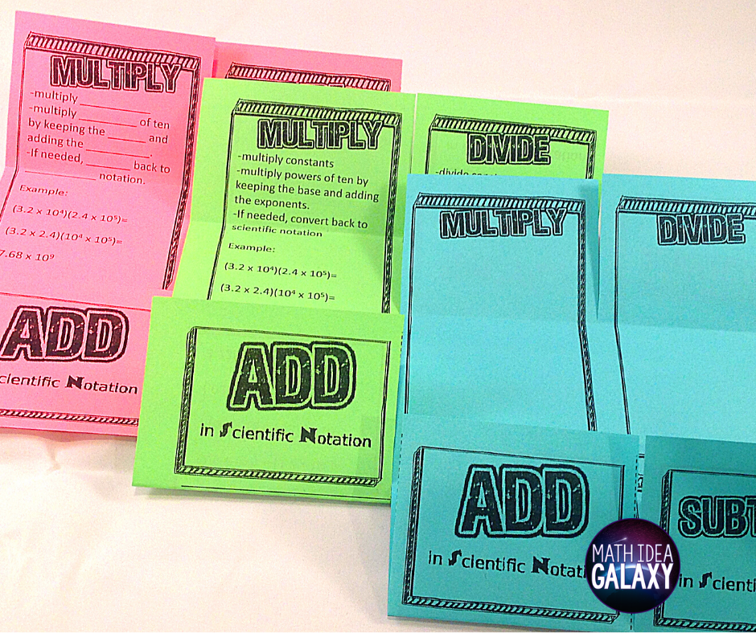
This technique requires upfront organization by the teacher. It’s particularly effective helps if there are two teachers in the room to help facilitate this modified note-taking by some students.
If you differentiate the notes, you can really make the note-taking experience fit the needs of individual students. It’s worth the little extra time to have 2 or 3 different versions of class notes.

Student Choice Activities or Stations
One way to meet students’ unique needs and abilities is to give them choice of activity. This can come in the form of choice boards or stations. You can offer these different activities at different levels, or just different activity types.
I’ve seen this done with a tic-tac-toe board of activities or through learning centers. My #1 suggestion for this strategy is to keep this very simple. If you are doing centers, don’t have more than three centers to choose from. With the choice board, don’t have too many activities. Also, make sure some of the activities have feedback embedded within them.

Partner work
Working in partners can be so beneficial for students. You might want to start working toward being a “partner whisperer”. Pairing students up to work together is both an art and a science. You can’t just randomly put students together. Finding a sweet spot so that each student in a partnership does some of the heavy lifting leads to success.
Setting up effective partners means balancing out students who will, for lack of a better description, get stuff done with those who are less inclined to finish. It also takes into account students’ personalities. Some people have a hard time helping others, while some 7th graders are masters at it. Finally, I’ve found that your students who struggle most often benefit from partnering with students who do well in class, but don’t necessarily learn everything the fastest.
If you get students with the right partner, then you’ll see a lot of working and talking to each other. This provides invaluable support for students as they learn and practice their math skills.

Model it Again
Another way you can split the activity or introduce a parallel task is by modelling it again. When teaching with the “I do, we do, you do” approach, often when you get to the “You Do” part of the lesson you’ll find that some students need more help before moving into practice.
So, when starting the “You Do” section of the lesson, I use the Got It, Not Yet name tent (see the section on this strategy above). Then, with the students who don’t get it yet, I keep modeling and doing guided practice together. I continue modeling a few more problems or until everyone turns their card to Got It, showing their confidence to move into trying it out.
I love this because it lets me work with a small group without the transition time or the singling kids out. Students really appreciate the extra modeling and if you keep helping them until they get it, they’re more likely to keep working at it. Meeting students where they currently stand helps them really improve.

Task Cards with increasing difficulty
There’s so much to love about task cards. I’m not sure where to even start! You can have students work on them in partners, they can be used in a variety of whole class review games, and they’re invaluable for quick cyclical review.
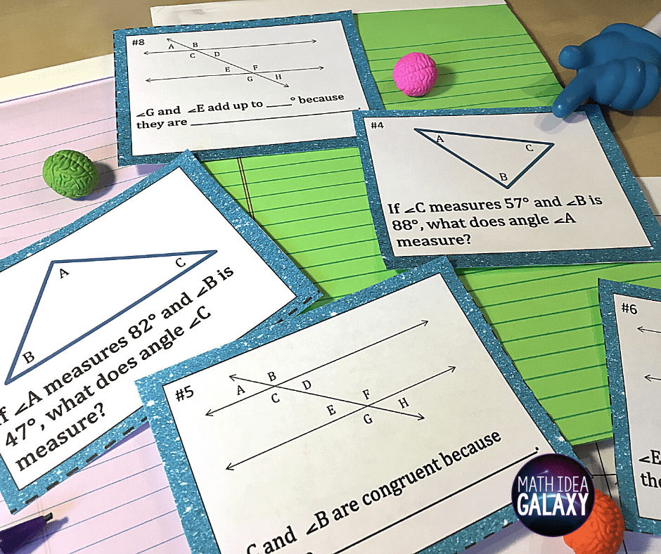
I design my task cards to increase in difficulty. By allowing students to answer questions in any order, they can attack the problems they feel comfortable with first. I also strongly believe students should use the answers and explanations on the backs of the cards. This gives everyone real time feedback while working at their own pace.
One of the biggest ways to differentiate with task cards comes from not emphasizing finishing all of them. Let students go at their own pace and as long as they’re working productively, they get credit for them.

More time for slower learners
Some students just take longer than others. This happens in every type of class. You can have a class of 30 advanced honor students and they all still work at different paces. So, how can we give the students who need it more time?
If you have some sort of advisory period, make sure that these kids get more time to complete their work and learning. Or, “find” time for them by removing another assignment for them. Finally- look at the rest of their school day. Is there a lab or support class that they’re also in where they can have some dedicated work time?
Giving them just a little bit more time can be the difference for some students. Some of them cut their learning off just before they “get it,” and then they move to the next topic.

Create a culture of “We Learn when We Fix Mistakes”
Differentiation can come in many forms, and imho mindset needs to be considered as one of them. Teaching students what growth mindset is, and creating a classroom culture that sees mistakes and temporary failure as a natural part of the learning process, can pay off in a huge way.
Many students see mistakes as bad and shut down when they make even the smallest mistake. This is particularly true with students who typically don’t feel successful at school. You can combat this by creating a culture that embraces the fixing of mistakes as the essence of learning.
Shower your students with examples of places where mistakes are accepted, fixed, and moved on from quickly like video games, playing an instrument, and sports. Creating this culture means explicitly teaching students how to deal with mistakes and failures in your classroom.
But, beyond a one-time lesson, this requires consistent reinforcement. You know, saying cheesy things like, “Remember, our mistakes help us learn!” and “What can we learn from this mistake?” (My Favorite No is one of the best routines to help students reframe how they see mistakes.)
Establishing a growth mindset culture will help all of your students, particularly those who may struggle in math. If you can get everyone on this train you’ll see improvement in effort, attitude and performance from all students.

Try One Thing- What will YOU differentiate?
Feeling overwhelmed? Good news! I just waved my magic wand and granted you permission to not differentiate everything all the time. Choose a few things to differentiate, and you’ll make a big difference for your students.
So what strategies will work best for your students and your classroom?

