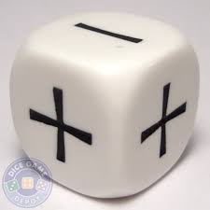

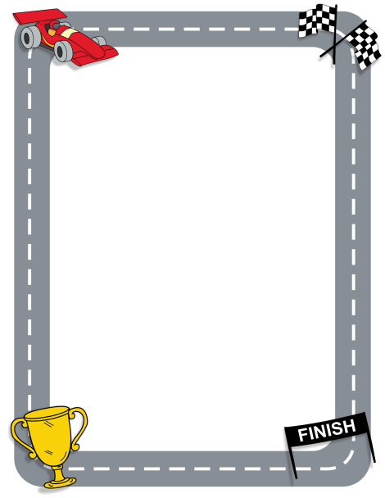
Race to 100 (or -100)!
Roll a double-sided die. The outer number is always positive and the little inside number is always negative.
Roll the operation die to see if you add or subtract the two numbers. You may add or subtract in any order. Winner is first person to have a total score of 100 or negative 100! All players calculate each roll and track total score.

