
Building Numbers Name________________
Shade the base ten blocks to make the number

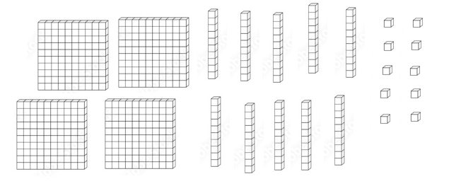 | 158
 | 261
 | 304
 | 340
 | 206

260
45
9
400
90
399

