3 stages example: Grade 6: Factors and multiples
This 3 stages example concerns outcome #3, only for the achievement indicators that directly concern factors and multiples. We recommend primes and composites be developed before developing factors and multiples. [Refer to 'Primes and Composites'.] In a sense, developing primes first serves as an EXPLORATORY experience for factors and multiples.
3.  Demonstrate an understanding of factors and multiples by  - determining multiples and factors of numbers less than 100  - identifying prime and composite numbers  - solving problems involving multiples. | - Identify multiples for a given number and explain the strategy used to identify them. [DEVELOPED]  - Determine all the whole-number factors of a given number using arrays. [DEVELOPED]  - Identify the factors for a given number and explain the strategy used (e.g., concrete or visual representations, repeated division by prime numbers or factor trees). [DEVELOPED]  - Provide an example of a prime number and explain why it is a prime number. [NOT DEVELOPED]  - Provide an example of a composite number and explain why it is a composite number. [NOT DEVELOPED]  - Sort a given set of numbers as prime and composite. [NOT DEVELOPED]  - Solve a given problem involving factors or multiples. [DEVELOPED]  - Explain why 0 and 1 are neither prime nor composite. [NOT DEVELOPED]
The assumption here is that students understand primes, composites, and divisors and the basic facts of multiplication are mostly in place.

The EXPLORATORY stage of teaching
EXPLORATORY activity
Have students play the Factor Finding Game.
Materials Needed:
- 10 each of two different colored disks
- Pair of dice
- Factor Finding game board (see diagram)
How To Play:
Two players play. The starting player rolls two dice. The largest number rolled is always used for the tens digit and the smallest is always used for the ones digit. For example, if a player rolls a 2 and a 3, the number would be 32 not 23.
The player places only one disk during each turn. He/she places it on the playing board over any number that is a divisor of the number he created in his roll. For example, if the number is 32, the player could place one marker on one of these numbers: 2, 4, 8, or 16.
- If a player rolls doubles, the turn is lost.
- If a player rolls PRIME (e.g. 31), he/she places a marker on any PRIME square.
- If a square is already covered, a player cannot use it.
- The first player to get four disks in a row (horizontal/vertical/diagonal) wins.
- If the grid gets locked and no one can win, players start a new game.
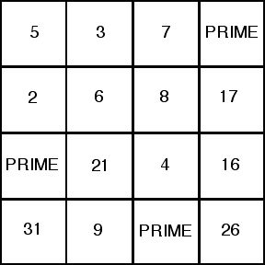

The EXPLICIT FOCUS stage of teaching
This EXPLICIT FOCUS lesson requires at least three class periods to complete.
3.  Demonstrate an understanding of factors and multiples by  - determining multiples and factors of numbers less than 100  - solving problems involving multiples. | - Identify multiples for a given number and explain the strategy used to identify them. [DEVELOPED]  - I [DEVELOPED]  - Solve a given problem involving factors or multiples. [DEVELOPED]
EXPLICIT FOCUS lesson
Activity #1
- Discuss the Factor Finding Game in relation to finding divisors of the number rolled. Ask the questions: (1) How did you figure out a divisor? and (2) Was there always more than one divisor? Discuss student responses. If no student has mentioned the strategy of dividing by primes in turn from smallest to largest possible, introduce students to it. [E.G.: To find divisors of 24, divide 24 by 2, by 3, by 5 (largest possible because 5 x 5 is bigger than 24) to find possible divisors.]
- Present students with the numbers 30, 45, and 58. Ask them to use the strategy of dividing by primes in turn from smallest to largest possible to find the factors (allow calculators). Discuss the results.
Activity #2
Ask students to give you a composite number between 21 and 66 (the smallest and largest numbers possible to form when playing the factor Finding Game). Suppose the students tell you '30'. Ask students to write the number using two divisors where one of the divisors is prime (e.g. for 30, possibilities are 2 x 15 or 5 x 6 or 3 x 10). Introduce the term 'factor' for the divisors of 30. Have students find other factors of 30 (include 1 and 30). Discuss the strategy they used for finding a factor.
Activity #3
- Present students with the number 12. Ask them to make all possible arrays/rectangles that have an area of 12/dot count of 12. [Refer to examples.] Ensure all rectangles/arrays are found (1 x 12, 2 x 6, 3 x 4). Discuss the sides of the arrays/rectangles as the factors of 12. Repeat for the numbers 16, 20, and 24.
- Ask students to define the term 'factor'. Discuss their definitions.
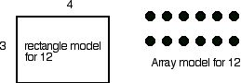

Activity #4
- Ask students to tell you a composite number between 50 and 100. Suppose the students say '56'. You make a prime factor tree of the number (see examples for two possibilities). Ask students to describe what you did. Discuss their responses. Ensure that students begin to realize what a prime factor tree is (you keep finding a prime factor for a branch until you cannot do it anymore, then that branch ends).
- Present students with the numbers 40, 72, and 85. Ask them to make two different prime factor tress for each number. Discuss the results.
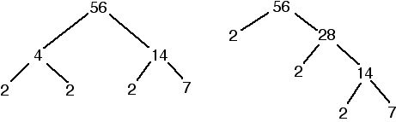
Note:
There are different styles for showing a factor tree. The two trees for 56 above are one style where each prime factor is written only once. When a prime is reached, the branch ends with no repetition of writing the prime down that branch.
Another style is to repeat write a prime factor until all branches end (see example on right). This style is laborious for students because they have to keep writing the factor(s) to match what happens elsewhere. It also results in a visually cluttered tree that can confuse students. We recommend the shorter style for showing a factor tree.
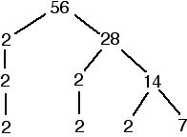

Activity #5
- Show students a non-symmetrical tree for 60 (see diagram). Ask them to make a prime factor symmetrical tree for 60, in the sense of the number of branches being balanced (see diagram). Provide three other numbers between 50 and 100. Ask students to make a non-symmetrical tree for each number and a symmetrical tree, if possible.
- Ask students to make a prime factor tree for the numbers 17 and 31. Discuss the results (e.g. for 17, only two branches that end at 1 and 17). Ask what type of numbers 17 and 31 are (primes). Discuss the matter of factor trees for primes.
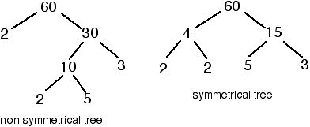
Activity #6
- Show students a skip counting list for 2s (2, 4, 6, 8, . . .up to 20). Ask them to extend the list for three more numbers. Ask them if 2 is a factor of each number on the list. Discuss why. Introduce the term 'multiple' for the numbers on the skip counting list (e.g. 4 is a multiple of 2, 10 is a multiple of 2).
- Show students a skip counting list for 3s (3, 6, 9, . . .up to 24). Ask them to extend the list for three more numbers. Ask them if 3 is a factor of each number on the list. Discuss why. Ask if each number on the list is a multiple of 3. Ask students to define the term 'multiple'. Discuss their definitions.
- Ask students if '0' is on a skip counting list for 2? for 3? for 4? (and so on) Discuss the matter. Ensure students realize that 0 belongs an any skip counting list. It can be seen as the start of the list (for the positive number side of a skip counting list).
Activity #7
Ask students to list five multiples of 5, 6, and 10. Discuss the results.
Activity #8
Revisit one of the array/rectangle models for factors, for example the model showing 2 x 6 is 12 (activity #3). Ask students which numbers are factors and which is a multiple. Ensure they realize the sides of the array/rectangle are the factors and the total count of dots/area of rectangle is the multiple.[ In the case of 2 x 6 is 12, 2 and 6 are factors of 12 while 12 is a multiple of 2 and a multiple of 6.] Repeat for a different array/rectangle model.
Activity #9
Present students with problems such as the example below. Have students solve the problems any way they want. Drawing diagrams or making skip counting lists can be helpful (see sample solutions). Discuss their solution strategies in terms of multiples and factors (e.g. the solution '6' is the first common multiple of the factors 2 and 3).
Mary works every second day at 7-11. Joe works at 7-11 every third day. Today they are both working there. In how many days will they work together again at 7-11?
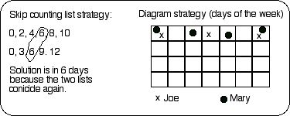
Activity #10 (assessment of teaching)
- Ask students to list three factors of 40. Ask them to explain what a factor is.
- Ask students to list five multiples of 4. Ask them to explain what a multiple is.

The MAINTENANCE stage of teaching
Rich Learning Task #1 (integrated with equivalent fractions, multiples, factors, and divisibility)
Ask students to invent a method for determining a fraction that is equivalent to another fraction by reducing it so that the smallest numbers possible form the fraction (e.g. 45/60 is equivalent to 3/4, where 3 and 4 are the smallest numbers possible). Suggest that prime factorization might be very useful for the method (e.g. 45 is 3 x 3 x 5 and 60 is 2 x 2 x 3 x 5).
Rich Learning Task #2 (integrated with divisibility, multiples, and factors)
Ask students to design a 5 x 5 game board for the Factors Finding Game. Have students play the game using their game board.
Rich Learning Task #3 (integrated with factors and patterns)
Have students investigate which of the following numbers can be the start of a perfectly symmetrical prime factor tree ('perfectly symmetrical' means that the branches are balanced on each side AND the prime factors are identical on each side). The numbers are: 24, 36, 49, 63, 64, 81, 90, 100, 110, 121, 144, 150. Have students come to a conclusion about what kind of numbers can be the start of a perfectly symmetrical prime factor tree (this involves finding a pattern).
Note:
Students should conclude that only numbers that are the result of multiplying two identical factors (perfect squares, using more sophisticated terminology) can be the start of a perfectly symmetrical prime factor trees (for the above list of numbers: 36, 49, 64, 81, 11, 121, 144).

