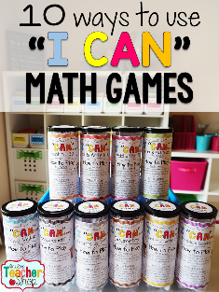

Math Activity One Pager Station Sheet Instructions

U-know / “I can”
(Title of the Activity/Game)

Grade Level : 7, but can be adapted for all ages
Topic/Math Concept Multiple topics and concepts are covered depending on the set.

Outcome(s) Ex: Many outcomes and can be modified!

Materials Required: U-know – just the cards and answer sheet (if necessary) / “I can” – questions cards, recording sheets and answer sheets

Instructions Each game comes with its own instructions. U-know is like the card game Uno. “I can” you answer as many questions as you can.

I love this because ex: It’s a new way to practice math that doesn’t involve the traditional pencil and paper work. It also encourages teamwork and a little competitive spirit. This is a great activity to offer early finishers, as well as great stations for math centers or for split classes for instruction.

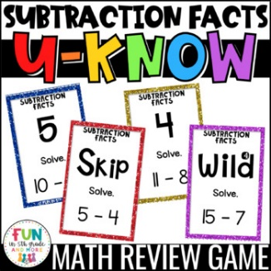

Source Teachers Pay Teachers Resource

Contributor and Email Christine Richardson, St. Michael’s School
christine.richardson@cttcs.ca

