Outcome SS1.4 Compare 2-D shapes to parts of 3-D objects in the environment.
Task 1: Ask the student to match a part of a 3-D object that is similar to a 2-D shape.
1. Draw a line from the object to a shape you see in the object.
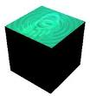

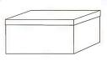

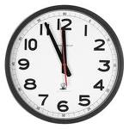

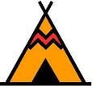

2. Name the shapes you see in each object.
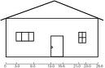
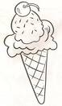
______________________________ _____________________________

______________________________ _____________________________

______________________________ ______________________________

Assess SS1.4a – Is the student able to identify shapes within a 3-D object?

Mathematics Rubric
Student Name | Date
Outcome SS1.4 Compare 2-D shapes to parts of 3-D objects in the environment.

1 | 2 | 3 | 4
Limited progress  Yet to show basic understanding, yet to show beginning performance | Progressing to the standard  Basic understanding, beginning performance | Meeting the Standards  Solid understanding, skilled performance | Advanced application  Advanced understanding, application of learning to new situations
 |  | SS1.4a | SS1.4a
With assistance, the student is sometimes able to:  -compare 2-D shapes to parts of 3-D objects in the environment.  - identify two out of a possible three, 2-D shapes within a 3-D object. | With limited assistance, the student is usually able to:  -compare 2-D shapes to parts of 3-D objects in the environment.  - identify two out of a possible three, 2-D shapes within a 3-D object. | Without teacher assistance, the child is able to:  -compare 2-D shapes to parts of 3-D objects in the environment.  -identify two out of a possible three, 2-D shapes within a 3-D object. | Without teacher assistance, the child is able to:  - compare 2-D shapes to parts of 3-D objects in the environment.  - identify three out of a possible three, 2-D shapes within a 3-D object.
With help, I can find 2-D shapes when I look at 3-D objects. | With a little bit of help, I can usually find 2-D shapes when I look at 3-D objects. | I can find 2-D shapes when I look at 3-D objects all by myself. | I can always see 2-D shapes in a 3-D object by myself.

