Array Array!

Walk to each picture in the hallway. You will see an array of objects. Record the multiplication division fact family that you see. Bring your triangle board to your supervisor to check and erase before going to your next picture.

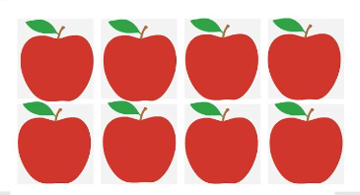
Picture:

You write:

