Skip Counting and Number Charts
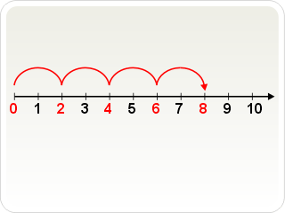

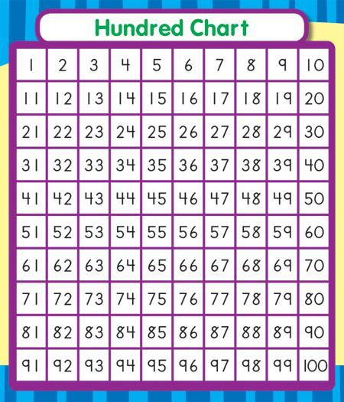

Why Skip Count?
Skip counting is sometimes viewed as an arbitrary math skill or something you recite on the playground; however, skip counting is so much more. It helps students see patterns in numbers as well as lays a great foundation for number sense and learning the multiplication facts. Skip counting is important in the development of fluency in calculation, number sense and as the basis of multiplication and division. It is also important to help students move from calculating by counting by ones to using number facts. For example, instead of working out 12 + 4 by counting 12, 13, 14, 15, 16, students can immediately add 4, or possibly add 2 twice. This transition to using fluent number facts is a key to success throughout school. As skip counting aids students in seeing patterns in our place value system it is a critical step in later working with money which is a critical, life-long skill.
Why Use Number Charts?
A number chart is a critical tool in the development of place value concepts and deserves special attention in our classrooms. A number chart is a rich representation for exploring number relationships. While the number line helps with the concept of sequencing, and base-10 blocks reinforce place value, the hundred chart combines these skills on a grander scale. Students see number lines, organized in groups of 10. They also observe patterns of tens and ones both horizontally and vertically. Those who internalize these patterns gain a distinct advantage in learning more advanced skills. Research shows that using multiple representations of an idea is a powerful approach to promote deeper mathematical thinking and conceptual understanding for your students.
Skip Counting Activities
Hands On Skip Counting (N1.1, N1.4, N2.1, AP-DV.8, N3.1, P3.1, 3N.1)
Use a tape measure and clothespins to visually skip count. Skip count beginning at any number. Decide by what increment you will skip count by and use clothespins to mark those spots on a tape measure. Smoothing the number line and pinching the clothespins helps the brain remember the number.
Skip Counting Movement Activities (PK.1, N1.1, N2.1, AP-DV.8, N3.1, 3N.1)
Mixing physical movement with skip counting is perfect for those kinesthetic learners. Design a hopscotch grid (like the one below) or ask students to put a movement to each count they make. For example, let’s count by 2’s, starting at 5. Each time we count we will (jump, clap, punch it out, march, snap, blink, nod, etc.)
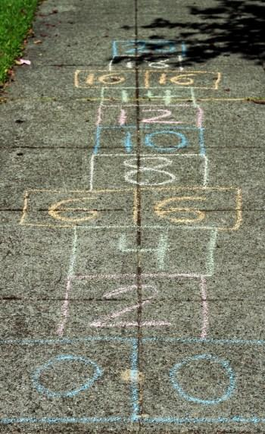

Skip Counting Connections (N1.1, N2.1, AP-DV.8, N3.1, 3N.1)
It is important for students to understand the criticalness of being able to skip count. While teaching skip counting, create an anchor chart together highlighting the importance of skip counting. Have the students help by coloring in what this looks like on the 100 chart (or numbers 800-900) and gluing in the appropriate category.
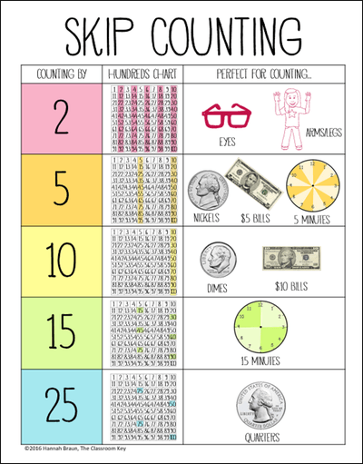
Money Skip Counting (N2.1, N3.1, P3.1, 3N.1)
For this activity, use counts that are used when counting money (coins or bills). Explain to students that they will start skip counting by one number, and at your signal they will shift to a count by a different number. Use any two of these numbers: 100, 50, 25, 10, 1. Always start the skip count with the larger number. For example, write the numbers 25 and 10 on the board. Point to the larger number (25), and have students begin to skip count. After three or more counts, raise your hand to indicate a pause in the counting from where they left off but now count by tens. Later, try three numbers in descending order. Some students may need to use a hundreds chart to help them with their skip counts.

Skip Counting Race (N1.1, N2.1, AP-DV.8, N3.1, P3.1, 3N.1, N4.3, 4N.5)
There are four versions of this game. Each version involves skip counting by a different unit: 2, 3, 4, or 5. To create the required special die, write on the stickers, then place them on a standard die or cube. The goal of the game is to be the first player to get to the end of the track.
To begin, players decide together whether they will be skip counting by 2s, 3s, 4s, or 5s. The number chosen is used by all players in a group. You may decide to let each group choose their own number, or you may choose to assign a number to each group. The instructions that follow are written for a game where the skip-counting unit is 3.
Player 1 rolls the die. The number rolled indicates how many times the player must skip-count by 3s. For example, if Player 1 rolls a 2, he must skip-count by 3s two times (3, 6), moving his game piece to 6. Alternatively, he may count rhythmically by ones, emphasizing every third number (1, 2, 3, 4, 5, 6). Play passes to the next player.
If a player lands on a square occupied by any other player, the other player must go back 3 squares (or whatever the skip-counting unit is for the game).
The first player to reach the end of the track (60) wins.
For children who are struggling with skip-counting, it may be beneficial to have them colour a separate game board so they see the end of each skip.

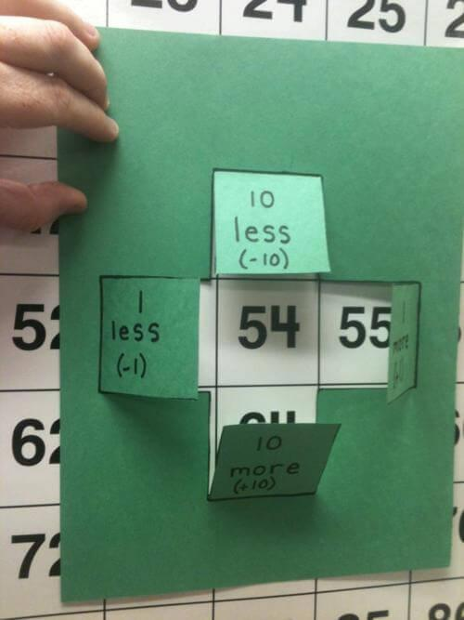
Number Chart Activities
10 More, 10 Less, 1 More, 1 Less (N1.8,E-DV.7, N2.1, AP-DV.8, AP-GV.8, N3.1, 3N.1,P4.1, 4RR.1)
Make the following cross to show students the relationships between the numbers on the hundred chart and the boxes touching it.
Number Chart Puzzles ( 2 ways) (N1.1, N2.1, N3.1, E-DV.7, AP-DV.8, 3N.1)
Each player (best done in pairs) gets a number cards that has been laminated. They fill in the blank squares on their card with a dry erase marker. Once they have filled in the card correctly they cover up a number on the hundreds chart (or whatever number chart they are using). The number they choose to cover up must be one of the numbers they wrote on their number puzzle. It may not be the number that was given to them on the card. Each person has a different coloured marker for the hundreds chart and fills in their square with the object of the game being colouring in 5 squares in a row to win!
In a second version of the game, students are given chunks of the 100 chart with many of the numbers missing. Without using the hundred chart, students are asked to fill in the missing numbers. After completing they use the hundred chart to help check their work.
Bump (N1.1, N2.1, N3.1, AP-DV.8, 3N.1)
Materials: Game board, 2 dice and transparent chips/markers
Directions: Students take turns rolling the dice to determine how many times they must skip count by 5, 10 or 100. Skip count that many times, starting from 0 and place a chip on the answer. If your partner is on a square with that number you can PICK them off and place your chip down. If you roll a number that you already have covered, you may place another chip on it and lock it so your partner can’t bump you off. If you roll a number that is not available, your turn is over. Be the first to use all your chips to win the game.

Hundred Chart Battleship (N1.1, N2.1, N3.1, 3N.1)
Each player in this two person game gets a copy of a laminated 100 chart (or other number chart that students are working with. Grab two dry erase markers and several mosaic gems. You could play without the mosaic gems, but it is often helpful to have a 3D visual of the "ships." Place some sort of divider inbetween the two students. Each player claims a group of 2, 3, and 4 numbers, and the opponent either states "hit" or "miss." We found it helpful to make an x over the "misses" and either checked or circled the numbers that were "hit."
Hundred Chart Addition (N2.1, N2.2, N3.1, N3.2, N4.2, EG-V.8, APGV.8, 3N.1, 3N.2, 3RR.1, 4N.4)
Display a hundred chart (or thousands chart) for all children to see or, alternatively, give children their own individual charts. Children use the hundreds chart to add two numbers (e.g. 38 and 24). There are many ways that children can use the hundreds chart to add two numbers so class discussions are a must. Have children work on one sum at a time and then have a discussion to compare the different methods used.
Missing Numbers (NK.1, N1.1, N2.1, N3.1, P4.1, E-DV.7, AP-DV.8, 3N.1, 4RR.1)
Provide children with a hundreds chart on which some of the number cards have been removed or a classroom pocket chart. The children’s task is to replace the missing numbers in the chart. Beginning versions of this activity have only a random selection of individual numbers removed. Later, remove sequences of several numbers from three or four different rows. Finally, remove all but one or two rows or columns. Eventually, challenge children to replace all of the numbers in a blank chart.
The 1000’s Chart (N3.1, 3N.1, N4.1, 4RR.1)
Provide children with several sheets of the blank hundreds charts. Assign groups of three or four children the task of creating a 1-to-1000 chart. The chart is made by taping 10 blank hundreds charts together in a long strip. Children should decide how they are going to divide up the task of filling in the chart with different children working on different parts of the chart.
The thousands chart should be discussed as a class to examine how numbers change as you count from one hundred to the next, what the patterns are, and so on.
A “Mazing” 100 (N1.1, N1.8, N1.9, N2.1, N2.2, AP-DV.8, AP-GV.8, N3.1, N3.2, 3N.1, 3N.1, 3N.2, 3RR.1, N4.2, EDV.7, EGV.8 )
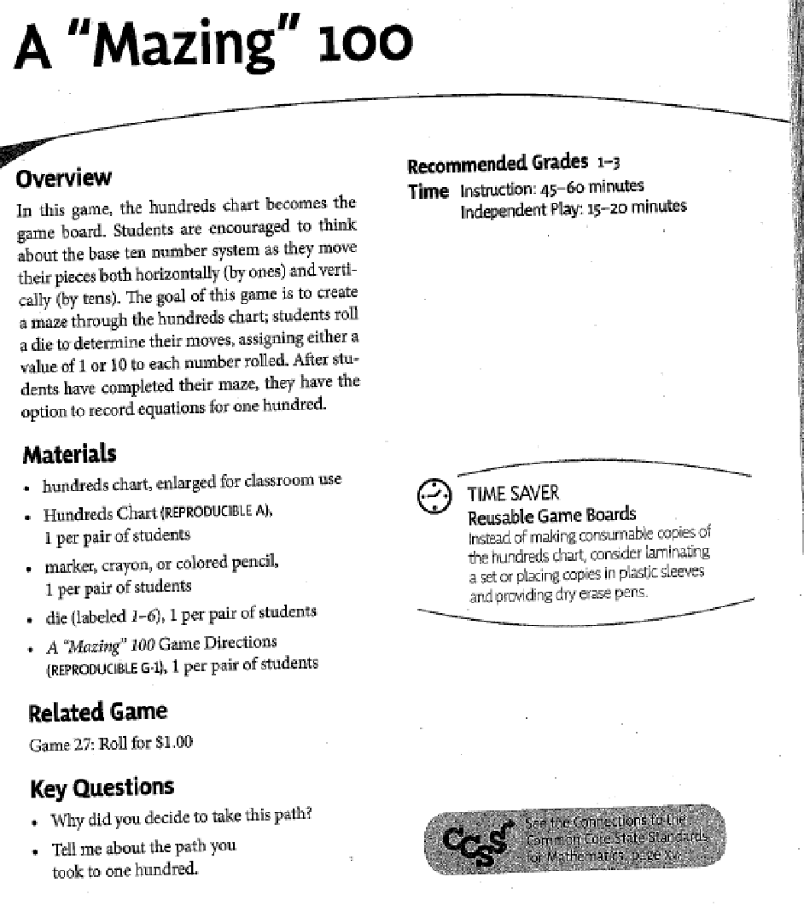
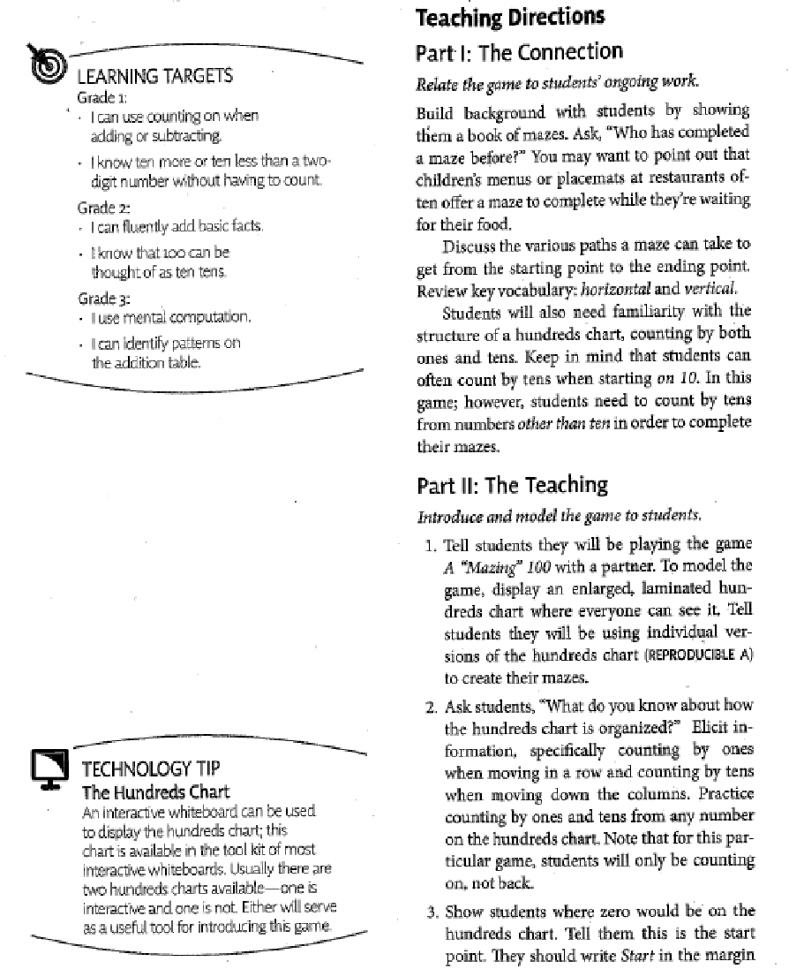
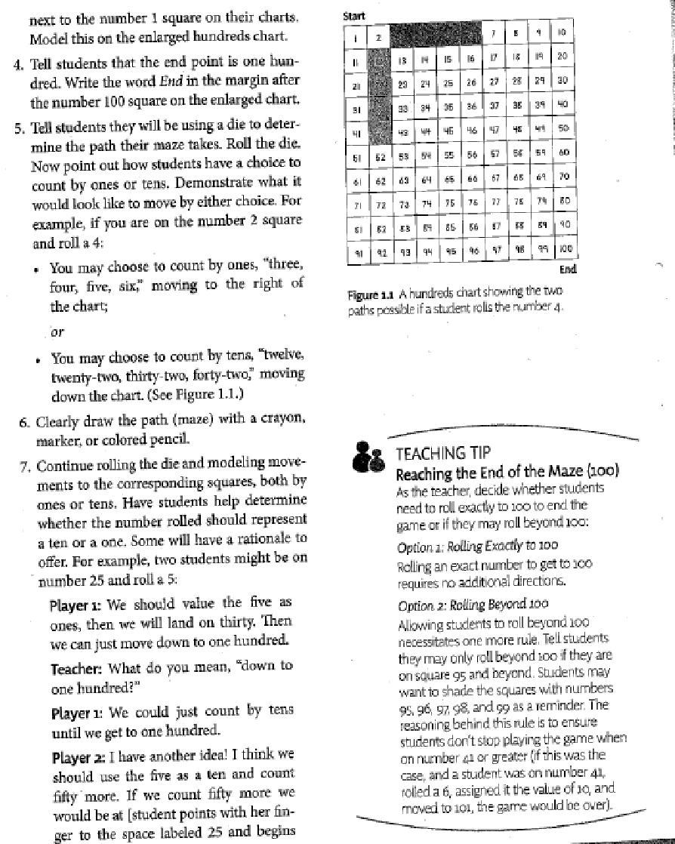
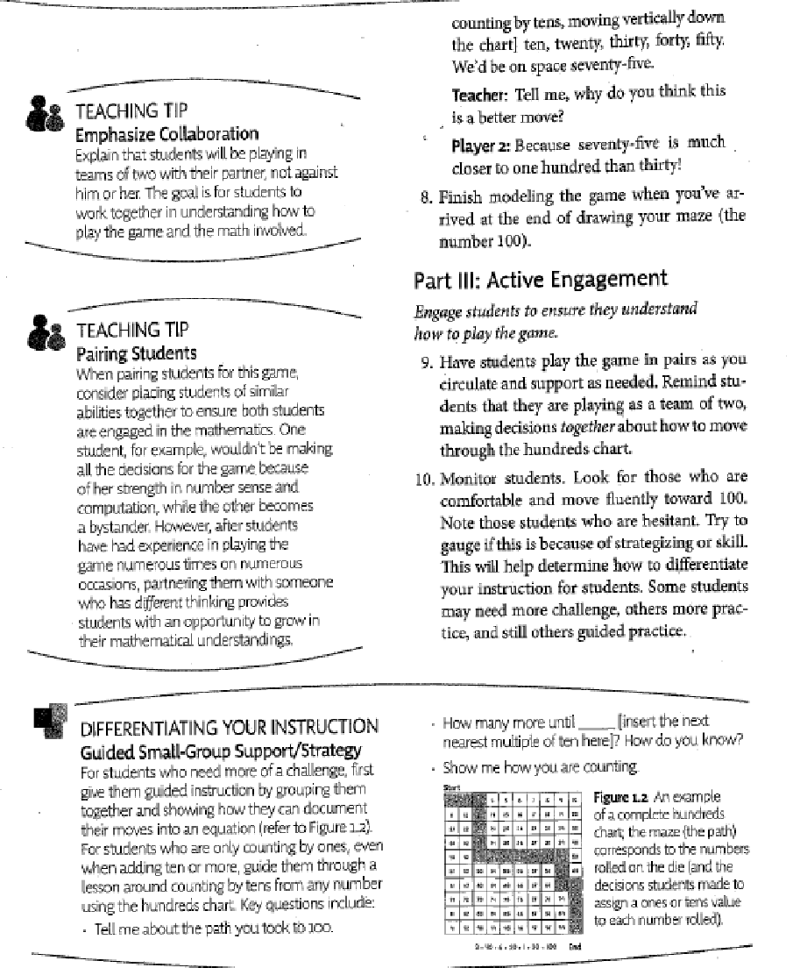

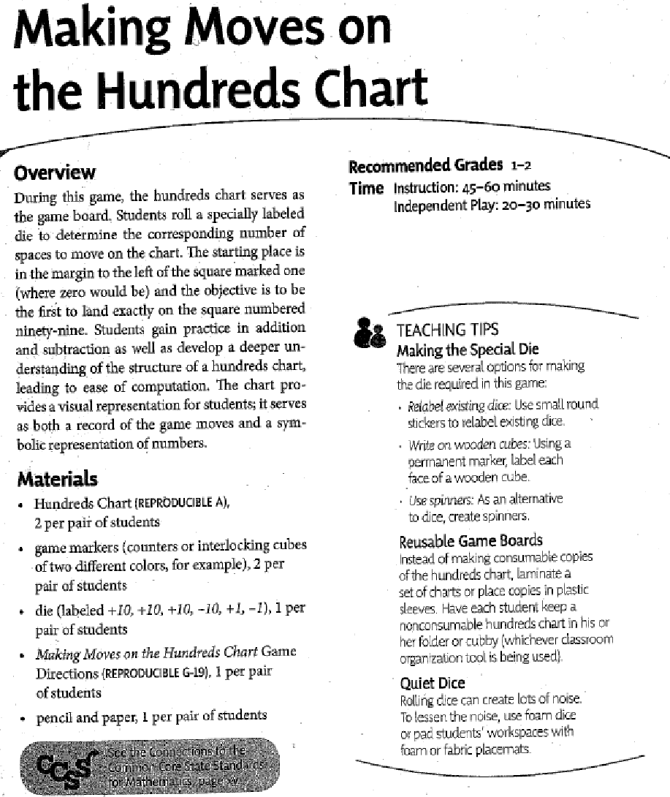
Making Moves on the 100 Chart (N1.1, N1.8, N1.9, N2.1, N2.2, AP-DV.8, AP-GV.8, N3.1, N3.2, 3N.1, 3N.2, 3RR.1, N4.2, EDV.7, EGV.8)

