Name:
- Draw a set that has the same number of squares.
=
same number

- Draw a set that has fewer triangles.
fewer

- Draw a set that has more circles.
more

- Draw sets of pencils, soccer balls and books that all have the same number.
books
soccer balls
pencils

=
=

- Cut and paste each dog beside a cat. Glue on any EXTRA animals. Describe how many cats compared to dogs using the words ‘more’ or ‘fewer’ or ‘as many’.
Glue here

Tell about the number of cats compared to the number of dogs.
____________________________________________________________________________________________________________________________________________________________________________

- Here is a set of five books.


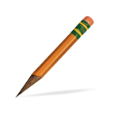
Compare the number of pencils to the number of books. Use the words more, fewer, or as many.

__________________________________
Compare the number of erasers to the number of books. Use the words more, fewer, or as many.

_____________________________________
- Sandy had 15 pumpkins in her garden. Bobby had 12 pumpkins in his garden. Compare the number of pumpkins that each person has using the words more, fewer or as many.
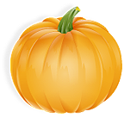
Bobby’s garden
Sandy’s garden

__________________________________________________________________
- Justin has 34 pennies in piggy bank. Phillip has 43 pennies in his piggy bank. Compare the number of pennies that each boy has using the words more, fewer or as many.
___________________________________________________________________________________________________

