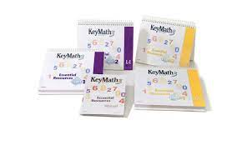


Key Math
Tier 3 Math Intervention
Christ the Teacher Catholic Schools

Prepared by
Cindy Smith, Instruction and Learning Consultant, Mathematics
2021

This document is intended as a framework for the use of Pearson’s Key Math-3 resource.

In Christ the Teacher Catholic Schools, this resource is designated as a Tier-3 intervention, although the Essential Resources (ER) may be useful as a part of Tier-2 small group interventions.

The Essential Resources are the critical component of Key Math. Use of the Diagnostic Assessment (DA) will do three things:
- Inform instruction by identifying specific gaps in foundational math concepts.
- Inform Inclusion and Intervention Plans(IIPs) and/or Individualized Education Plans (IAPs).
- Point to specific lessons and assessments in the Essential Resources.

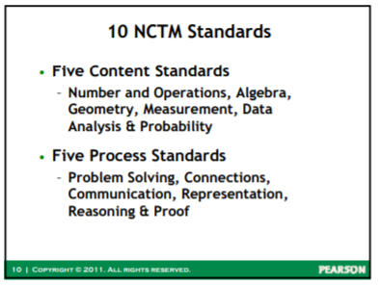

Key Math is a useful tool if it is used with fidelity. Student Services Support Teachers, Administrators, learning achievement coaches, and classroom teachers must ensure that this resource is used in the way it is intended. Effective intervention in mathematics requires robust instruction, using manipulatives, whiteboards, spaced practice, close monitoring, and student math talk for meaning making. While the printable worksheets attached to the lessons provide guided practice that could be supported by the teacher, educational assistant, or family, as well as individual practice and both formative and summative assessment, the worksheets must be only a supplemental learning tool in a targeted, rich and researched-based intervention program.

Reminder: When logging in to the Key Math software, the first password you enter is your regular log on password that you use to log in to your computer every day. The second screen is your key math classroom.

**Remember to LOG OUT not CLOSE the program when you’re done

- Administer the Key Math Diagnostic Assessment

There are 2 forms of this, A and B, which are parallel so that a follow-up assessment can be done using a different form. This is meant to illustrate growth over time. Follow-up assessments must be at least 3 months apart. A practitioner could use only one area of the assessment if the program is targeting one area.
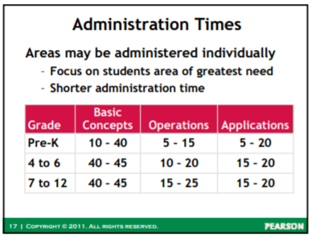
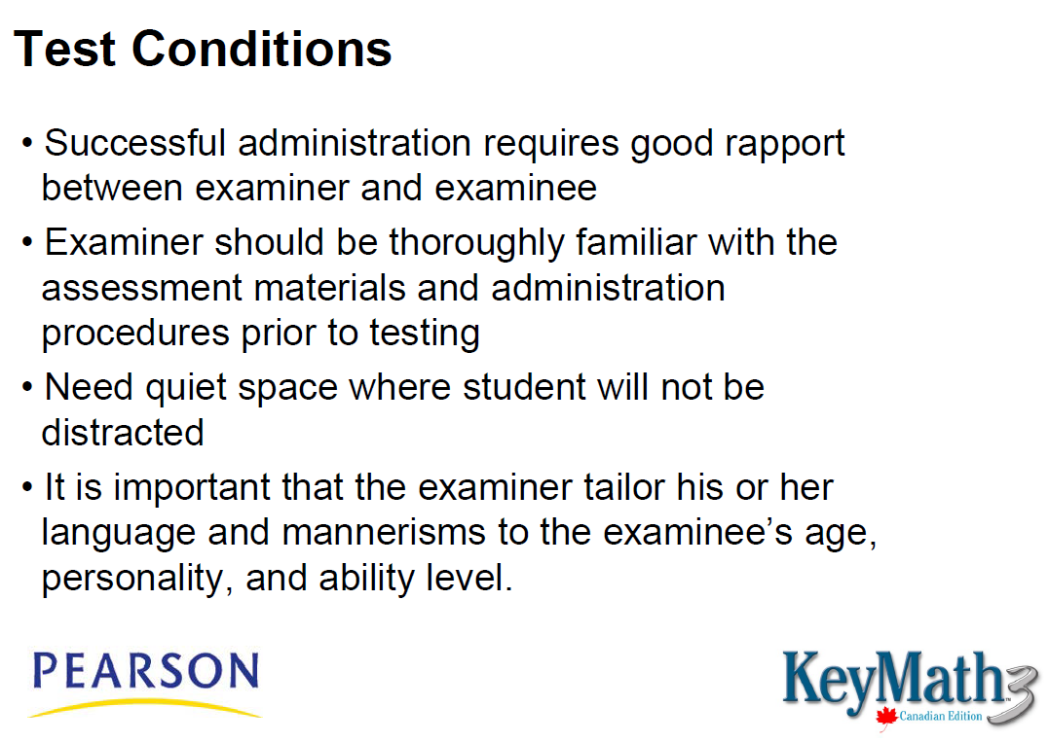
The assessment takes time
You may choose to only test one area

Note: Establish a basal and ceiling, and only administer test items based on the sequence directed by the basal and ceiling. For example, if a student scores below 6 in numeration, you would NOT administer the Addition and Subtraction Subtest. If the numeration ceiling is below 15 you would NOT administer the Multiplication and Division subtest. Consult the directions on the scoring sheet and the manual.
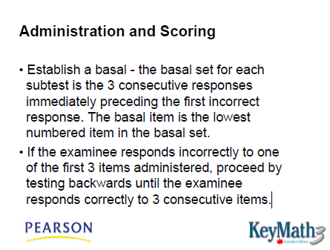
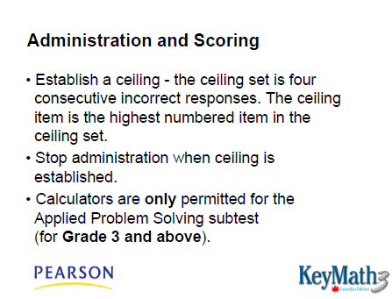

The manual gives instructions for scoring the assessment, or the right and wrong answers can be entered directly into ASSIST software, and the program scores the assessment.

Here’s a useful video on administering and scoring the assessment:
https://youtu.be/nd-_DTzwc-E

What is most beneficial from the scoring is the identification of gaps in learning that will be addressed in the intervention program. The program creates a targeted curriculum for each student, identified within the “Functional Range”. This is the area where the student is developing knowledge, and would be the content to teach and assess during intervention.
“Praise effort and engagement, not achievement”

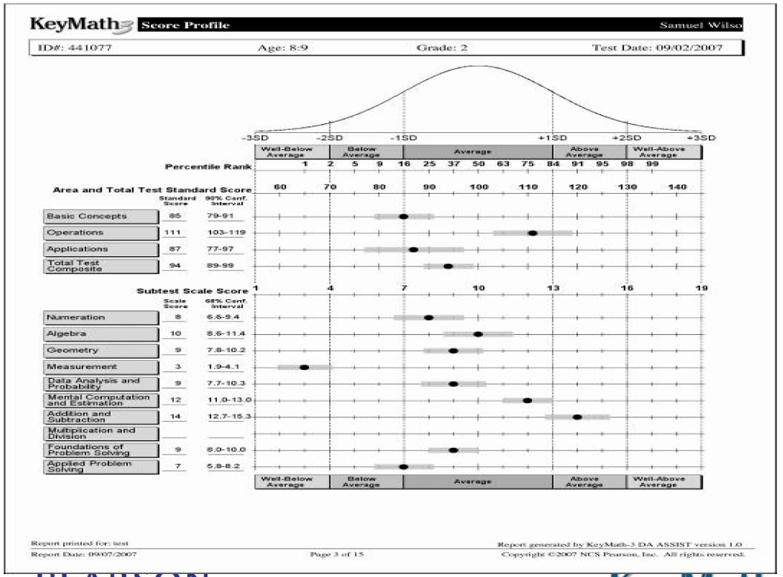
Do:
- Read questions as scripted. Encourage effort. Respond to correct and incorrect answers the same.
- Establish a basal and a ceiling, and follow the instructions in the manual and score sheet.
- Ensure the student cannot see what you enter in to the score sheet.
Don’t:
- Prompt the student unless scripted.
- Provide prolonged wait time (unless the student is documented as needing extended processing time).
- Give away disappointment or encouragement with facial expressions.
- Praise correct answers or reveal wrong answers.
- Teach.

A note about interpreting results:

The program will identify an age and/or grade equivalent, based on the student’s results. This does not mean the student is operating at that grade level, or should work specifically on outcomes at that grade level, nor should the student be labeled as working at that grade level. It simply means that in the statistically norming procedure of the assessment, the bulk of students scoring in a similar range were of that age/grade level.
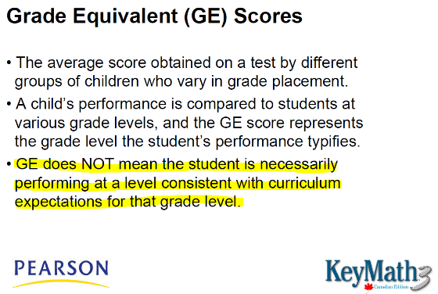
This measure should not be recorded as part of an IIP/IAP or reported to families and care givers, as it is frequently misunderstood as a specific cognitive delay, and will undermine a growth mindset which is necessary to move the student forward. It may also be misused to program for the student or adjust instruction to an inappropriately low level.

Instead, we should focus on the Functional Range, which shows where the student is developing their concept knowledge, and follow the software’s printed curriculum to create a program. (Refer to page 24 of the manual).

No staff should communicate test results to the student or family. Test scores reside with the Administrator, SSST and classroom teacher, and are considered confidential. While the report generated by the program contains information intended to be shared with parent/caregivers, this is only shared during a meeting with the SSST to ensure parents do not misinterpret statistical standing as a diagnosis. This test does not provide a “diagnosis” of anything. It simply points to gaps in understanding that need to be addressed to move the student forward in mathematics.

Do:
- Use the gaps identified by the Key Math Diagnostic to construct a curriculum and program for the student.
- Attend to the Functional Range.
- Ensure you address the areas in order as there are prerequisite learnings to consider.
- Communicate a growth mindset.
- Ensure the student that the test is not to judge their ability but to design a program.
Don’t:
- Jump to a certain concept because it aligns with the outcomes being addressed in the classroom.
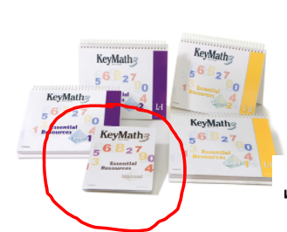
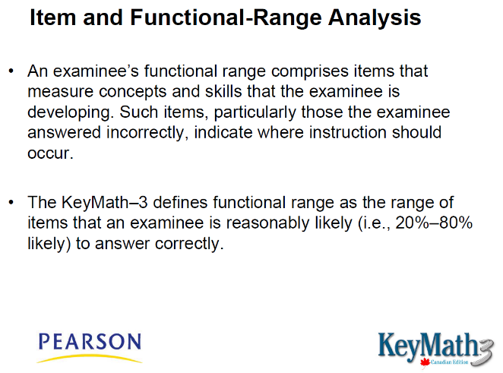
It is important to read the Key Math 3 Essential Resource manual, especially Chapters 3 and 4 which discuss how to use the ER to respond to the student’s assessment.

“In developing an appropriate instructional program (IEP), attention should be directed to items within an examinee’s functional range. Particular attention should be given to the items answered incorrectly, as such items will likely have the greatest instructional impact. Look for (a) relationships among these items that might represent an instructional unit and (b) identify the concepts and skills that establish foundation prerequisites for subsequent learning” (From Key math training webinar).

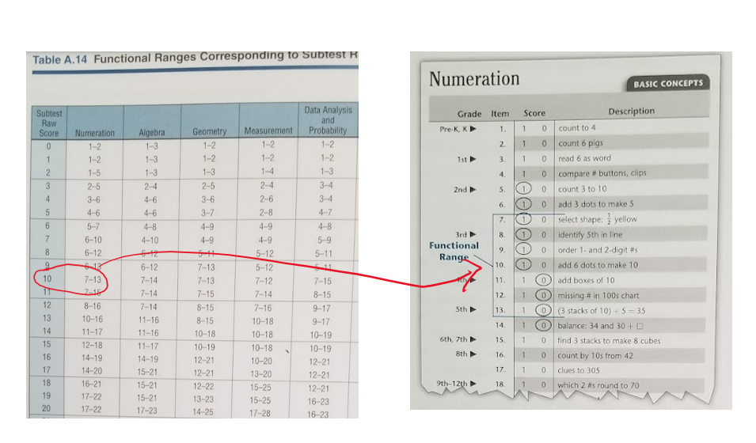
**This student would have had a raw score of 10 in Numeration, which converts to a functional range of 7 – 13, based on other measures of the test. The question items in 7 – 13 represent concepts at which this student’s understanding is emerging. Here is where we begin instruction.

- Using the Key Math Essential Resources
The curriculum for intervention will be outlined in the report generated by the ASSIST software, and will target concepts within the student’s functional range.

Based on this, create an instructional plan for the student.
Questions to consider: Will instruction be individual, or small group? Within the classroom, or in a separate room? How often (hopefully daily)? What will be taught? How often will you assess? How will you chart progress? How will you communicate progress? What is the goal for this student (can they be caught up to grade-level? Are we addressing goals in the IIP? Will we retest at a later date using the other form? How will the printed resources be used? Will you teach only what is designated by the assessment results, or will you be also teaching life skills math such as money, measurement, time, estimation, etc? Are you using a calculator and teaching the student to use it efficiently and reliably? How are you involving parents/caregivers? How are you directing EAs?

When making an instructional plan, pay attention to any concept clusters that the program lists as recommendations. These are likely items that the student got incorrect but were below their functional range, indicating a gap in understanding.

There are four teaching easels—two for Level I (K- Gr 2) and 2 for Level II (Gr 3 – 5). The curriculum generated for the student will identify exactly which lessons to teach. Note that the visuals in the easels are also provided as projectable PDFs within the software.

Guidelines for using the easels are found within the manual, but in general:

BEFORE
- Take time to become familiar with the material in the lesson.
- Use “cluster readiness test” as a pre-assessment to determine if the student has the prerequisite skills (students should have over 85 on the readiness test to be considered able to proceed.
- Gather material and equipment needed. Some lessons require manipulatives, dry erase board, and or transparent overlay so students can write on the easel.

BEGIN
- Display easel for student or small group.
- Use the script on the back, though is it only a guideline for teaching. It is not prescribed as it is in the diagnostic assessment. ( For young learners or struggling readers, instructions on printed materials are given verbally.)

TEACH
- Wherever possible, augment the instruction with activities, manipulatives, and rich instruction. Quality instruction leads learners along the concrete-representational-abstract (CRA) continuum.
- Have students communicate their thinking, reasoning, conjectures and understanding. We process math differently and construct meaning by communicating about our thinking. Students take more risks when using dry erase boards than using paper and pencil. Watching students work on a dry erase board provides an opportunity for specific, timely feedback and correction.
- Supplement the program with other resources, such as Math Makes sense, Leaps and Bounds, Mathletics and Mathletics ebooks, videos, and other quality instructional materials.
- Encourage and model a growth mindset, and help the student see progress.
- Provide formative assessment that creates flow to the lessons (tap and activate prior knowledge, recall), helps consolidate, (exit slips, self-reflection, small quizzes), and promote metacognition (self-assessment, reflection on learning, goal setting).

AFTER
- Provide spaced practice to enhance retention.
- Use the Lesson Summary at the end of each lesson, which may involve an activity or discussion point to reinforce the key concept of the lesson.
- If the student is supported by and EA, the EA should sit in on the lesson, and then support the student through the guided practice sheet.
- Decide how you will use other printed resources provided by the program. You can use them as independent practice, formative or summative assessments, or spaced practice. Students do not need to do every question on every sheet. Printed materials should only be used to help an EA guide practice, as assessment, and to augment rich instruction.
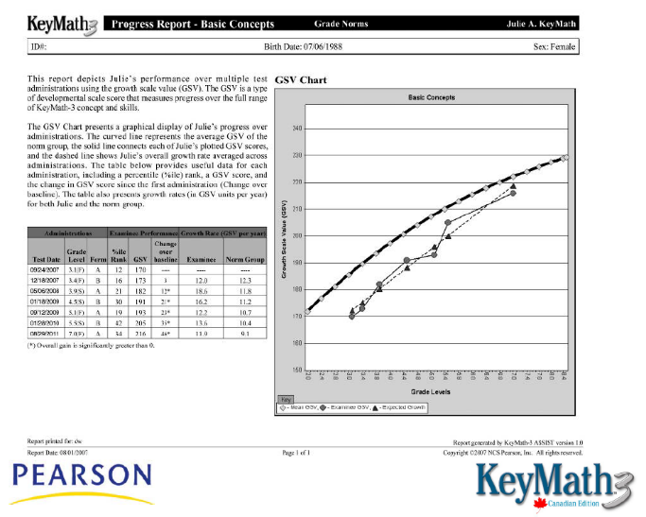
- Progress can be monitored by re-administering all or parts of the Key Math Diagnostic Assessment (parallel form), if desired. The program can generate a progress report and create a graph to show growth. This is not necessary to our programs in CTTCS, as we are well equipped to assess and report according to goals in a CTTCS IIP.

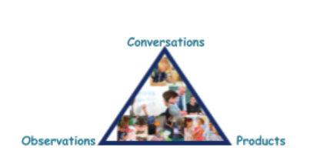

Image from SaskMath

Do:
- Create a program plan.
- Ensure instruction is robust, interactive, and draws out student communication as much as possible. Use all tools, whiteboards, transparent overlays, activities and dialog as directed by the teaching easels, as well as adding even more interactive components.
- Teach entire clusters.
- Embed formative assessments.
- Encourage and model a growth mindset.
- Monitor progress and help the family and student see growth.
- Embed spaced practice to support retention.
- Consider the goals of the student, and augment the Key Math program with math skills for life such as money and measurement.
- Have EAs partake in the lessons, and make use of EA time to support students through guided practice.

Don’t:
- Use the Key Math Diagnostic Assessment in isolation, without responding to it with an instructional plan.
- Print all the worksheets selected by the program and make a “workbook” for the student to work through.
- Skip the activities, suggestions for student dialog, opportunities for students to use the dry erase boards or transparent overlays or do kinesthetic activities, as suggested in the Essential Resource lessons.
Are we discouraging “worksheets”?
Independent practice certainly has its place, as does assessment based on “products”. But there is research that shows that teachers sometimes confuse “on task” behaviour with “learning behaviour”. Research also indicates that worksheets—while easy prep and keep students busy-- are not engaging, and can be considered “surface learning”. They do not create nearly the deep learning students experience through constructing meaning with manipulatives, engaging in conversation, and receiving specific, non-graded feedback. Furthermore, as assessment, they are a “product” and must be considered along with observations and conversations when we determine student growth.
Because the Key Math ASSIST software bulk-selects the worksheet items correlating to identified gaps, it is easier to print them all than individually select or deselect items. However, it is very easy to turn to these worksheets as a primary resource, rather than a supplementary resource meant as a part of a rich teaching program. Key Math is only effective if used with fidelity, to directly target learning gaps using good, researched-based pedagogy.

Response to Intervention (RTI) in Mathematics Christ the Teachers Catholic Schools
Key Math Diagnostic used to create learning plan, and Essential Resources may be part of instructional plan. Students benefit from concrete materials, dry erase boards and closely guided practice.

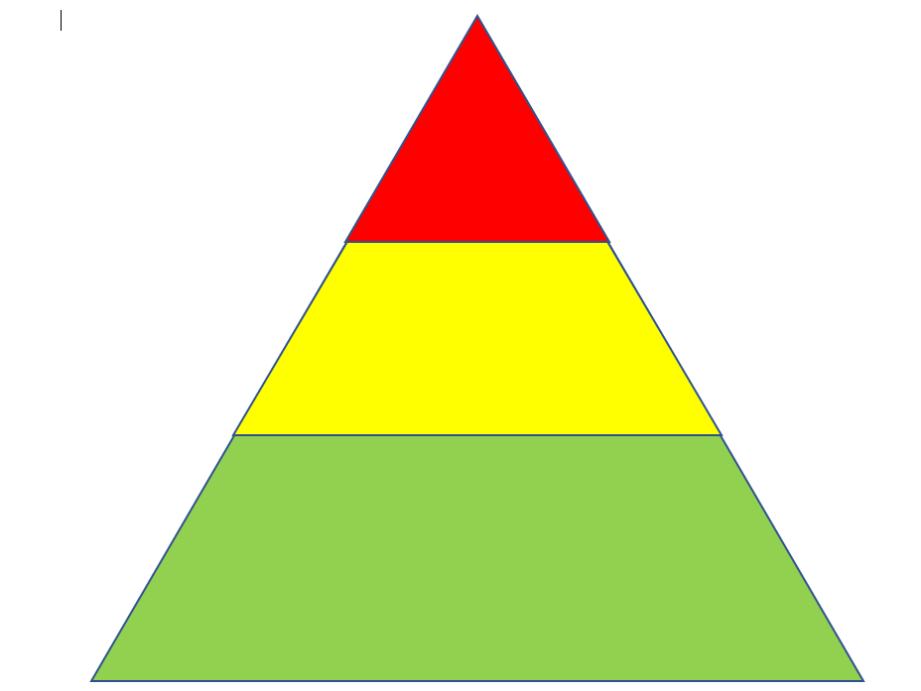

Tier
3
Intensive
Intervention.
Students with an IIP, LD, or other diagnosis. Grade level instruction will not benefit these learners.

Students may have adaptations, such as multiplication charts or other anchor tools, calculators, and technology

Struggling students benefit from fluency practice, and logical, sequential explicit instruction

Tier 2
Student falling behind grade level.
Identify gaps with screener. Respond
to gaps in small group within classroom, and possibly supplemental time outside of
class. Differentiate, scaffold, monitor. Goal is to help student achieve grade level learning. Students goal setting and growth mindset improve student success. Tier 2 instruction is embedded in Tier 1 classroom instruction, and movement between the two is fluid.

All math learners benefit from vocabulary instruction

Tier 1
Rich, differentiated classroom instruction. Teacher uses
research-based pedagogy, small group, student dialog, numeracy
routines, and triangulated assessment data. Teaching concepts follows
the concrete-representational-abstract (CRA) continuum, and there is spaced practice to enhance retention. Teacher provides scaffolding for struggling students and enrichment for high-achieving students. Frequent, student-centred formative assessments drive instructional planning. There is a variety of learning activities, and the teacher promotes and models a growth mindset with the acknowledgement that mistakes in math essential for learning. Focus is on learning, not grades. Students are involved in assessment and aware of the criteria for success.

Saskmath.ca
Cindy Smith, CTTCS

Intensive Interventions in Mathematics

The National Centre for Intensive Interventions (NCII) lists eight recommendations for establishing an intervention program in Mathematics.
11. Screen all students to identify those at risk for potential mathematics difficulties and provide interventions to students identified as at risk.
22. Instructional materials for students receiving interventions should focus intensely on in-depth treatment of whole numbers in kindergarten through grade 5 and on rational numbers in grades 4 through 8. These materials should be selected by committee.
33. Instruction during the intervention should be explicit and systematic. This includes providing models of proficient problem solving, verbalization of thought processes, guided practice, corrective feedback, and frequent cumulative review.
44. Interventions should include instruction on solving word problems that is based on common underlying structures.
55. Intervention materials should include opportunities for students to work with visual representations of mathematical ideas and interventionists should be proficient in the use of visual representations of mathematical ideas.
66. Interventions at all grade levels should devote about 10 minutes in each session to building fluent retrieval of basic arithmetic facts.
77. Monitor the progress of students receiving supplemental instruction and other students who are at risk.
88. Include motivational strategies in tier 2 and tier 3 interventions.
Taken from: Assisting Students Struggling with Mathematics: Response to Intervention (RtI) for Elementary and Middle Schools. (2009.) The Institute of Education Sciences, U.S Department of Education.

Key Math lessons are taught using teaching easel, manipulatives, and activities.
Lessons are taught by classroom teacher. EA sits in on lessons, supports guided practice.
Independent practice can be used as formative assessments. Summative assessments can be printed in the Assist software, essential resources.

Read More here
https://saskmath.ca/tiered-intervention-in-math/
https://intensiveintervention.org/
https://www.ldatschool.ca/evidence-based-interventions-for-math/
https://ies.ed.gov/ncee/wwc/practiceguide/2
https://www.edonline.sk.ca/webapps/blackboard/content/listContent.jsp?course_id=_3941_1&content_id=_128062_1&mode=reset

Sources
The Institute of Education Sciences, U.S Department of Education.
Assisting Students Struggling with Mathematics: Response to Intervention (RtI) for Elementary and Middle Schools. (2009.)
Connolly, A. (2008). Key math diagnostic assessment manual. Pearson, Canada. Toronto, ON
Connolly, A. (2008). Key math essential resources manual. Pearson, Canada. Toronto, ON
Charron, M. Clinical Assessment Training Webinar. www.pearsonclinical.ca
Hattie, J. (2017). Visible learning for mathematics, grades K-12: What works best to optimize student learning. Corwin. Thousand Oaks, CA
National Center on Intensive Intervention. (2016). Principles for designing intervention in mathematics. Washington, DC: Office of Special Education, U.S. Department of Education.
Overview of KeyMath-3 Gloria Maccow, Ph.D., Assessment Training Consultant http://images.pearsonclinical.com/images/pdf/keymath-3handout.pdf
SaskMath https://saskmath.ca/

Helpful videos

Here’s a useful video on administering and scoring the assessment:
https://youtu.be/nd-_DTzwc-E

https://youtu.be/pT8tRdxi8LE 19 minutes. Possibly too much prompting? And saying “good job” after correct answers….we have to praise effort and engagement, and be sure we don’t praise correct answers.

https://youtu.be/FIQcK2x5qKo In this video there is a problem. The administrator should set the easel upright, so the candidate sees only the side intended, and the score sheet should be completed behind the easel, out of view of the candidate.

https://youtu.be/m1Nd_WarTvs a mock up, but gives an idea
https://youtu.be/8fQIDGVgBX0 looks like what we would expect

