- Use these words to identify the 2-D shapes.
triangle rectangle
square circle
Name:

- __________

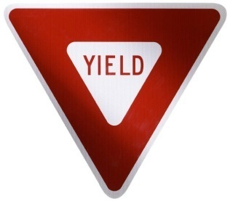
- __________

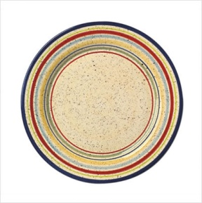
- __________

- __________

- Name two attributes of each given 2-D shape.

- ____________ ____________

- ____________ ____________

- ____________ ____________

- ____________ ____________

Which shapes are most similar? ______________________
______________________________________________
Explain your answer: ____________________________________________________________________________________________

