
Math Activity One Pager Station Sheet Instructions

Race to 100 (game)

Grade Level K-4
Topic/Math Concept Place value

Outcome(s) Ex: Place value outcomes (ex. N3.1)

Materials Required 2 dice, 2 place value tables, 2 plastic page protectors, 2 whiteboard markers
(foam dice to reduce noise)
(Pre teaching: how to draw base ten blocks, and trading)

Instructions 2-4 players
Players take turns rolling both dice and drawing their number on their place value table.
When you get 10 ones you “trade” them in for a ten.
When you get 10 tens “trade” them for a hundred.
The first player to get to 100 wins.

This game can easily be played to 1000 with more dice.
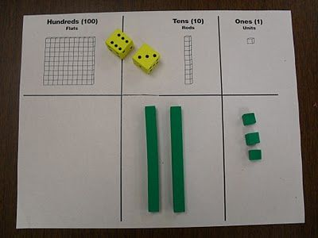

I love this because it helps reinforce understanding of place value and regrouping. It’s very easy to set up as the students already have all the materials at their desks.

Source: myself

Contributor and Email Carly Stein, St. Michael’s School, carly.stein@cttcs.ca

