
Christ the Teacher Grade 7 Screener G1 Name___KEY_______________

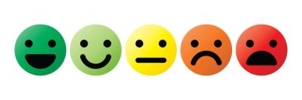
How do you feel about Math? Circle one.

Recall: We can represent a number several ways
Standard Form | Expanded form | Word form
86 458 | 80 000 + 6000 + 400 + 50 + 8 | Eighty-six thousand four hundred fifty-eight

- Write 301 982 in word form.
Three hundred one thousand nine hundred eighty-two
N 5.1 Representing Number
2) Write 40 000 + 3 000 + 700 + 60 + 2
in standard form. 43 762

N5.1 Representing Number
3) Write the number seven hundred fifty-six thousand nine hundred thirty-
seven in expanded form

700 000 + 50 000 + 6 000 + 900 + 30 + 7
N 5.1 Representing Number
4) Write the number three million two hundred thirty-nine thousand thirty-seven in standard form.  3 239 037 | 5) Write the value of the underlined digit.  62 421 384  Two million or 2 million  If the student writes 2 000 000 have them say the number and/or write it in words.
N6.1 Representing Number | N6.1 Place value

6)  Write the value of the underlined digit in words or fraction form.  81.375 seven hundredths or 7/100 | 7) Write a number greater than 4.1 and less than 4.2  4.11 or 4.15 or 4.1008 etc. The concept is that they can move to the next decimal place.
N6.1 Place Value Decimal | N5.1 Place value
8) Write the number 2.3 billion in standard form

2 300 000 000 This question is from the curriculum guide

N6.1 Place Value
9) Fill in the blanks to continue the counting pattern:

54 997 , 54 998 , 54 999 , 55 000, 55 001
N5.1 Representing Number, Place Value
10) Write the number that is represented by these base ten blocks in standard form.
Note:
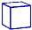 = 1 whole
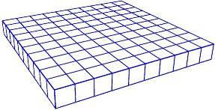
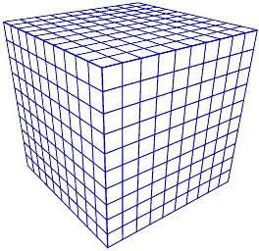
2 347
N 5.1 Representing Number
11) Order these numbers from least to greatest.
99 856
665 104
800 279
618 951

99 856 618 951 665 104 800 279

N 5.1 Place Value
12) Fill in the blanks (Continue the pattern)
8 452, 8 462, 8 472, 8 482, 8 492 8 502 8 512
N5.1 Place Value
13) Estimate the sum of the following. Show your strategy.
3 395 + 4 623 approx 8 000 (make sure students don’t write an = sign when they estimate. Correct this with a conversation) (If students calculate then round, mark it wrong and review estimation especially front-end estimation)

N5.4 Estimation
14) Add 15 341 + 13 201 = 28 542

N5.4 Add (no regrouping)
15) Add  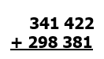  639 803 | 16) Subtract  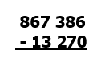  854 116 |  |  |  | 17) Subtract 1 524 696  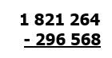
N5.4 Add (regrouping) | N5.4 Subtract (No regrouping) |  |  |  | N5.4 Subtract (regrouping)
18) Multiply.726  22 x 33 = | 19) Find the product.  45 x 1000 =  45 000 If a student needs an algorithm to calculate the product, we need to reteach multiplying by powers of ten |  |  |  |  | 20) Divide.  40 ÷ 8 = 5 We would expect a single character answer if students know their mult/div facts. If a student needs an algorithm to divide, we should work on fact fluency
N 5.2 Multiply 2 digit by 2 digit | N 5.2 Multiplying by factors of ten |  |  |  |  | N5.5 Division
21) Divide. Show your remainder. 145 r4  5 729 |  | 22) Divide.  245 ÷ 5 = 49 student can be prompted to use algorithm |  | 23) What is the greatest common factor of 48, 16 and 40? 8
N 5.3 Division 3 digit by 1 digit with remainder Strategy |  | N 5.3 Divide 3 digit by 1 digit no remainder |  | N6.2 Factors and Multiples
24) Estimate the product:  18 × 72 20x 70 = 1400  answers may vary slightly.  Students should not insert an = sign behind the question. You may prompt or remind them. If they calculate then round, reteach estimation |  |  | 25) Estimate the quotient:  198 ÷ 4 200 $÷4$ = 50
N 5.4 Estimate (Compensation) |  |  | N 5.4 Estimate (Front End Rounding)
26) What is the least common multiple of 3,4, and 6? 12 | 27) Circle all the prime numbers  10 15 17 5 21 29 11
N6.2 Factors and Multiples | N6.2 Factors and Multiples
28) Use any method you like to write all the prime factors of 36 | 29) Calculate  $$10÷2+3×\left(9-2\right)=$$
N6.2 Factors and Multiples | N 6.3 Order of Operations
30) Place these three fractions on the number line.

1
10
3
4
1
3
1
$$\frac{1}{2}$$
0
1
N 5.5 Fraction
31) Place these three fractions on the number line.
$\frac{7}{20}$ 1$\frac{1}{4}$ $\frac{15}{10}$ You can prompt students to approximate rather than create common denom
and calculate. We are looking for a sense of number

N 6.7 Fractions
32) Split this chocolate bar into fourths.  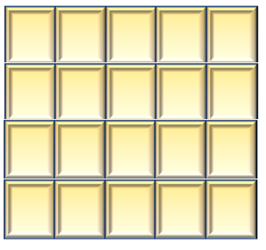 | 33) Insert either < , >, or = between these two fractions  2  5  5  9
N 5.5 Fraction | N 5.5 Fraction, compare
34) Change to a mixed number  $2\frac{2}{3}$ | 35) Write as an improper fraction (common fraction)  $\frac{17}{5}$ | 36) Write in lowest terms (reduce/simplify) $\frac{2}{3}$  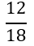
N6.7 Fractions | N6.7 Fractions | N6.7 Fractions
37) This thousandths grid represents one whole. Express the shaded part as a decimal.  0.892  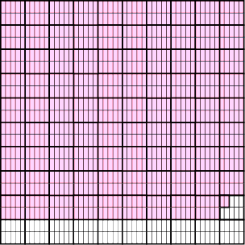 |  |  |  |  |  |  |  | 38) Add.  $366.298 + 53.74$ 420.038  Students can be prompted  to use the algorithm but it  will be interesting to see  how students approach this
N 5.6 Decimals to thousandths |  |  |  |  |  |  |  | N5.7 Decimals to thousandths, add (regrouping)
39) Place the decimal where it belongs in this product  $$16.324 ×3.15=51.4206$$  16 X 3 = 48 so about 51 |  |  |  |  |  |  | 40) Place the decimal where it belongs in this quotient  $$42.539 ÷5.15= 8.26$$  40 $÷$ 5 = 8
N 6.4Mult and Div of decimals |  |  |  |  |  |  | N 6.4Mult and Div of decimals
41)Find the product  $$0.89$$  $$×6$$  5.34 | 42)Divide (do not leave a remainder)  $24.025 ÷ 5 =$ 4.805  Students can be prompted to use the algorithm but it will be interesting to see what strategies they’ll use, like mult by 10 and then take half. |  |  |  |  |  |  |  |  | 43) Shade 18% of this hundred grid  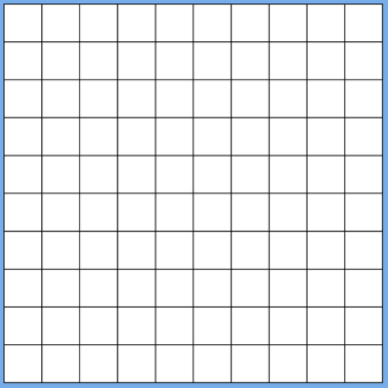
N 6.4Mult and Div of decimals | N 6.4Mult and Div of decimals |  |  |  |  |  |  |  | N 6.5 Percent
44) What percent of this shape is shaded? 20%  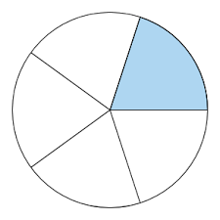 |  | 45) Express 35% as a fraction $\frac{35}{100}$ or $\frac{7}{20}$  We can accept the unreduced form |  |  |  |  |  |  | 46) Insert either < , >, or = between these two integers  -6 > -10
N 6.5 Percent |  | N 6.5 Percent |  |  |  |  |  |  | N6.6 Integers
47) Place these integers on the number line
+5 -5 +2 0 -4 +4

N6.6 Integers
48) What is the ratio of cars to trucks?  3:5  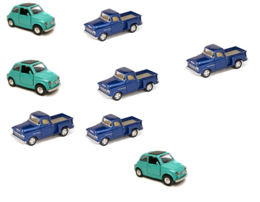 |  |  |  | 49) Write an equation with a variable for:  Five groups of a number is 30.  5n=30  For all equation questions, if students simply report an answer, like “6” or ‘the number is 6”, prompt them to write the equation. If they are unable then the item is incorrect
N6.8 Ratios |  |  |  | 5.2 Equations
50) Write an equation with a variable for 15 is 4 less than a number
15 = x-4 or x-4 = 15
5.2 Equations
51) Four friends each bought a package of game cards. All together they have 64 cards. Write an equation using the variable x to represent how many cards are in each package.  4 x=64 o r 4 x x = 64 |  |  |  |  |  |  |  |  | 52)  Write an equation with a variable for seven more than a number is 18.  x + 7 = 18 or 7 + x = 18
P5.2 Equations |  |  |  |  |  |  |  |  | P5.2 Equations
53) Solve for n.  $$n + 6= 14$$  n = 8 |  |  | 54) Solve for x:  $4 x = 24$ x = 6
P5.2 P6.2 Equations |  |  | P5.2 P6.2Equations
55) Write the rule with words or an equation y = 4 x -1
x y

1 | 3
2 | 7
3 | 11
4 | 15
5 | 19

P6.1 Tables and Graphs
Figure number | Number of Blocks
1 | 1
2 | 3
3 | 5
4 | 7
5 | 9
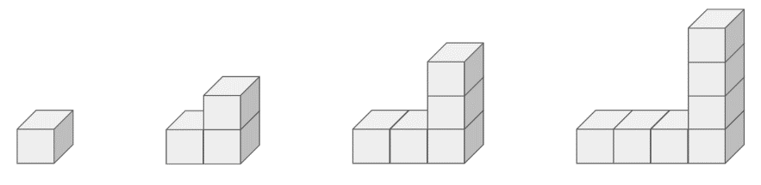
56) Create a table of values for this increasing pattern

Fig. 4
Fig. 3
Fig. 2
Fig. 1
P6.1 Tables and Graphs
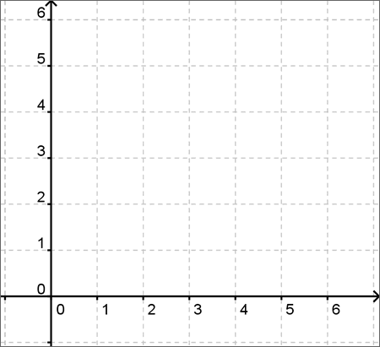  57) Plot the point (4,2) |  |  |  |  |  | 58) Create an input/output table  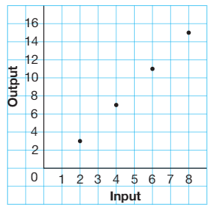
  Input | Output
  2 | 3
  4 | 7
  6 | 11
  8 | 15
P6.1 Tables and Graphs SS6.4 Cartesian Plane |  |  |  |  |  | P6.1 Tables and Graphs
59) Write an equation to represent the rule for this table. Use C for cost and n for number of guests. C = 20n
Number of Guests | Cost
1 | 20
2 | 40
3 | 60
5 | 100
n

N6.3 Patterns and Relations
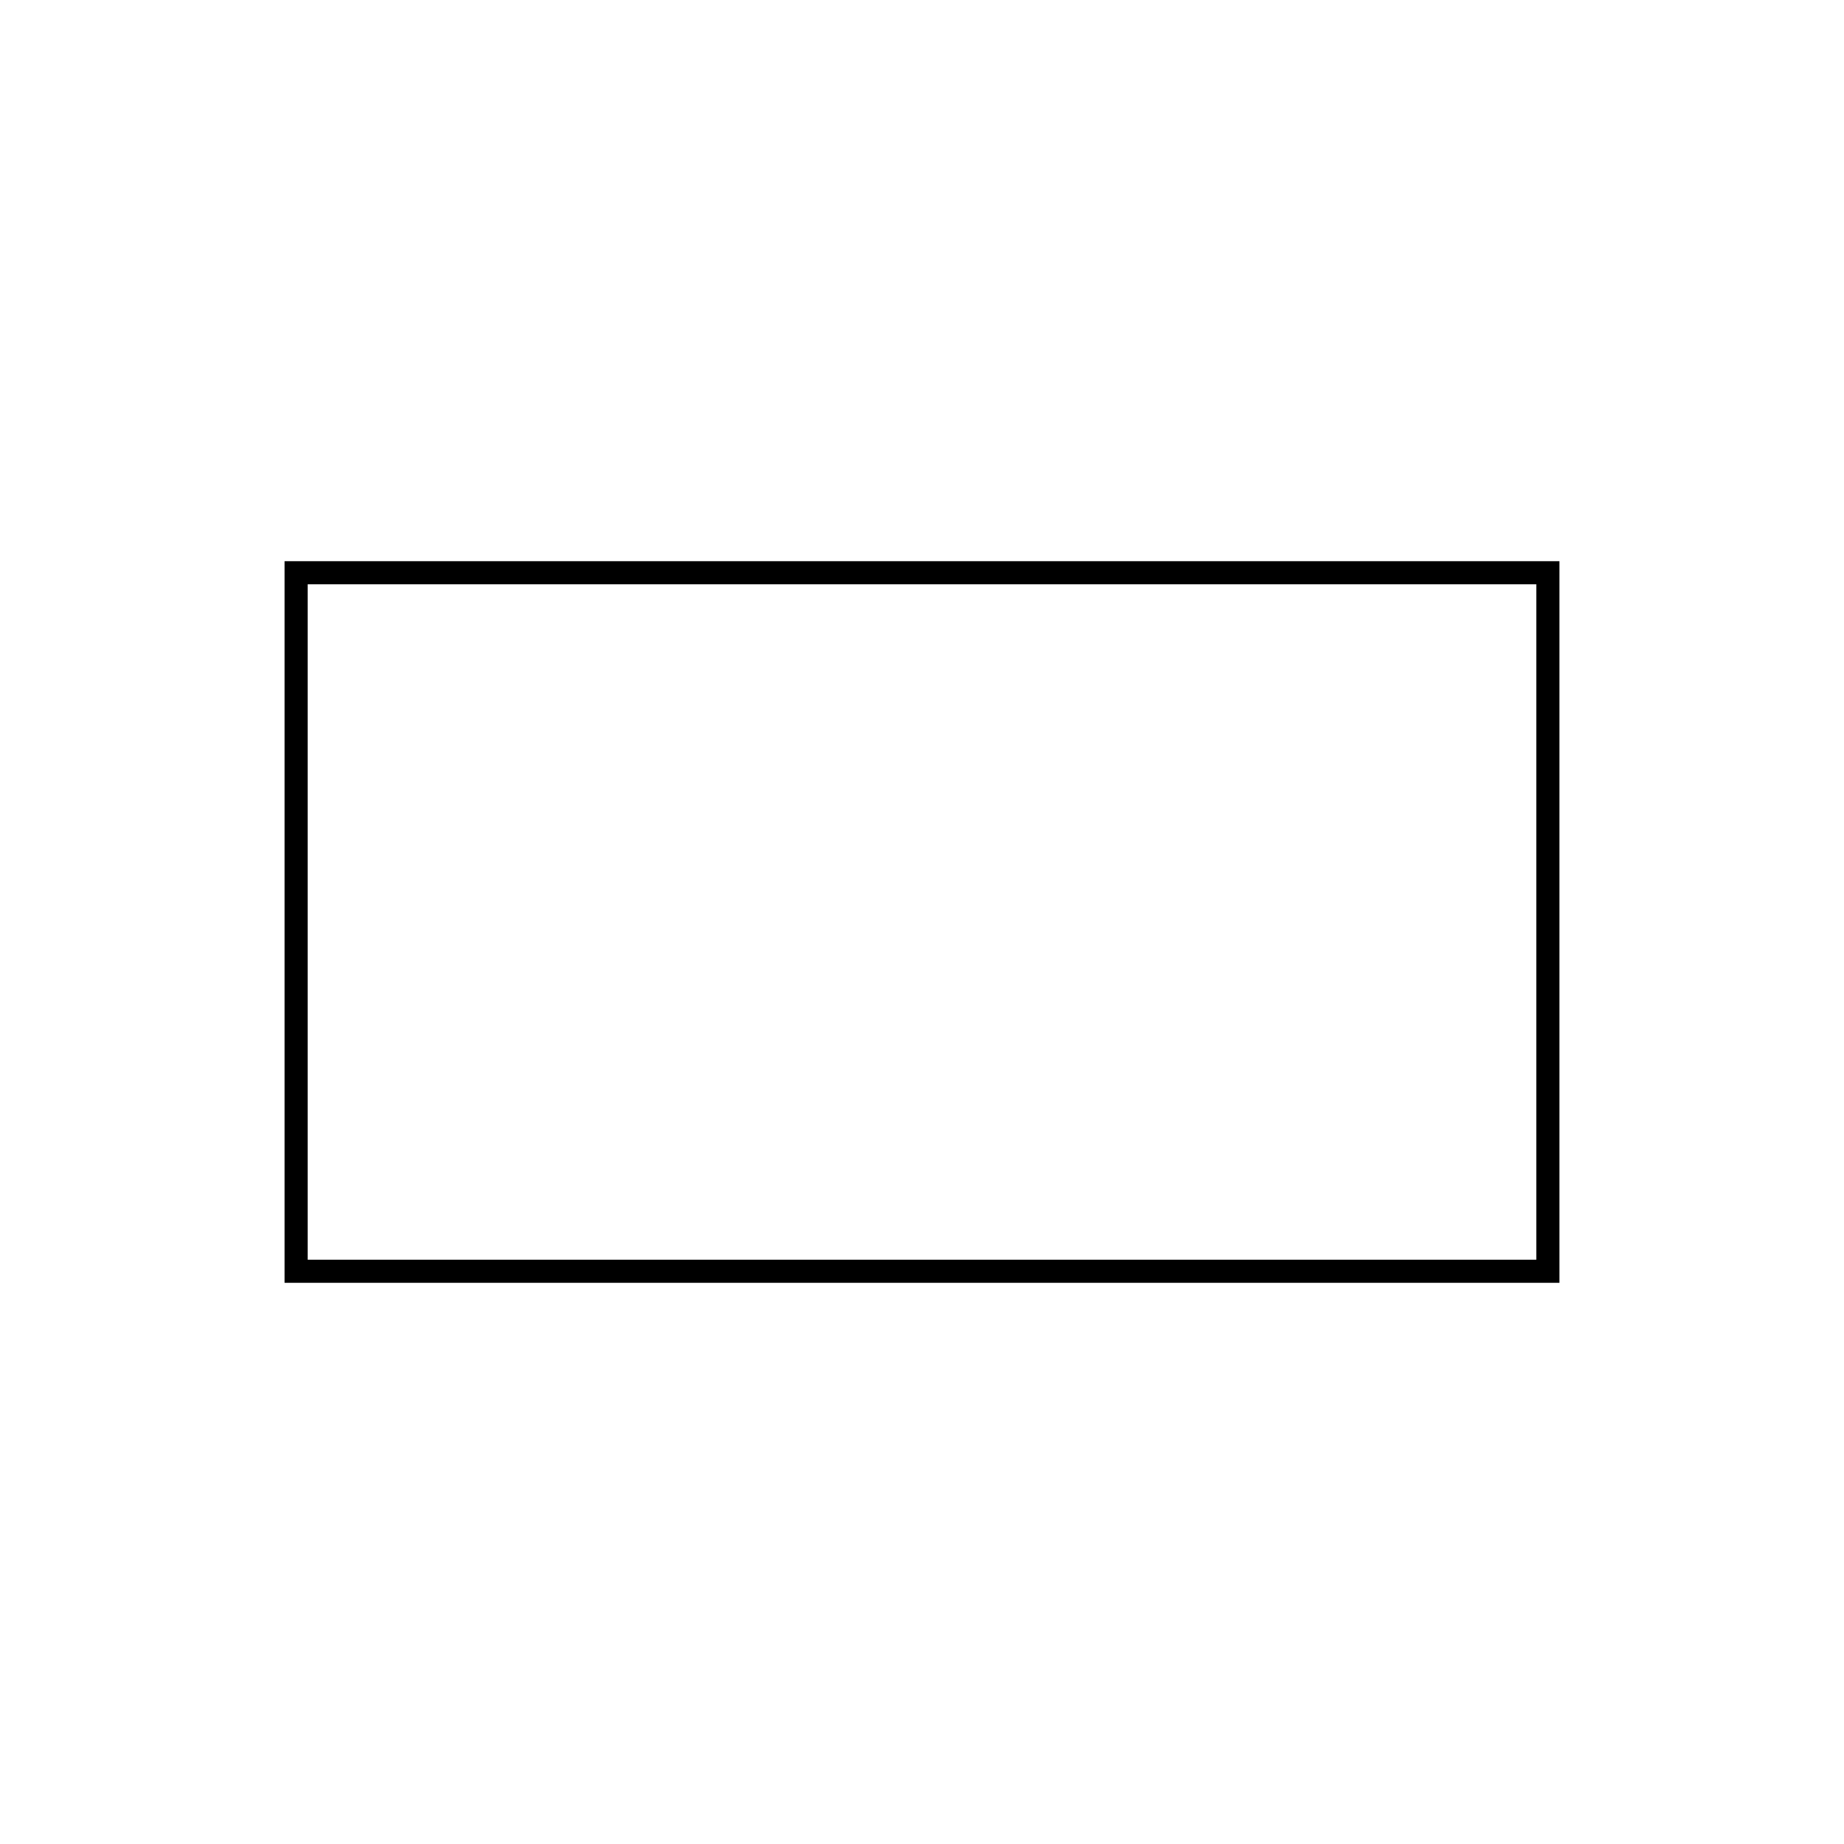  60) The area of this rectangle is 24m², what could the length and width be? |  |  |  |  | 61) Find the perimeter of the garden:  40m  12m  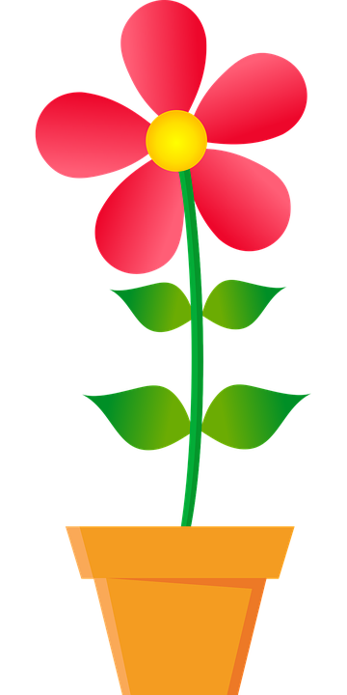  For SS questions, if students forget units, prompt them. If they skip exponents or write incorrect exponents, have a conversation and make a note to review this, but as long as the computation is correct, the item is correct. If students don’t remember how to find rectangular area or are unable to apply given formulas, then the item is incorrect  8m
SS5.1 Area (rectangle) |  |  |  |  | SS 5.1 Perimeter (rectangle)
62)Circle the angle that is about 45  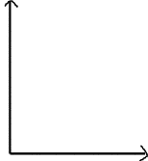  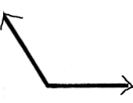  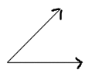 |  |  |  |  | 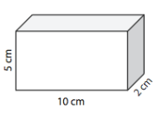  63) Find the volume 100 cm³
SS6.1 Angles |  |  |  |  | SS 6.2 Volume
64) How many people bought ice cream during the second week of August? 900  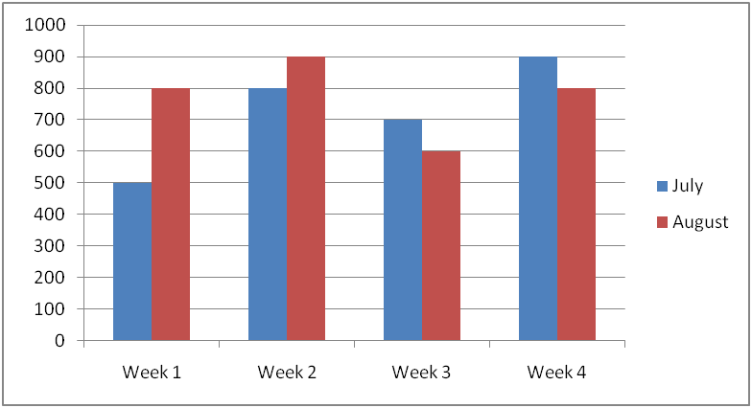  Ice cream sold in July and August |  |  |  |  | 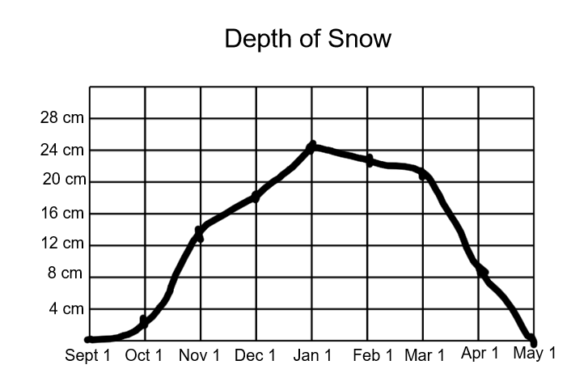  65) How deep was the snow on Dec 1? About 18 cm
SP5.2 Double Bar Graph |  |  |  |  | SP 6.1 Line graphs and data

How did you feel about this assessment? Circle one.

