FP10.6, FP10.7, FP10.8, and FP10.9 Pre-Assessment
Linear Relations and Functions (Chapter 5 and Chapter 6)
Multiple Choice: Identify the choice that best completes the statement or answers the questions.

_____1. Using the diagram given below, which one of the line segments is vertical?

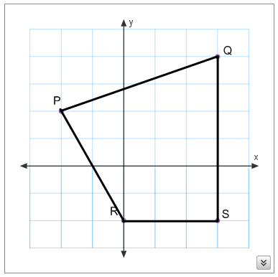

a. Line RS b. Line PQ c. Line QR d. Line QS

_____2. The pattern in this table continues. Determine an equation that relates the term value to the term number.
Term Number, s | 1 | 2 | 3 | 4 | 5
Term Value, w | 5 | 8 | 11 | 14 | 17

a. w = 2s + 2 b. w = 2s + 3 c. w = 3s + 2 d. w = 5s

_____3. Which graph(s) represent a linear relation?
a. | Q only | b. | P, R, and S | c. | P and S only | d. | Q and R only

_____4. Describe the relationship between the variables x and y in this graph.
The graph represents the following equation .

a. When x increases by 1, y decreases by 12
b. When x increases by 1, y decreases by 2
c. When x increases by 1, y increases by 2
d. When x increases by 2, y increases by 12

_____5. Which table of values represents a linear relation?

a.
x | 1 | 2 | 3 | 4 | 5
y | 4 | 7 | 12 | 19 | 28

b.
x | 0 | 1 | 2 | 3 | 4
y | 0 | 5 | 15 | 25 | 35

c.
x | 1 | 2 | 3 | 4 | 5
y | 5 | 9 | 13 | 17 | 21

x | 1 | 2 | 3 | 4 | 5
y | 2 | 4 | 8 | 16 | 32
d.

_____6. Complete the table of values for the linear relation y = 3x – 5.

a. b.

c. d.

_____7. This graph represents a linear relation. Determine the value of y when x = 5.

a. 8 b. 3 c. 2 d. 5

_____8. This graph represents a linear relation.
Determine the value of x when y = 7.

a. 1 b. -1 c. 8 d. 6

____9. Describe the graph of the equation $x+7=0.$

a. A vertical line that intersects the x-axis at 7 .

b. A horizontal line that intersects the y-axis at –7.

c. A vertical line that intersects the x-axis at –7.

d. A horizontal line that intersects the y-axis at 7.

_____10. Eric went to a pie-tasting festival. The festival charges an admission fee of $5.00, plus $2.00 for every slice of pie you eat. Which one of the following equations would be correct for this situation relating the total cost, C, to the number of slices of pie eaten, r?

a. C = 2r + 5 b. r = 2C + 5
c. C = 5r + 2 d. C = 7r
_____11. The ordered pair (5, ) is on the linear relation with equation y = -2x +8.
Find the missing number in the ordered pair.
a. 1 b. 11 c. -18 d. -2

_____12. Solve the following linear equation that is modeled as a balance scale.

a. x = -3 b. x = 3
c. x = 11 d. x = $\frac{11}{9}$

_____13. Solve the following equation $\frac{x}{7}- 3=5.$

a. 14

b. 56

c. 26

d. 1

_____14. The pattern in this table continues. Determine the expression that relates the number of triangles to the figure number.

Figure, f | 1 | 2 | 3 | 4 | 5
Number of Triangles, t | 2 | 4 | 6 | 8 | 10

a. | 2f | b. | 2 + t | c. | 2t | d. | 2 + f
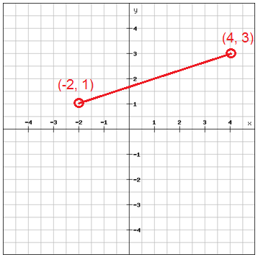
_____15. What would be the horizontal distance between the points (-2, 1) and (4, 3)?

a. 12 b. 8
c. 6 d. 2

_____16. Which points lie on the graph represented by the equation ?

P(1, 9), Q(2, 18), R(2, 4), S(0, 9)

a. P and Q b. Q and R c. R and S d. P and R
_____17. Using the diagram below, which one of the following pairs of lines is perpendicular?

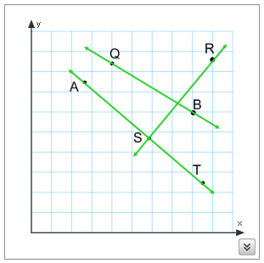

a. Lines RS and ST b. Lines RS and PQ
c. Lines ST and PQ d. Lines AB and RS
Short Answer: Show your work whenever possible.
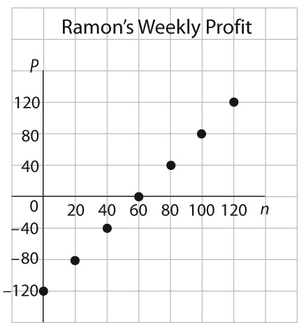
18. Ramon sells hot dogs at the park. Each week, he pays $120 for an operating license.
An equation for the relation is P = 2n – 120, where n represents the number of hot dogs Ramon sells, in one week, and P represents his weekly profit in dollars. The graph below represents this relation.

Weekly Profit
in Dollars

Number of Hot Dogs

a) Describe the relationship between the variables in the graph. ______________________
_________________________________________________________________________
_________________________________________________________________________
_________________________________________________________________________

b) Explain why the points in this graph are not connected. __________________________
_________________________________________________________________________
_________________________________________________________________________
c) How many hot dogs would Ramon have to sell in order to make a profit of $300.00?

19. Graph the following lines on the same grid.

i)
ii)
iii)

Answers
Multiple Choice:
1. d (SS5.5a)
2. c (P6.3f)
3. b (P9.1b)
4. b (P7.1i)
5. c (P8.1f)
6. b (P7.1f)
7. a (P9.1g)
8. d (P9.1e)
9. c (P0.1d)
10. a (P9.2c)
11. d (P8.1e)
12. b (P7.3c)
13. b (P9.2i)
14. a (P9.2b)
15. c (SS7.5d)
16. d (P9.2h)
17. a (SS7.3b)
Short Answer:
18. a) (P8.1a) Answers may vary. For an answer to be considered correct it should include a statement such as, when the number of hot dogs (n) increases by 20, Ramon’s weekly profit (P) increases by $40.
b) (SP6.1b) Answers will vary. For an answer to be considered correct it should include that you cannot have a fraction of a hot dog.
c) (P9.2k) P = 2n – 120
300 = 2n – 120
420 = 2n
210 = n

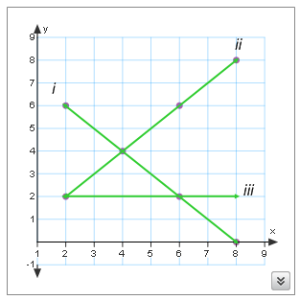
19. (P9.1c)

Pre-requisite Outcomes:
MC = Multiple Choice, SA = Short Answer
SS5.5 (MC1)
SP6.1 (SA18b)
SP6.3 (MC2)
SS7.3 (MC17)
SS7.5 (MC15)
P7.1 (MC4, MC6, SA19)
P7.3 (MC12)
P8.1 (MC5, MC11, SA18a)
P9.1 (MC3, MC7, MC8, MC9, SA19)
P9.2 (MC10, MC13, MC14, MC16, SA18c)

