FP10.7 Post-Assessment
Linear Functions (Chapter6)

FP10.7 Demonstrate, with and without the use of technology, understanding of slope (concretely, pictorially, and symbolically) with respect to:
- line segments and lines
- rate of change
- ratio of rise to run
- parallel lines
- perpendicular lines.

Multiple Choice: Identify the choice that best completes the statement or answers the question.

____ 1. Determine the slope of this line segment.

a. |  | c.
b. |  | d.
____ 2. Determine the slope of the line that passes through G(3, –3) and H(–5, 9).

a. |  | c.
b. |  | d.
____ 3. Is the slope of this line segment positive, negative, zero, or not defined?

a. | zero | c. | not defined
b. | positive | d. | negative

____ 4. Is the slope of this line segment positive, negative, zero, or not defined?

a. | positive | c. | zero
b. | negative | d. | not defined

____ 5. Is the slope of this line segment positive, negative, zero, or not defined?
a. | negative | c. | positive
b. | not defined | d. | zero

____ 6. A road rises 9 m from left to right for every 60 m measured horizontally. Determine the slope of the road.
a. |  | c.
b. |  | d.

____ 7. A skateboard ramp rises 2 ft. for every 7 ft. measured horizontally. What is the run?
a. |  | c. | 2
b. | 7 | d.
____ 8. Which of these line segments are parallel?
a. | CD and EF | c. | AB and CD
b. | EF and GH | d. | AB and EF
____ 9. The slope of a line is . What is the slope of a line that is perpendicular to this line?

a. | – | c.
b. | – | d.
____ 10. Determine the slope of a line that is parallel to the line through L(–6, 3) and K(12, –9).

a. |  | c.
b. |  | d.
Short Answer: Show your work whenever possible.

11. A school plans to build a wheelchair ramp from the sidewalk to the front entrance of the school. The slope of the ramp must be . The entrance to the school is 75 cm above the ground. What is the horizontal distance needed for the ramp?

12. a) Draw a line segment whose slope is $\frac{3}{5}$ and it passes through the point (1, -2).

b) Name another point on this line. ____________

13. Tom has a part-time job. He recorded the hours he worked and his pay for 3 different days. Tom plotted this data on the graph below.

- What is the slope of a line through these points?

- What does the slope represent in this situation?

14. Describe a real life situation where knowledge of slope is important.

Answers
Multiple Choice:
- b (FP10.7 c)
- d (FP10.7 f)
- c (FP10.7 d, e)
- c (FP10.7 d, e)
- a (FP10.7 d, e)
- d (FP 10.7 j)
- b (FP 10.7 j)
- d (FP 10.7 i)
- a (FP 10.7 i)
- c (FP 10.7 i)

Short Answer:
- (FP10.7j)
$$\frac{3}{32}=\frac{75}{x}$$
$2400=3x$
$800 cm=x$
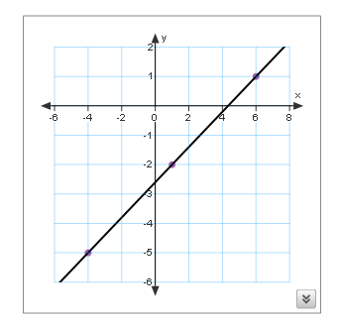
- a) (FP10.7g)

b) (FP10.7h) Answers may vary. Other points include (6, 1) and (-4, -5)

13. a) (FP10.7c) +12
b) (FP10.7b) Tom’s pay/hour.
14. (FP10.7a) Answers may vary. Possible responses include the pitch on a roof, grade of a road, drainage for water, building a ramp or staircase, snowboarding or skiing on a mountain, etc.

