
Targeted Intervention
Factors and Multiples

Curriculum/Learning Progression
N6.2
Demonstrate understanding of factors and multiples (concretely, pictorially, and symbolically) including:
- determining factors and multiples of numbers less than 100
- relating factors and multiples to multiplication and division
- determining and relating prime and composite numbers.
([C, CN, ME, PS, R])

Though factoring, factors, and multiples are explicitly taught in grade 6, the concept begins with multiplying in Grade 3, 4, and 5, and continues through fractions in grade 7 and 8 (Greatest Common Denominator is Least Common Multiple. Reducing Fraction requires students to recognize and divide out common factors. This outcome is closely linked with divisibility rules in grade 7).
Common Student Misconceptions and Errors
The main cause of this gap is VOCABULARY. Students don’t know what the words “factor” and “multiple” mean. They may misunderstand “Prime” factors. The factoring unit in grade 6 is often taught in isolation and not connected to processes.

How can we help?
- Introduce vocabulary early. This requires vertical teamwork among grades.
- Continually reinforce vocabulary.
- Teach divisibility rules early (grade 5 and 6) even if its only with an anchor chart.
- Link division and multiplication.
- Continually return to fluency practice and strategies with mult/div.
- Explicitly teach vocabulary.
- Use anchor charts!
- Work with vertical team grade 3 to 8 teachers meeting around the learning progression of multiplication, division, factors, multiples, prime and composite numbers).
- Teach multiplication with rectangular arrays. Use arrays to study factors and prime vs composite numbers. Use manipulatives and grid paper.
- Once divisibility rules are taught, continue to refer to them. Keep anchor charts into grade 8,9,10.
Links
(see below)

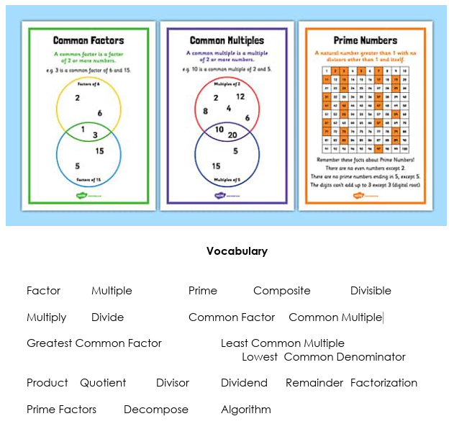
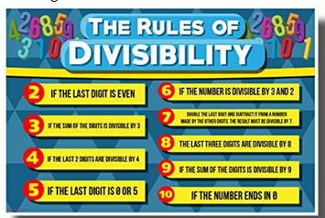
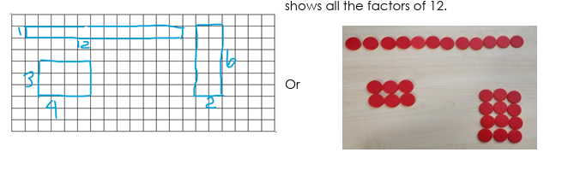
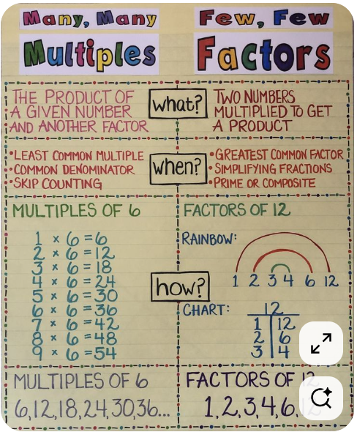

Factors and multiples game https://slideplayer.com/slide/12547402/
Factors and Multiples

Juniper Green http://manghammath.com/Activities/Juniper%20Green.pdf
How to play: https://themathbehindthemagic.wordpress.com/2021/02/26/juniper-green/#:~:text=To%20play%20Juniper%20Green%2C%20you,of%20the%20previous%20player's%20choice.
Online practice
Recognizing multiples!!!! https://www.topmarks.co.uk/times-tables/coconut-multiples

GCF
https://mrnussbaum.com/greatest-common-factor-online
https://www.mathmammoth.com/practice/gcf
https://www.mathgames.com/skill/6.52-greatest-common-factors-gcf
Love this one https://www.sheppardsoftware.com/math/fractions/greatest-common-factor-game/

LCM
https://www.mathgames.com/skill/6.53-least-common-multiples-lcm
https://mathkite.com/least-common-multiple-lcm/
https://mrnussbaum.com/least-common-multiple-online

From Nrich https://nrich.maths.org/factorsandmultiples

Recognizing Multiples https://www.sheppardsoftware.com/math/multiples/catch-the-stars/

From NCTM Illuminations (2 person game) :
Factor Game: https://www.nctm.org/Classroom-Resources/Illuminations/Interactives/Factor-Game/
Multiple Game https://www.nctm.org/Classroom-Resources/Illuminations/Interactives/Product-Game/

Printable in-person games
https://www.youtube.com/watch?v=yZ2qsDw_g7E this is a printable game, video how to play it

Another in person game https://occupymath.wordpress.com/2019/11/14/the-multiple-game/
The Product Game: https://connectedmath.msu.edu/covid-19-cmp-resources/resources-for-families/math-games/product-game/
How to play the product game video https://www.youtube.com/watch?v=6-FZ2Boug9s
A collection of rich tasks https://mrbartonmaths.com/topics/number-skills/factors-multiples-and-primes/richtasks.html

Multitrap: Printable paper pencil game
https://mathcurious.com/2021/01/27/multi-trap-multipication-facts-multiples-factors/
Multitrap google slides https://docs.google.com/presentation/d/1iMcE5iOkjuyUdXvXy1nyxDZrJNvDm1z4YIZ0Sx49hjo/edit#slide=id.gb930cebdfa_0_385

Practice

Identifying multiples online worksheet
https://study.com/skill/practice/identifying-multiples-questions.html
https://www.topmarks.co.uk/Search.aspx?q=factors%20and%20multiples

https://www.multiplication.com/our-blog/jen-wieber/buzz-plus-number-game
https://calculate.org.au/2020/08/11/there-are-better-games-than-buzz/

https://helpingwithmath.com/worksheet/understanding-factors-and-multiples/

