Using Ten Frames For Subtraction
Leave a Comment / Number Sense, Addition and Subtraction / By Tze-Ping Low
Ten frames is a useful visualization tool when kids first learn about numbers and is often used to introduce addition at the kindergarten or pre-school level, but what about subtraction? How should we use properly ten frames for subtraction? Today, we will explain how we use ten frames to build up the number sense required for learning subtraction at early elementary levels.
If you are not familiar with what a ten frame is, please see our introduction to ten frames and number bonds here.

Subtraction within ten
The first stage of learning subtraction using ten frames is for numbers less than 10, for example 7 – 2 = 5.
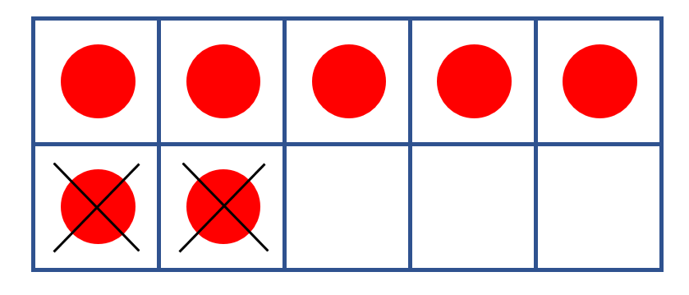Subtraction less than 10
The objective of this stage is to let kids get familiar with “seeing” numbers in relation to the two landmark numbers, i.e. 5 and 10. By showing quantities in two rows of five, we practice counting (subtracting) within 10 and build up subitizing skills. Here we also use number bond to see numbers as being “broken” into two parts:
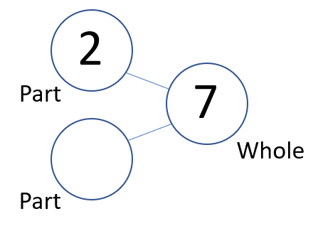Number bond for subtraction less than 10
The important thing when mapping from ten frames to the number bond is to see where to place the two numbers, i.e. 7 and 2, on the number bond circles.

Subtraction from Ten
The second stage in using ten frames for subtraction is subtracting from 10, for example, 10 – 3 = 7.
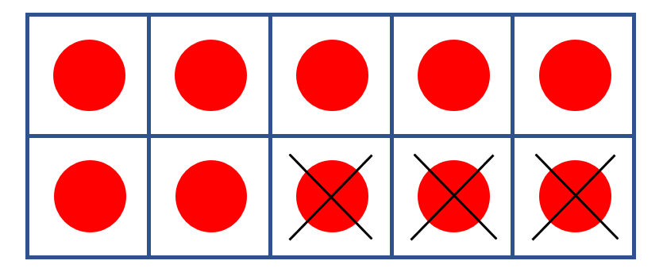Subtraction from 10
Here, we are trying to visualize how to take away from 10 to get the required result. Both forms of the number family should be used:
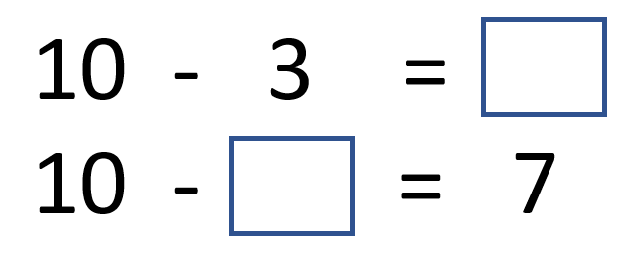
This is closely related to the concept of making ten, and is especially important for the next step.

Subtraction within 20
The final stage is subtraction within 20. This relies on the solid understanding in the previous two stages, for example, 12 – 5 = 7.
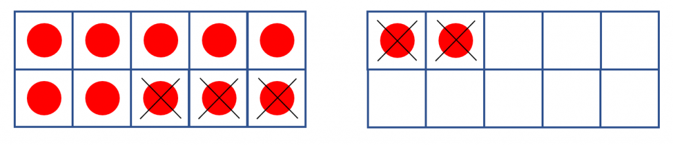Subtraction within 20
Here, we can think of the subtraction problem as a multi-step process.
First, we know that to make ten, we need to take 2 away from 12. So, out of the 5 we need to take away, we have accounted for 2.
Then, we ask: how many do we still need to take away? 5 – 2 = 3. Here, students rely on the foundation they built up in stage 1 (see above) for subtraction involving numbers less than 10.
Finally, we need to take 3 away from 10, which is exactly what we practiced in stage 2.
In number bond, we can visualize the problem as:
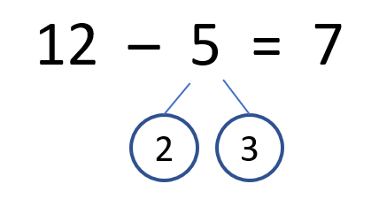

Conclusion
Ten frames and number bonds are great visualization tools that can be used to build up a strong foundation in number sense at early elementary levels. In this article, we discussed the use of ten frames to teach subtraction. In particular, ten frames are used in three stages to build up towards subtraction within 20. Once students mastered addition and subtraction within 20, extending to higher order numbers will be easy.

