
For example. You roll a 6 and the inside die shows 10. The 10 is negative.

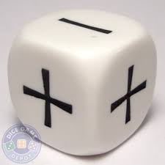
Now roll the operation die to find if you add or subtract.

Suppose you roll a “+” (add): Then you have $6+\left(-10\right)=-4$

Next, your opponent rolls a 3 and the inside die shows 8 (so -8). They roll the operation dice and roll “-“ (subtract). So they have $3-\left(-8\right)=11$

Keep a running total of your scores down the side.

In level 1, we always use the outside positive number first, then the operation, then the inside negative number.

$$3-\left(-8\right)=11$$

Inside number (negative)
Outside number (positive)

Operation –ADD or SUBTRACT

In Level 2, players can choose which of the numbers to put first. So for the above equation, if the player was trying to get to -100, they could rearrange the equation to $\left(-8\right)-3= -11$

