FP10.4 Post-Assessment
Trigonometry (Chapter 2)
FP10.4 Develop and apply the primary trigonometric ratios (sine, cosine, tangent) to solve problems that involve right triangles
Multiple Choice: Identify the choice that best completes the statement or answers the question.
____ 1. The angle between one shorter side of a rectangle and a diagonal is 64°. One longer side of the rectangle is 9.2 cm. What is the width of the rectangle, to the nearest tenth of a centimetre?

a. | 4.0 cm | b. | 18.9 cm | c. | 8.3 cm | d. | 4.5 cm

____ 2. A submarine rises a vertical distance of 200 m to the surface. The distance measured along the submarine’s path is 500 m. Determine the angle of inclination of the submarine’s path to the nearest degree.

a. | 24° | b. | 68° | c. | 22° | d. | 66°

____ 3. A ladder leans against a wall. The base of the ladder is on level ground 1.2 m from the wall. The angle between the ladder and the ground is 70°. How far up the wall does the ladder reach, to the nearest tenth of a metre?

a. | 0.4 m | b. | 1.3 m | c. | 3.5 m | d. | 3.3 m

____ 4. Determine tan Q and tan R.
a. | tan Q = ; tan R = 0.75 | c. | tan Q = ; tan R =
b. | tan Q = ; tan R = 0.75 | d. | tan Q = 0.75; tan R =

____ 5. Determine sin A and cos A to the nearest tenth.
a. | sin A = 1.7; cos A = 0.8 | c. | sin A = 0.6; cos A = 1.3
b. | sin A = 0.8; cos A = 0.6 | d. | sin A = 0.6; cos A = 0.8

____ 6. An airplane is flying at an altitude of 7000 m. At a certain time, the angle between the ground and a person’s line of sight to the airplane is 22°. About how far away is the person from a point on the ground vertically below the airplane, to the nearest hundred metres?

a. | 17 300 m | b. | 7500 m | c. | 2800 m | d. | 18 700 m

____ 7. A flagpole casts a shadow that is 21 m long when the angle between the sun’s rays and the ground is 48°. Determine the height of the flagpole, to the nearest metre.

a. | 19 m | b. | 16 m | c. | 14 m | d. | 23 m

____ 8. From the top of an 80-ft. building, the angle of elevation of the top of a taller building is 49° and the angle of depression of the base of this building is 62°. Determine the height of the taller building to the nearest foot.
a. | 211 ft. | b. | 112 ft. | c. | 129 ft. | d. | 276 ft.

____ 9. A 55-ft. guy wire helps to support a tower. The wire is anchored to the ground 37 ft. from the base of the tower. What is the measure of the angle formed between the wire and the ground, to the nearest degree?

a. 48° b. 56° c. 34° d. 42°

______ 10. A student stood 8.0 m from the base of a tree. He used a clinometer to sight the top of the tree. The angle shown on the protractor scale was 65°. The student held the clinometer 1.6 m above the ground. Determine the height of the tree to the nearest tenth of a metre.

a. | 10.4 m | b. | 5.3 m | c. | 3.7 m | d. | 18.8 m

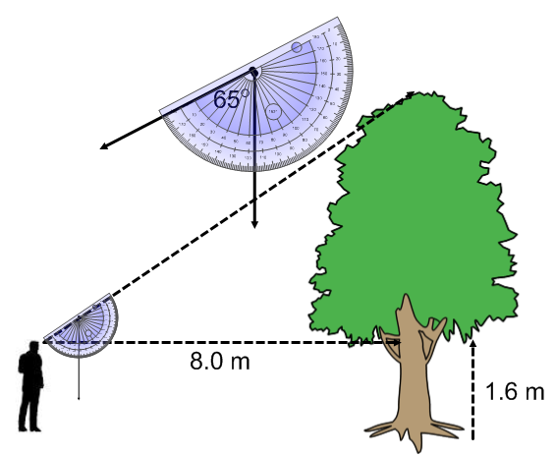

Short Answer: Show your work whenever possible.
11. Guy wires are attached to buildings as shown. A student says the angles of inclination of the wires are the same. Is the student correct? Justify your answer.

- Solve this right triangle. Give the measures of the lengths of the sides to the nearest tenth of a centimeter and the angle to the nearest degree.
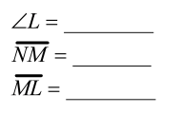

- Sue used a clinometer to sight the top of a tall building from a point 160.0 m from the base of the building. The angle shown on the protractor was 46°. Sue held the clinometer 1.8 m above the ground. Determine the height of the building to the nearest tenth of a metre.

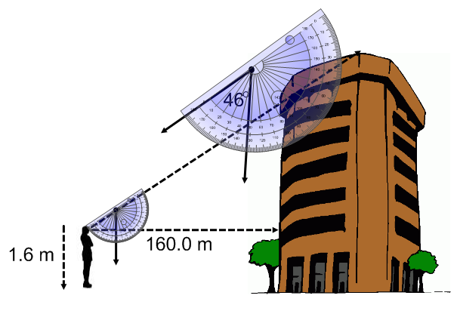

- A rectangular lawn has the dimensions shown. A gardener wants to use an electric lawnmower to mow the lawn. The electrical outlet is located at O.

- Determine the length of cord needed to reach corner C, to the nearest tenth of a metre.

b) Determine the distance between the electrical outlet and corner N, to the nearest tenth of a metre.

- Two boys are standing at the same elevation on opposite sides of a mountain. The peak of the mountain is 1350 ft. above them. Their angles of elevation to the top of the mountain are 65° and 50°. Determine the total distance, to the nearest foot, both boys have to hike in order to meet at the peak. Assume both boys are able to hike in a straight line to the peak.

