Name:
- Circle the objects that roll.
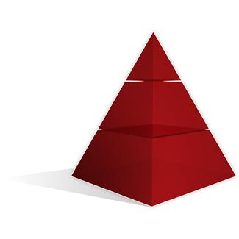






- Circle the shapes that have vertices.

- 1. Sort some or all of the 3-D objects into two sets. Tell your sorting rule.
Set 1 | Set 2
My sorting rule is _________________________________________________________________________________________________________________________________
- Sort some or all of the 2-D shapes into two sets. Tell your sorting rule.
Set 1 | Set 2

My sorting rule is
___________________________________________________________________________________________________________________________

- 1. What is the sorting rule for these 3-D objects?
Set 1 | Set 2
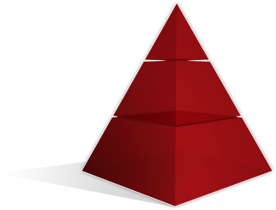 | 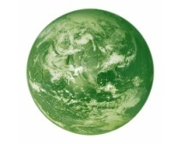

The sorting rule is ____________________________
__________________________________________

2.What is the sorting rule for these 2-D shapes?
Set 1 | Set 2
The sorting rule is ___________________________
_________________________________________
- What is the sorting rule for these 2-D shapes?
Set 1 | Set 2

The sorting rule is ___________________________
_________________________________________

