FP10.6 Post-Assessment
Relations and Functions (Chapter 5)
FP10.6 Expand and apply understanding of relations and functions including:
- relating data, graphs, and situations
- analyzing and interpreting
- distinguishing between relations and functions.

Multiple Choice – Identify the choice that best completes the statement or answers the question.

______1. A person in a car drives away from a stop sign, cruises at a constant speed, and then slows down as she approaches another stop sign. Which graph best represents this situation?

a. b.
.

c. d.

______2. Identify the range of this relation.

a. {-2, 3, 5}
b. {-2, 0, 3, 5}
c. {3, 6, 8}
d. {1, 3, 6, 8, 9}

______3. This table shows the cost, C dollars, of different numbers of tickets sold, n. Identify the range.

Number of Tickets,  n | Cost, C  ($)
1 | 12.50
2 | 25.00
3 | 37.50
4 | 50.00
5 | 62.50

a. {1, 2, 3, 4, 5, . . .}
b. {12.50, 25.00, 37.50, 50.00, 62.50, . . .}
c. {1, 2, 3, 4, 5, 12.50. 25.00, 37.50, 50.00, 62.50, . . .}
d. {1, 12.50, 2, 25.00, 3, 37.50, 4, 50.00, 5. 62.50, . . .}

______4. Joshua went on a bike ride. Which statement best describes what is happening for line segment DE in this graph?

a. Joshua spends time at the park.
b. Joshua leaves home.
c. Joshua cycles to the park.
d. Joshua cycles home from the park.

______5. Which set of ordered pairs does not represent a function?

a.
b.
c.
d.

______6. Which one of the following graphs represents a function?

a. b.
c. d.

______7. State the domain of this relation.

a. {-8, 7, 9, 10} b. {-11, -8, 7, 10}
c. {5, 6, 8, 9} d. {5, 6, 9, 10}

______8. Marbles are placed in a jar one at a time. Which graph below best represents the total mass of the jar and marbles as the marbles are added?

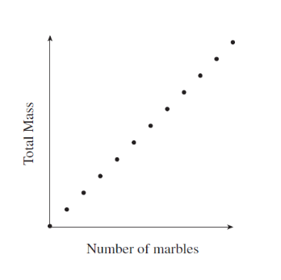
a. b.
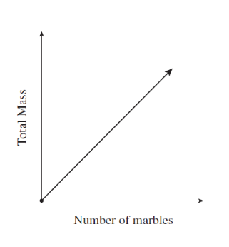

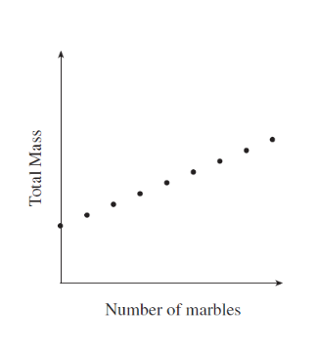
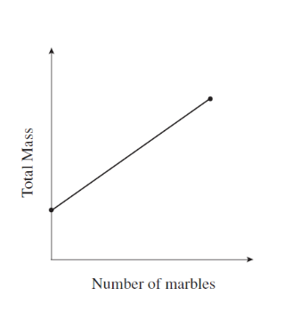
c. d.

______9. This graph shows the volume of water remaining in a leaking hot tub as a function of time. Determine the domain and range.

a. Domain: $t≤129$ b. Domain: $0≤V≤1800$
Range: $0≤V≤1800$ Range: $t≤129$

c. Domain: $0≤t≤129$ d. Domain: $0≤t≤129$
Range: $V≤1800$ Range: $0≤V≤1800$

______10. This graph shows the cost of hosting a dance, c, as a function of the number of students attending, n. What is a restriction on the domain?

a. The domain can only contain positive numbers.
b. The domain can only contain whole numbers between 1000 and 3500.
c. The domain can only contain whole numbers.
d. The domain can only contain whole numbers that are multiples of 50.

Short Answer: Show your work whenever possible.
11. This graph shows the number of people, n, at a garage sale as a function of time, t.

Explain why the points on this graph are not joined.
______________________________________________________________________
______________________________________________________________________
______________________________________________________________________

12. Provide and explain an example of a situation that could be represented by the given graph.
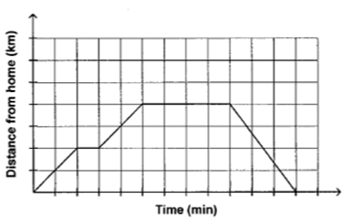

_________________________________________________________________________
_________________________________________________________________________
_________________________________________________________________________
_________________________________________________________________________
_________________________________________________________________________
_________________________________________________________________________

13. Look at the tables below to answer the following 2 questions.
a) Which one of the following tables of values represents a function? Circle one.
b) Explain below how you know that it is a function.
Table 1 Table 2
Team Member | Age
Julie | 15
Hayley | 16
Cassie | 16
Jennifer | 15
Marie | 17
Meaghan | 15
Angela | 16
Kim | 17
Age | Team Member
15 | Julie
16 | Hayley
16 | Cassie
15 | Jennifer
17 | Marie
15 | Meaghan
16 | Angela
17 | Kim

a) Table 1 Table 2
b) _______________________________________________________________________
_______________________________________________________________________
_______________________________________________________________________
______________________________________________________________________

Answers
Multiple Choice:
1. d (FP10.6g)
2. b (FP10.6h)
3. b (FP10.6h)
4. d (FP10.6f)
5. a (FP10.6i)
6. a (FP10.6i)
7. c (FP10.6h)
8. c (FP10.6e)
9. d (FP10.6h)
10. c (FP10.6d)

Short Answer:

11. (FP10.6e) Answers will vary. In order to be considered a correct response the answer should include that there cannot be a fraction of a person therefore the points should not be connected.

12. (FP10.6f) Answers will vary. In order to be considered a correct response the answer should include having one short stop, one longer stop, travelling away from home and back home again.

13. (FP10.6i) a) Table 1 is a function.
b) Answers will vary. In order to be considered a correct response the answer should include that in Table 1 every first element (domain) is different but in Table 2 some of the first elements (domain) are repeated.

