Double Trouble
Addition
My Roll Total work area
_______ + ______ = ______
_______ + ______ = ______
_______ + ______ = ______
_______ + ______ = ______
_______ + ______ = ______
_______ + ______ = ______
_______ + ______ = ______
_______ + ______ = ______
_______ + ______ = ______
Instructions: Roll 2 dice. Find the sum by adding the two numbers. Fill in the equation under “My Roll. Keep a running total in the second column

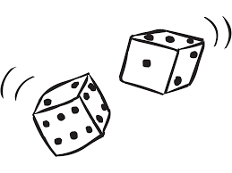
If you roll doubles, find the sum, but the amount gets subtracted from your total instead of added!
Person with the highest score wins!
Games by Cindy

